SASVIYA Exercise

Linear Regression

(4/2/2019)

Sources
Steve Nolan, Ron Freeze, Elizabeth Keiffer, Michael Gibbs
Enterprise Systems, Sam M. Walton College of Business, University of Arkansas, Fayetteville
SAS® VIYA 8.2 Release V03

Copyright © 2018 For educational uses only - adapted from sources with permission. No part of this publication may be reproduced, stored in a retrieval system, or transmitted, in any form or by any means, electronic, mechanical, photocopying, or otherwise, without the prior written permission from the author/presenter.

Use Case – Linear Regression
Razorback Stores is a local department store serving a metropolitan area. As a department store, they offer a wide variety of items and services and track sales through a point of sale system. Over the past several months, Razorback Stores performed a marketing campaign designed to promote and incentivize a loyalty program.
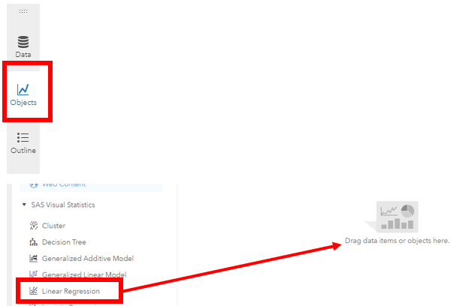

Step 1: Select Data
Select the RAZORBACK STORES.SASHDAT dataset for use. There is an assumption that the Razorback Stores has already been loaded into memory. Where is the tutorial that did this?

Step 2: Select Model
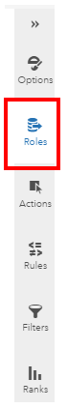
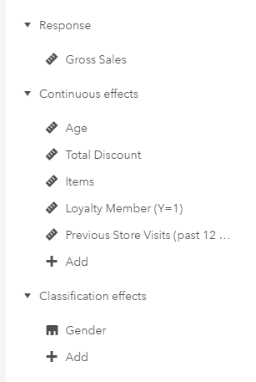
Select New Report and use the object panel to select Objects>SAS Visual Statistics>Linear Regression and drop it into the middle space

Step 3: Select Variables
From here, you will have the data Roles on the right to work. Add a Response variable (dependent variable) and the Effect variables (independent variables). Note that your effect variables are separated by Continuous and Classification effects.

Step 4: Review Results
Once you have selected your response variable and “effects”, the linear regression will update and display. Key things to keep in mind: There is a Training and Validation data set. Where were these selected?
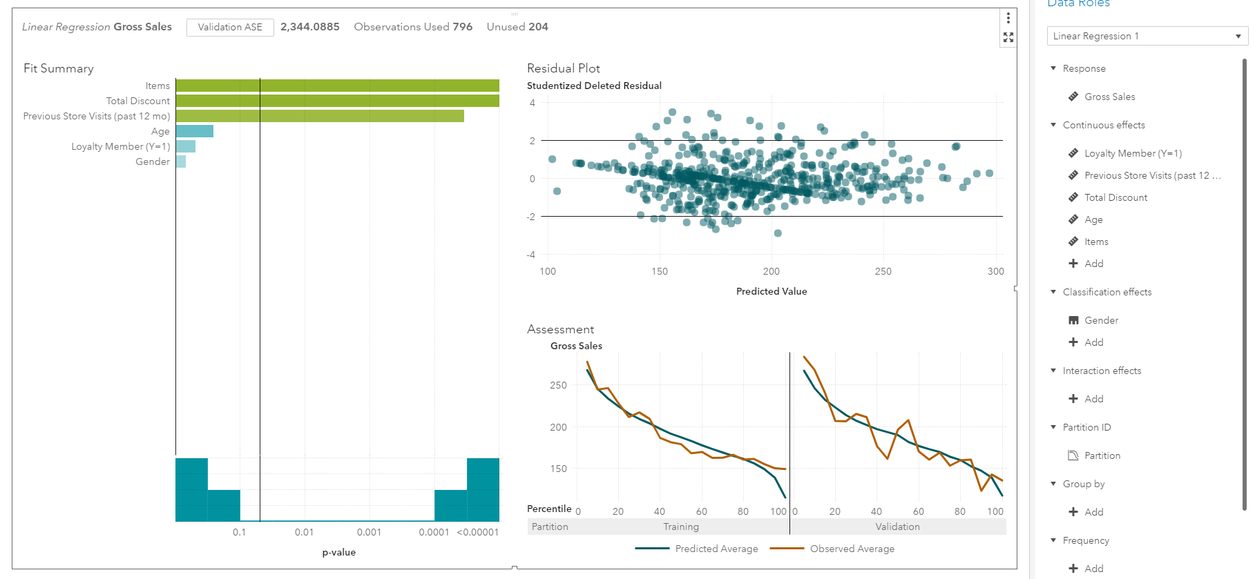

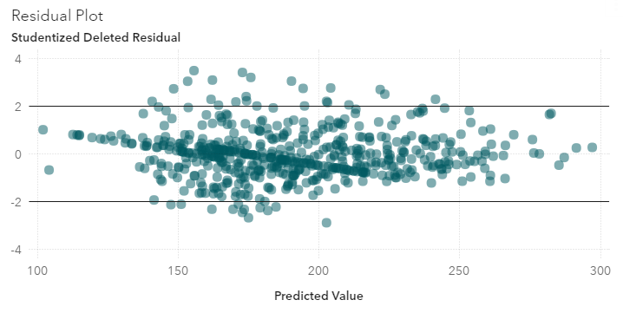
Residual Plots
Residual plots are displayed in the upper-right hand part of the display. This is used to check to ensure residuals do not have a pattern.

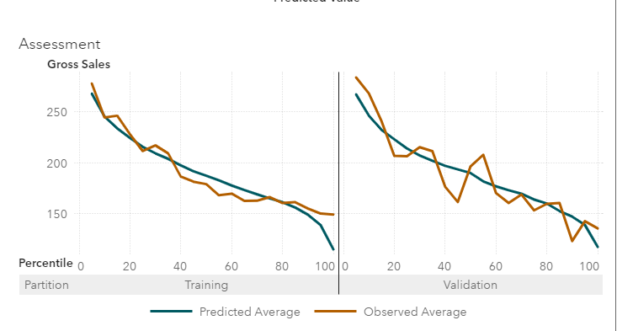
Lift Chart
Lift chart is used to evaluate overfitting. The chart is in the bottom-right hand corner of your screen. Ensure that the validation data is not overfitting.

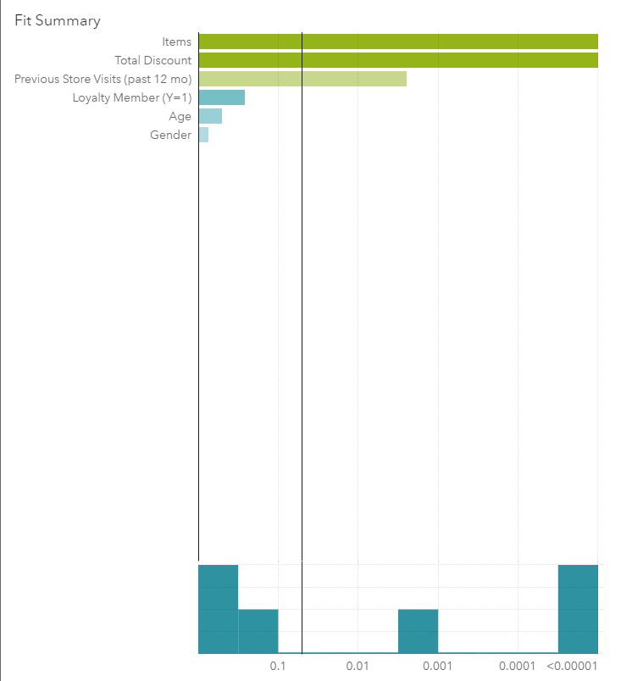
Fit Summary
The fit summary shows you variable importance and the p-value threshold for statistical significance. You can adjust the p-value significance by using sliding the vertical bar.

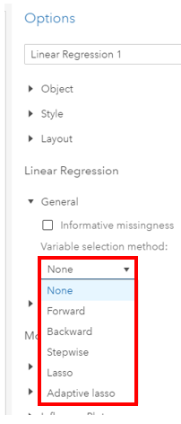

Options
Once you have this, you can then select from a variety of Options in the Options panel on the right. A key option to note is under the Linear Regression>General option. You can select various regression methods (forward, backward, stepwise, etc.). (Note: Make sure you have selected the report in order for the Options to be available.)

Parameters
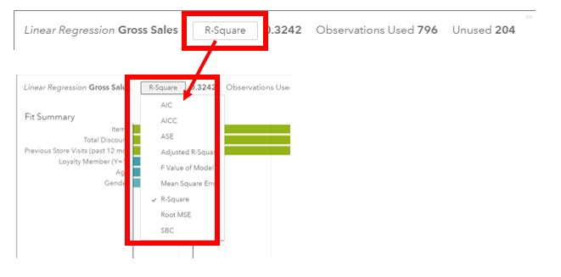
As part of the review process you can click on the textbox at the top of the screen and change the shown parameter to several different options:

Step 5: Evaluate Model
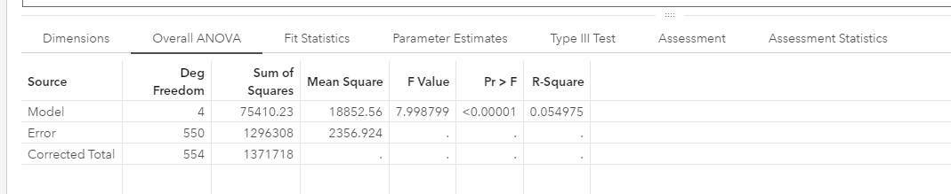
Now that the settings are in place, we can evaluate the predictive model. Click on the icon below that is located in the upper-right corner of the modeling screen: This will bring up the evaluations table at the bottom of your screen.

The overall ANOVA will display your R-Square value as well as the Sum of Squares, p-Value, and Mean Square.

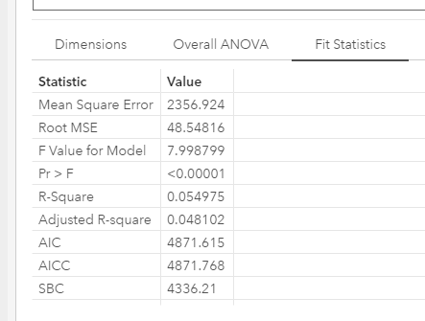
Step 6: Fit Statistics
You can also evaluate your model on the Fit Statistics tab. This has values such as your root mean squared error (RMSE) and Adjusted R-square.

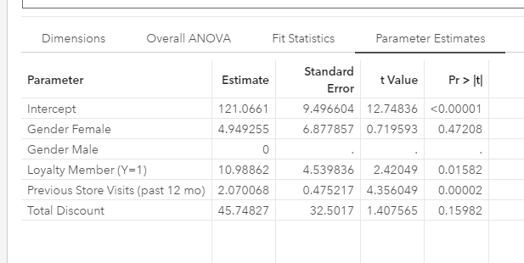
Parameter Estimates
On the Parameter Estimates tab, you can review the linear regression formula. Be sure to check t-value significance of the variables.

Regression Equation
The above example would produce this formula
Gross Sales = 121.0661 + 4.949255*(Female Gender) + 0*(Male Gender) + 10.98862*(Loyalty Member) + 2.070068*(Previous store visits) + 45.74827*(Total Discount)

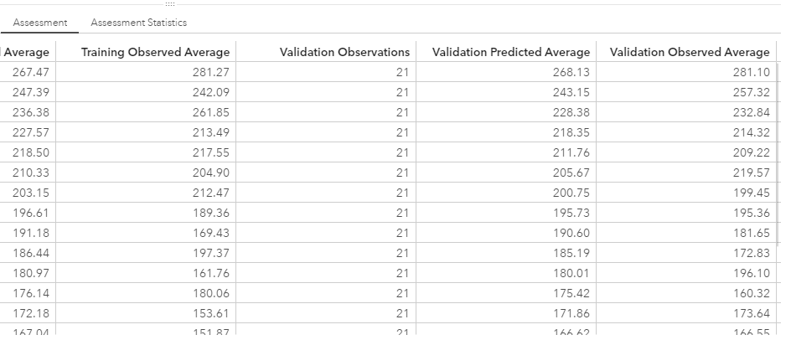
Assessment
On the assessment tab, you can review the predicted average of an observation against the observed average. This shows a visual of your predictive model and how well it is performing.

