SASVIYA Exercise

Logistic Regression

(4/2/2019)

Sources
Steve Nolan, Ron Freeze, Elizabeth Keiffer, Michael Gibbs
Enterprise Systems, Sam M. Walton College of Business, University of Arkansas, Fayetteville
SAS® VIYA 8.2 Release V03

Copyright © 2018 For educational uses only - adapted from sources with permission. No part of this publication may be reproduced, stored in a retrieval system, or transmitted, in any form or by any means, electronic, mechanical, photocopying, or otherwise, without the prior written permission from the author/presenter.

Use Case – Logistic Regression
Universal Bank is a banking dataset with the goal of identifying if a customer accepted a personal loan from a marketing campaign.

Step 1: Load Data
The dataset used is UNIVERSALBANK.sashdat.

Use the object panel and select “logistic regression” and drop it into the middle space
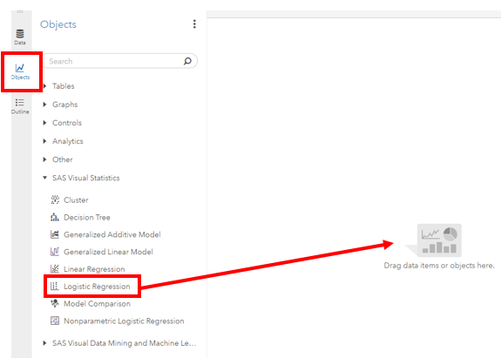

Step 2:
Once you have the object in place, you will need to select a response variable (dependent) and effect variables (independent). Note that the effects are broken into continuous and categorical
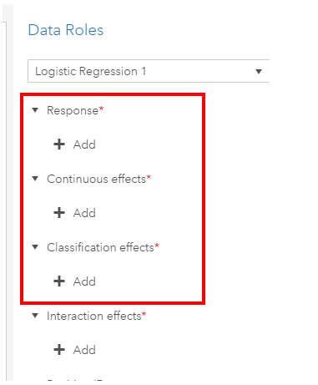
Step 3:
Once you have selected your data, the logistic regression will update on the screen and display several outputs:
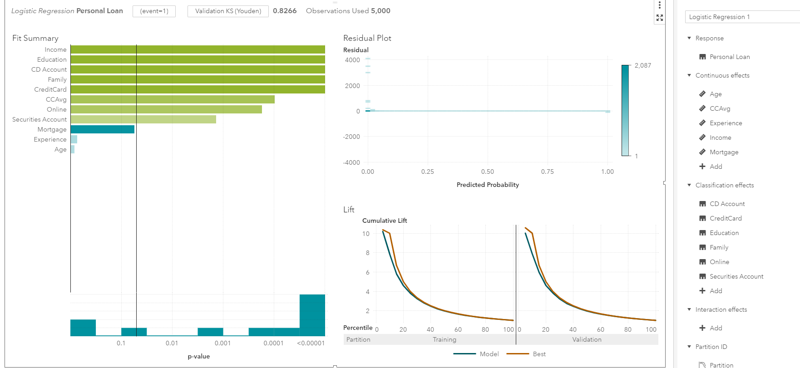
Step 4:
Here are some key things to note:
The event is currently set to 1.
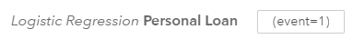
One of the key results is set to determine which error metric you would like to view. The default value is “Validation KS(Youden)”. This is a clickable button that you can change error metrics. Our recommendation is to toggle between Misclassification Rate (Event) and Validation Misclassification Rate (Event) to observe both the values and their relationship to each other.
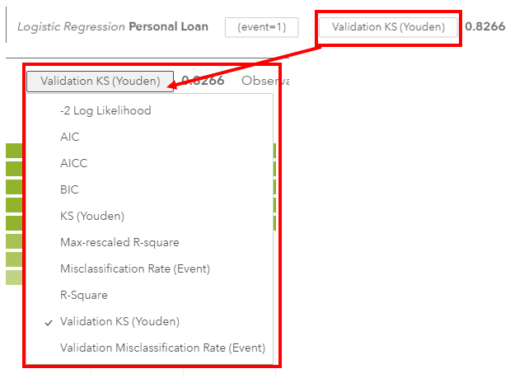

You can change the lift chart into the ROC curve by hovering over the graph and selecting the three vertical dots in the upper right hand corner.
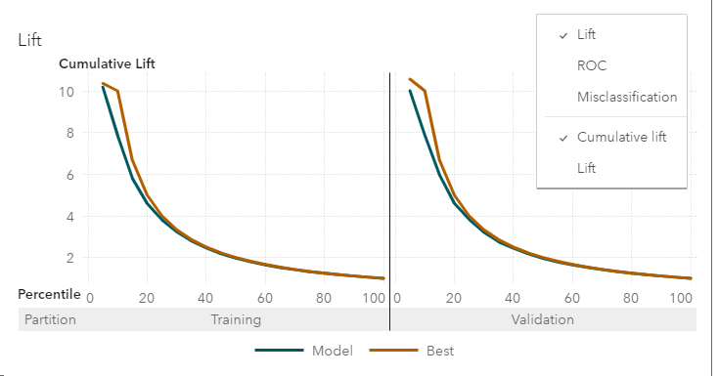
Step 5:
Click on the maximize button in the upper-right portion of the visuals
From here, you can view the response profile of how individuals answered to the target variable.
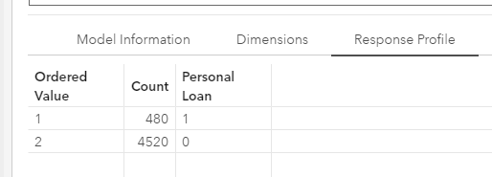

You can view the fit statistics
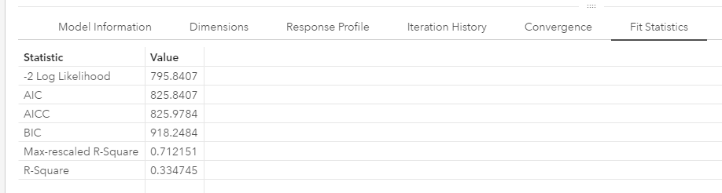
You can evaluate the parameter estimates and develop the logistic regression formula for classification.
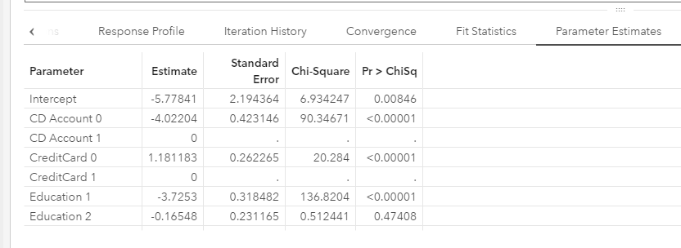
You can also view the confusion matrix under the misclassification tab.
