SASVIYA Exercise

Clustering

(4/2/2019)

Sources
Steve Nolan, Ron Freeze, Elizabeth Keiffer, Michael Gibbs
Enterprise Systems, Sam M. Walton College of Business, University of Arkansas, Fayetteville
SAS® VIYA 8.2 Release V03

Copyright © 2018 For educational uses only - adapted from sources with permission. No part of this publication may be reproduced, stored in a retrieval system, or transmitted, in any form or by any means, electronic, mechanical, photocopying, or otherwise, without the prior written permission from the author/presenter.

Use Case
Razorback Stores is a local department store serving a metropolitan area. As a department store, they offer a wide variety of items and services and track sales through a point of sale system. Over the past several months, Razorback Stores performed a marketing campaign designed to promote and incentivize a loyalty program.
Razorback Stores would like to know if there are specific groups of customers that they should incentivize to shop at their stores.

Step 1:
First, select from the objects panel the cluster visual and drag it into the center of the screen.
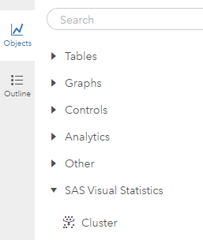

Step 2:
From there, you can add roles from the right-hand panel. This is going to be all the variables that you wish to include in your cluster analysis.
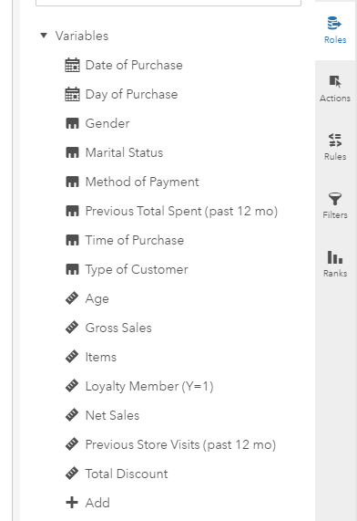
Step 3:
Now that you have variables, the cluster analysis will begin to build. From here, there are various options that you can manipulate in order to achieve the desired results.
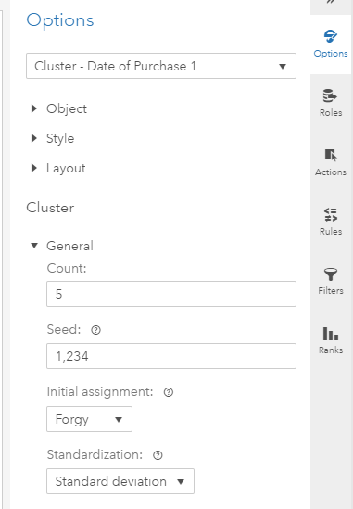
Step 4:
Click on the maximize button
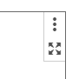
From here, under the centroids tab, you can view variables that make up each cluster.
