Loading Data with Date Fields

Into Teradata Studio and SAS Viya

(3/30/2022)

Sources
Ron Freeze, Odessa Elie, Guy Webb
Enterprise Systems, Sam M. Walton College of Business, University of Arkansas, Fayetteville
Teradata Viewpoint 16.50.01.00-b710

Copyright © 2020 For educational uses only - adapted from sources with permission. No part of this publication may be reproduced, stored in a retrieval system, or transmitted, in any form or by any means, electronic, mechanical, photocopying, or otherwise, without the prior written permission from the author/presenter.

Use Case – Loading Date Fields
The purpose of this document is to understand and demonstrate the processes of loading data containing date fields into Teradata Studio Express and SAS Viya. These steps require access to the University of Arkansas applications: VMware, Teradata Studio Express (also referred to as Teradata Studio in this document) and SAS Viya.
When navigating personal databases, it should be noted that the authors are allotted permanent space on the Teradata Intelliflex system to create their own databases, views, and more. [insert something about space on SAS viya]
Authors that have additional questions concerning the Teradata Intelliflex system or SAS Viya platform at the University of Arkansas should contact Ron Freeze or Michael Gibbs. They are also available via email for additional support with creating accounts, accessing enterprise data sets, and general questions about the system.
- Ron Freeze at rfreeze@walton.uark.edu
- Michael Gibbs at mgibbs@walton.uark.edu

Part 1: Data set Description
The data set used in this tutorial contains 51 columns with 4,337 rows of data. Each row represents a date written in a different format based on the list of date and datetime formats frequently used in the US. The data set was created in Microsoft Excel, with two main data types: Date and Custom. Double click on the icon below to access and save the Excel file.

To recreate the file, follow the steps below.

- Go to https://help.talend.com/r/6K8Ti_j8LkR03kjthAW6fg/~wDyssNBFPIG2jgx3fux3Q to find a list of date and datetime formats for the EN_US locale.

- Create a new Excel spreadsheet and use the date or timestamp formats as column headers as seen in the screenshot below.

- Copy and paste the date and timestamp examples from the website table into the Excel file.

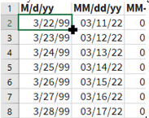
- Place your cursor in the bottom right corner of one of the cells until you see a plus sign. Drag it down to populate the column until you have reached your desired number of rows. In this example, we used 4,337 rows. Repeat this step for all the columns.

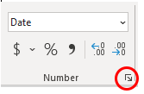
- Highlight each column one by one, to verify the data types for the dates stored in them.

You can verify the data type by looking at the Number Tab in the tool bar. Since all the fields are dates, the data should be formatted as dates. If the data type is not listed as “Date” in the Number Tab, click on the expand icon to edit the data type.

- Select the Date Category in the left panel to change the column type to date, and select the correct date type from the Type panel on the right. Click OK.

If you do not see your desired date type in the list, remain on this screen and go to step 7.

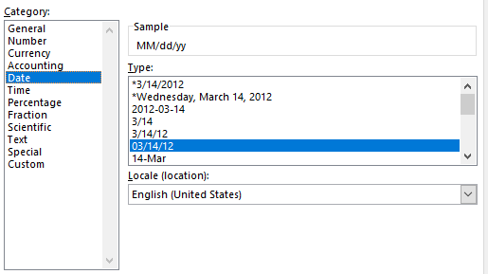

- Select the Custom Category in the left panel to manually specify your desired date format.

A list of alternative date formats will be provided in the Type panel on the right. Select the appropriate one if it is on the list. If it is not on the list, you can manually enter the format in the text box at the top of the Type panel, and view a sample of what the data will look like in that format. Click OK.

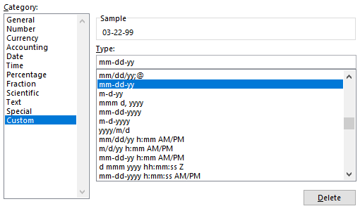

- Repeat steps 5 through 7 to verify the data types and formats for each column.

- Go to File > Save As > Text (Tab delimited)(*.txt) to save as a tab delimited text file.

Don’t forget to name your file. In the screenshot below, the name of the file is Date_Data.

- Click Save.

Part 2: Loading Data into Teradata Studio

Step 1: Request Access to Teradata System
- Go to https://request.information-systems.uark.edu/login.

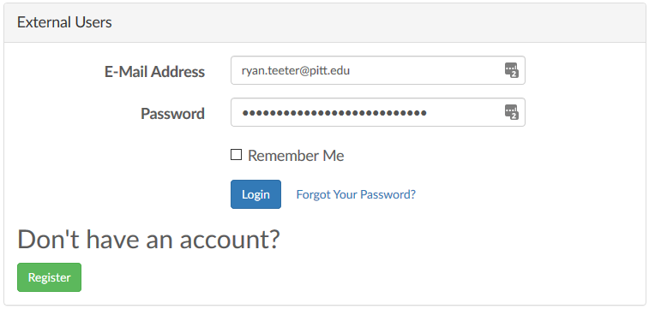
- Enter your e-mail address and password and click Login.

If you don’t already have an enterprise systems account, register for an account at the same place

- Go to https://request.information-systems.uark.edu/login.

- Click Register.

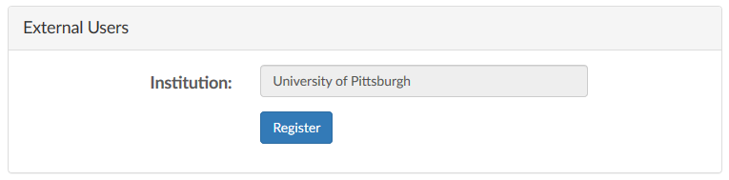
- Type the name of your institution and click Register.

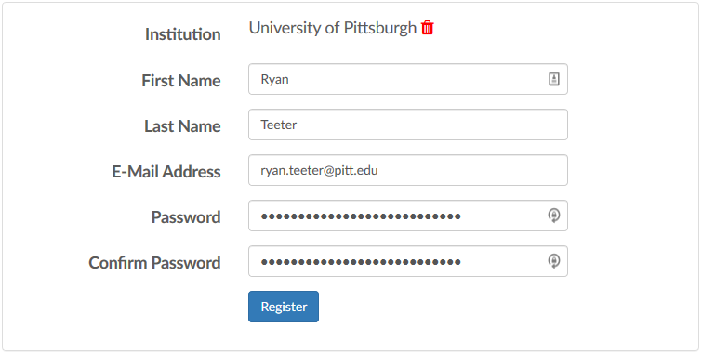
- Type in your first name, last name, e-mail address, and password, and click Register.

You only need to create an author account once. If you plan on submitting multiple datasets, you can continue to use your prior account to load your data for the new acceptances.

Step 2: Request Access to the Journal databases
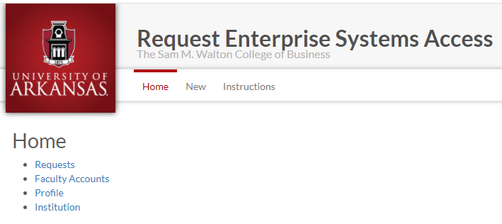
Walton Enterprise Systems provides support for multiple authors and their datasets as well as access to many applications used in industry. This example outlines the process for requesting space and access for the data sets being shared with the Data & Analytics for Good journals.
- Log in.

- Click “New” on the Home screen.

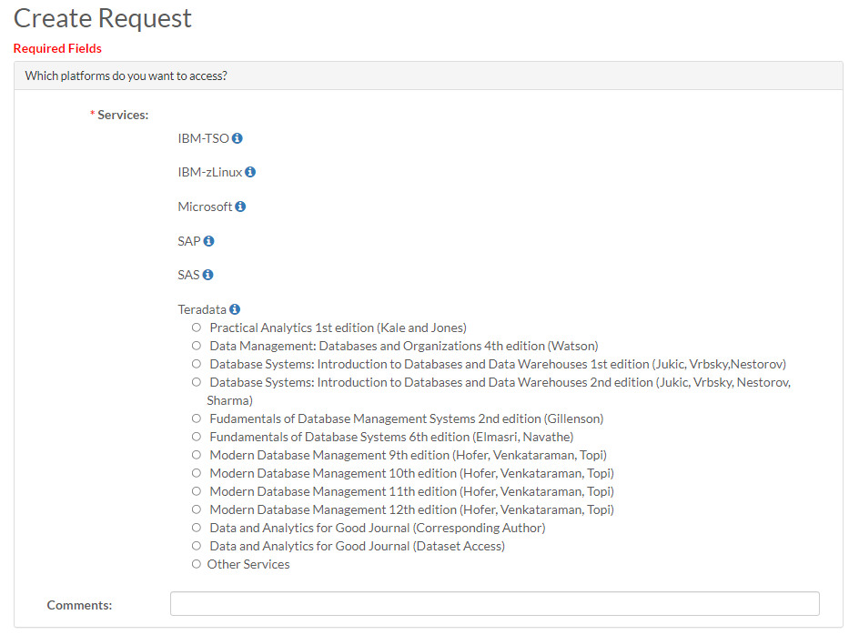
- On the Create Request screen, under “Which platforms do you want to access?”, Select the Teradata platform

There are two selections for the Data and Analytics for God Journal. The first is for the corresponding author (or co-authors). Selecting this will allow you to upload your data to the appropriate Issue and Article #. If you are the corresponding author, th following information will be requested.
- Corresponding Author:
- Accepting Senior Editor:
- Manuscript Titles”
- Journal Issue:
- Article Acceptance Number:

The second selection is for those wishing read access to all of the Journal’s datasets.

- Select appropriate Data & Analytics for Good Journal rquest

- For “How many new accounts would you like?”, there is no need to indicate anything for new accounts unless you are getting accounts for students where they will be using the DAG datasets.

- In the “Anything else you would like us to know?” box, enter additional information that could help provide context behind your request.

- Read the agreement, and check I agree.

- Click Submit to finalize your request.

Note: you won’t receive confirmation of account creation until the accounts are created. This includes the Teradata databased that will be created for you.

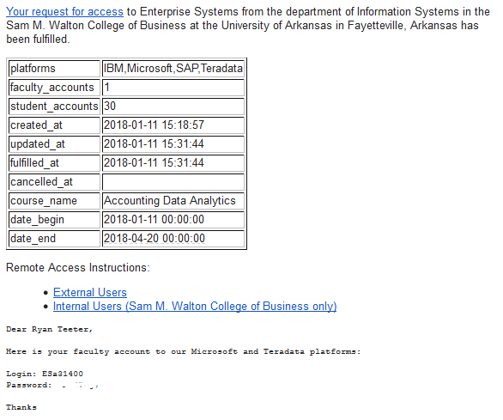
Step 3: Wait for the e-mail
A systems specialist at the University of Arkansas will manually review your request and create the account usernames and passwords requested. Account creation should be completed within 2 business days.

You will receive an e-mail with your login username and password, similar to the image on the right:

Once your author account is created, you may continue with the Step 4: Using VMware in order to log into the Walton Enterprise System.

Step 4: Using VMware
In order to upload your dataset, you will need to use Teradata Studio which is accessible from the Walton Enterprise System virtual desktop – VMware. You can install VMware on your local desktop or use the browser version to access your virtual desktop. Either the downloaded VMware or browser version are acceptable and provide you with the same access.
- Refer to the document “VMware Guide via Windows Client” to view the tutorial on how to download, install, and use VMware on your computer.

- Refer to the document “VMware Guide via Browser” to view the tutorial on how to access VMware through your browser.

Step 5: Data Loading verification
This step provides a short check list for the guidelines you will use in Step 6 & Step 7. Once you have uploaded all of your tables, the following bullet points are the data loading verification that will be performed by the Data and Analytics for Good reviewers prior to final acceptance of the article.
- Do the table names uploaded to Teradata match the table names in the …
  - Data Dictionary
  - Entity Relationship Diagram
  - Other locations in the article…
- Do the data types in the Teradata database match …
  - The variables in the Entity Relationship Diagram
  - The variables loaded in the Data Dictionary
With concurrence of data load, final acceptance of the article will be issued.

Step 6: Transferring Files to VMWare
For the ease of loading your .csv data files to Teradata, it is recommended that you first transfer your files to either your VMWare desktop or your folder in the S: drive that is accessible in VMWare. Step 6 shows how to transfer files to VMWare. For this example, you will need to make your file(s) available to the VMWare desktop.
- Expand the Navigation pane for your Desktop by selecting the tab located in the middle of your screen on the left side
- Open the Transfer Files pop-up by selecting the icon
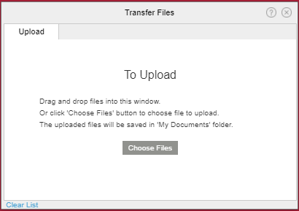
- Select the “Choose Files” on the Transfer Files pop-up and navigate to the directory on your computer to select the files to be uploaded to the tables in your database.

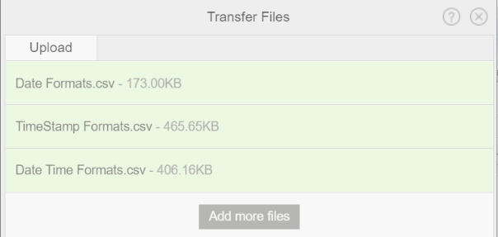
- Select each of the files you have created for uploading to Teradata. The screen shot shows three files (tables) moved to VMWare that are to be uploaded to Teradata. These files were for testing the Date, TimeStamp and Date Time formats. (See the section on Checking Date//Time formats.)

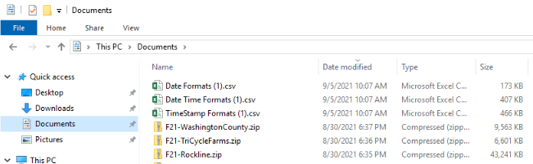

The files show in the Transfer Files pop-up will be in your VMWare Documents directory for selection by Teradata. You could also place them in your personal S: drive folder or on your VMWare Desktop. Screen shots for all three locations have been provided.
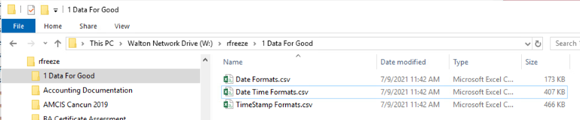
You have now loaded your data to VMWare and are ready to load your data to the Teradata tables.

Step 7: Loading into Teradata Studio
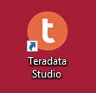
Teradata Studio is a more robust application used to access the Teradata IntelliFlex system. Teradata Studio will be used to upload your dataset. On your desktop, you will see the Teradata Studio icon.

Accessing
- Double click the Teradata Studio icon. You may need to open the Microsoft Start button in the lower left hand corner
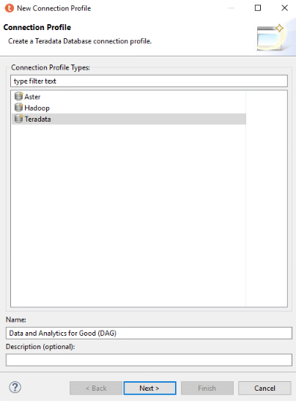
Teradata Studio will open. If you have logged in before, Teradata Studio may prompt you for your password to the University of Arkansas IntelliFlex system. Please enter your provided password. If you have not logged in before, you will be prompted with a Quick Tour which you may go through if you wish. After clicking out of the Quick Tour, you will be prompted to create a connection profile.
- Once you have logged on, you will need to right click on Database Connections and select “new”
- Select “Teradata” from the Connection Profile window
- Place the database name for your connection as “Data and Analytics for Good (DAG)”
- Click “Next”

After clicking next, you will be prompted with a new window, “Specify a Driver and Connection Details”. Specify the drive and connection details by entering in the database server name, and your username and password given to you by the University of Arkansas.
Database Server Name: uofaifx.walton.uark.edu
User Name(Domain): (your username)
Password: (your password)
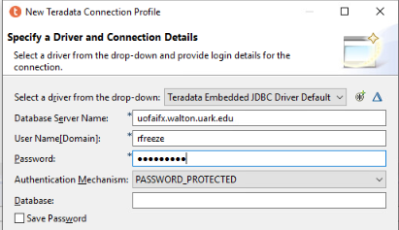
You may leave the rest of the dialog boxes blank.
- Select “Finish”

Viewing Datasets
This section explains how to navigate Teradata Studio and view your dataset and all available datasets.
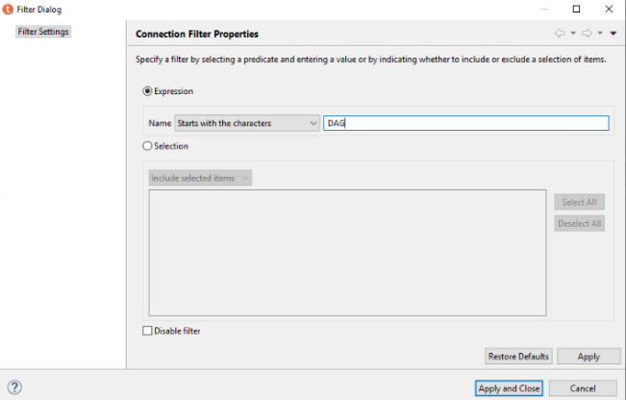
- View the Data Source Explorer on the left by selecting the down arrows on your username
This will show you the databases and Foreign Servers you can view in the Database Connections folder. This is where you can explore which databases are available to you and expand the Data and Analytics for Good (DAG) (Teradata v 16.20.32.35) icon to see the databases. Due to the large number of databases, you will need to filter to only those databases for which you are interested. Since you will be uploading the dataset associated with your accepted article in the journal, you will need to search for only those databases associated with your article. These have already been set up for ease of uploading.
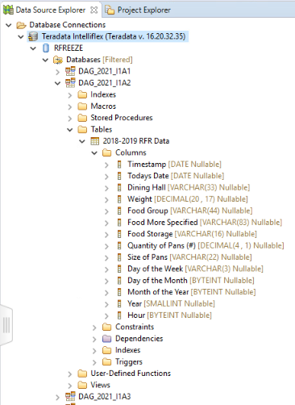
- Right click on the Databases folder
- Select Filter
A Filter Dialog pop-up will appear.
- Make sure the “Disable Filter” at the bottom has been deselected
- Enter “DAG” in the Expression
- Select “Apply and Close”
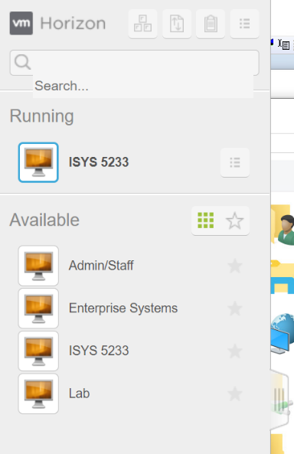
You can use the same process to select other databases for which you are able to view the data. The example shows the first issue of the Data and Analytics for Good journal databases.Additionally, Article twos table and variables have been displayed. The data types of the Teradata Intelliflex table should match the data dictionary provided in your article. As new articles are accepted, you will have read access to the new data.

Checking Date/Time formats
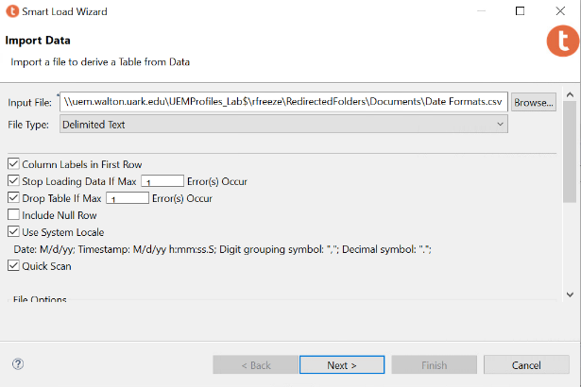
Data types are critical to communicating through analytics. One of the most frequent issues is with the uploading of date and time formats. The following highlights the uploading of date and time formats associated with the private database of rfreeze. There are two important aspects of uploading your data that will enable our community to replicate and expand on your initial article. The first aspect is ensuring correct Date, Date-Time and Timestamp formatting in your CSV file. In this example, the CSV file was created in Excel and saved appropriately for uploading to Teradata. The examples provided are from a CSV file named “Date Formats.CSV”, “TimeStamp Formats.CSV” and “Date Time Formats.CSV”. Please replicate this section with your own .CSV file in order to practice your data load from your article. The Date Formats section shows the process of uploading the Date Formats.CSV file. The next two sections provide the results of uploading the TimeStamp Formats.CSV and Date Time Formats.CSV files. For this example, the Date Formats.CSV file is being uploaded to the personal RFREEZE database. An example of this formatting has been provided. All three examples will be uploaded to this location.
- Right click the Tables folder in Teradata
- Navigate to the Smart Load Data wizard.
The Smart Load Wizard pop-up will appear.
- In the Smart Load Wizard, click on the “Browse” button to locate the file you would like to import. Your file should be either on your Desktop or in your S: drive folder as laid out in Step 6.
The File Type for all Data & Analytics for Good data sets should be a Comma Separated Text (.CSV file). The example uses the “Date Formats.csv” file.
- Select Next
The next pop-up will allow you to verify and change any of the data types. In this case, the formatting has already been identified as a DATE and is the correct data type. To change the data type, you can select the three dots to the right of each variables data type. NOTE: This is also the pop-up where you can select the variables that are the primary index (primary keys) for your dataset
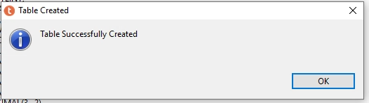
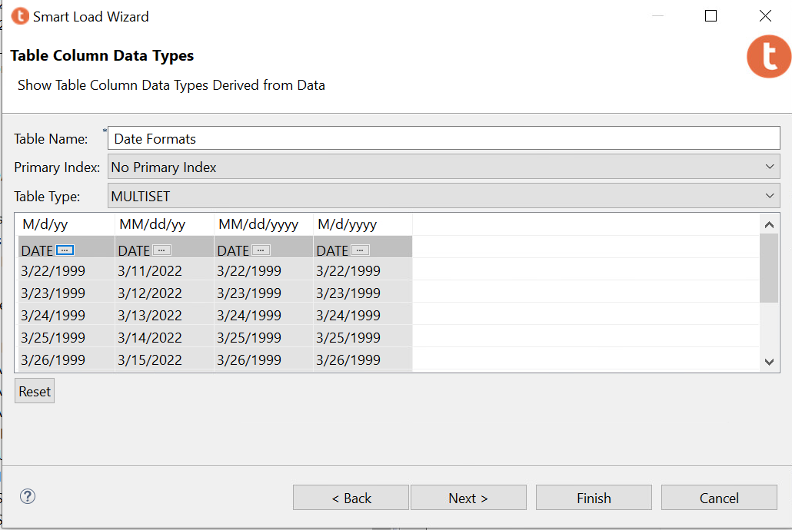
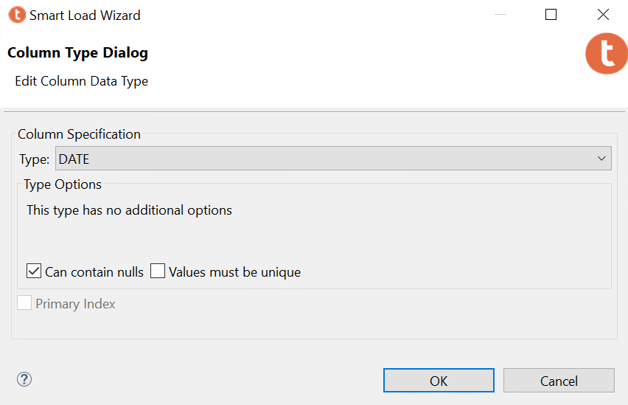
- Select Finish once each of your varaiables have been validated.
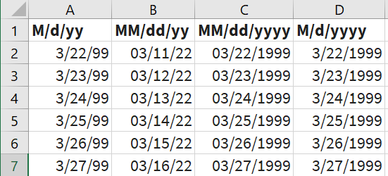
- You should receive a pop-up indicating that your Table was successfully created.
This process was duplicated for the indicated TimeStamp and Date Time Format files. The CSV formatting representations in Excel are shown below. NOTE: the formatting in the CSV file is critical for Teradata to correctly identify the variable data type for both dates and times.
TimeStamp Formats
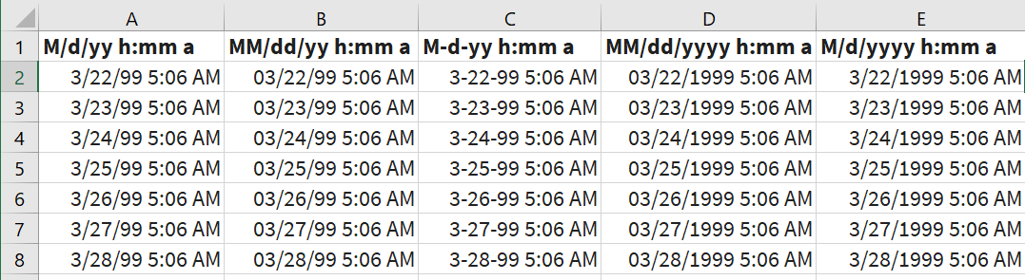

Date Time Formats
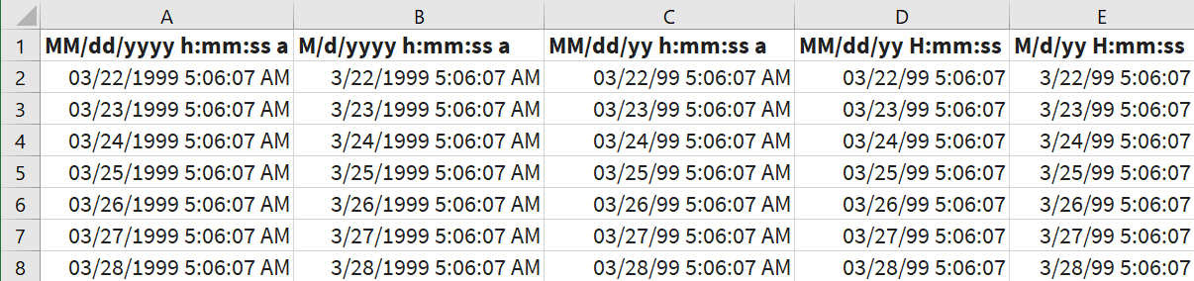

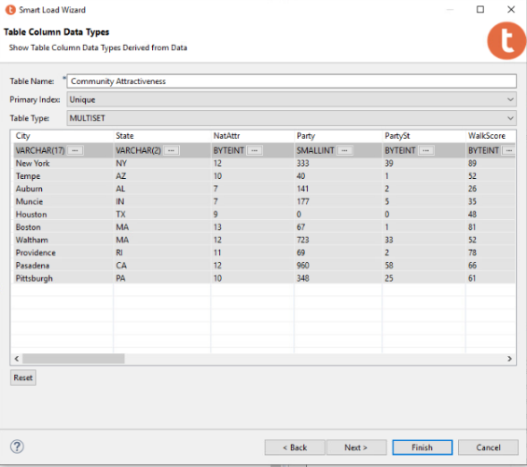
Setting Primary and Composite Keys
The second aspect is to ensure that your tables have been correctly identified with the appropriate keys and match the ERD that has been provided with your data set. For this example, the table “Community Attractiveness” from I1A3 article is used. The table “Community Attractiveness” has a composite key consisting of the two variables: “City” and “State”. When the table is loaded, there are two places to indicate the Primary Key (Composite Key) for the database. The first place to indicate that there is a Primary Index is in the second pop-up when you are using the Teradata Smart Load Wizard. At the top in the Primary Index: box, change the selection to “Unique”. This indicates that this table has a Unique primary key.
The second place is within the named variables (City and State) for that table. Select the three horizontal dots that are next to each variable in order to make appropriate selections. You will need to go to each of the variables to make these selections. Screen shots of these points have been provided.
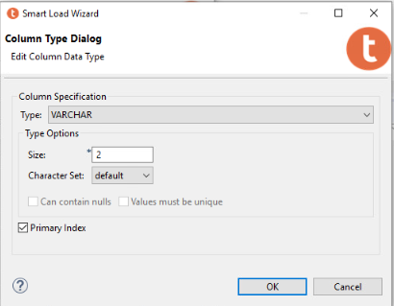
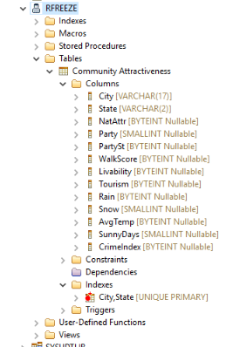
Once all of your keys have been designated, you will need to hit NEXT to get a preview of the Generated SQL. Select the “Show in Editor” and select OK when the pop-up indicates you are switching to editor. NOTE: for this version of Teradata, you must go to the editor and run the SQL code from here in order to continue loading other tables.
Run the SQL that is in the editor. The table (Community Attractiveness) will load and you can see the City,State UNIQUE PRIMARY key when you open the Indexes.

SQL
The authors of the Issue and Article acceptance will be responsible for uploading the data to the appropriate tables. During this process you may need to delete tables that were not properly uploaded so you can reload them correctly. If this is the case, the Teradata SQL statement needed to remove your tables are as follows. The first example is an actual statement with the database name and the table name. The second example provides you with the generic form of the SQL statement needed to remove your table. You should replace the “Database Name” with the appropriate Data and Analytics for Good Year-Issue-Article that you were given when the article was accepted. Only the authors are allowed to create and remove tables from their assigned database.
Drop Table “DAG_2021_I1A2”.”2018-2019 RFR Data2”;
Drop Table “Database Name”.”Table Name”;

Uploading Your Data
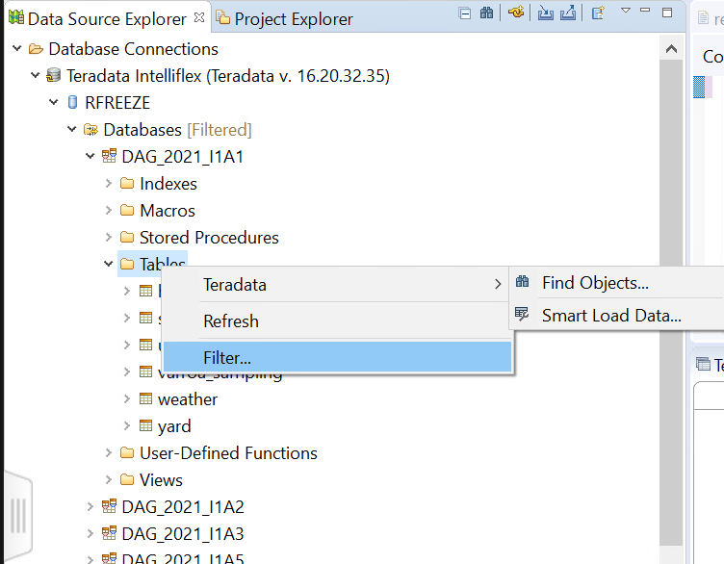
Each author requesting access has been provided a private database area for testing the upload of the data associated with your article. This testing allows you to Read, Write and Create tables in your database. NOTE: you must have already been given the issue number and article number in which your article will appear prior to uploading your data. You can request access to Teradata to view datasets. You can practice in your private database area prior to article acceptance. The following steps are for uploading your article’s data.
- Expand the appropriate location for your accepted article – DAG_YYYY_InAn
  - YYYY – the year of your articles publication
  - InAn – Issue number Article number
- Right click the Tables folder
- Navigate to the Smart Load Data wizard.
The Smart Load Wizard pop-up will appear.
- In the Smart Load Wizard, click on the “Browse” button to locate the file you would like to import.
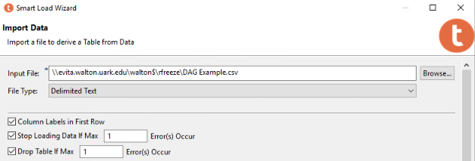
- The File Type should be Delimited Text (a .csv file). All Data & Analytics for Good data sets should be imported from a .csv file. This is especially true if one of your tables will be exceeding the approximately 1 million records that excel files are limited to. The example uses either a file named “DAG Example.csv or the Date Time Formats.csv”. NOTE: Excel files may be needed for more appropriate data type specification.
- Make sure your file has column labels in the first row and Check the box for “Column Labels in First Row”.
- Click Next
The next pop-up allows you to check the variable types along with your labels. This procedure was covered in the Checking Date/Time formats and Setting Primary Keys sections above.
- Click NEXT to get a preview of the Generated SQL.
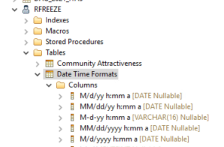
- Select “Show in Editor” and select OK when the pop-up indicates you are switching to editor. NOTE: for this version of Teradata, you must go to the editor and run the SQL code from there in order to continue loading other tables. The script created will only create the data structure.
- Run the SQL that is in the editor. This will create the data structure to receive your data

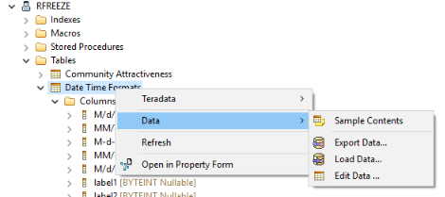
If you successfully created the data structure, you should “Refresh” your database and open the Tables folder. To verify that the table was created, expand the “Tables” option inside of the database. In this case, we created the Table inside of the “rfreeze” user, so we expand the “Tables” folder and see that the Date Time Formats table was created. Expanding the “Columns” subfolder also indicates which columns were successfully imported from the file and whether all the columns were imported as the correct data type.

The next steps will be to load the contents of the file into the data structure created.
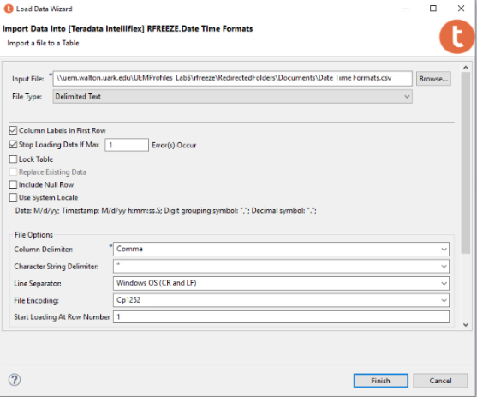
- Right click on the table you just created and navigate to the Load Data selection

- The Load Data Wizard pop-up will appear and you should reselect the file you used to create the data structure
- Select Finish
If you successfully imported the data, you should “Refresh” your database and open the Tables folder.
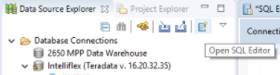
Verify that the contents of the file were loaded.
- Click the “Open SQL Editor” button at the top of the Data Source Explorer
- When the editor opens on the right, type the query “select * from rfreeze.<table name>;”.
- Click the “Execute button to run the query
You may have to select “No” when asked whether you wish to stop at the default 2000 records for viewing. The Teradata Result Set Viewer should show the result of the query at the bottom of the page, which should be the full contents of the table selected.

Part 3: Loading Data into SAS Viya

Accessing
SAS Viya can be used to upload the data set and access existing data sets on Teradata through a live connection.
- Go to https://viya.walton.uark.edu
- Enter your User ID and Password

Loading Your Dataset
- Click on the Menu icon in the top left corner.
This will show you a list of menu items to choose from. Select the Manage Data option to navigate to the Data Explorer.

- Click on Import to upload the file to SAS Viya. Navigate to the Local files drop down and select Local file to upload the text file stored on your device.
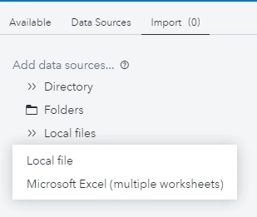
- Enter the name and target location of the table. To set the target location, click on the “Find” button and set the location of your choice. In this example, the file will be saved in the CASUSER(omelie) directory.
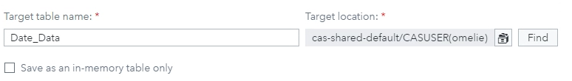
- In the File Specifications section, change the input file delimiter to Tab.
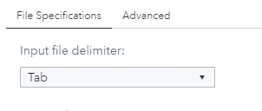
- Click the “Import Item” button in the top right of the page. If the data was successfully loaded, you should see the following message.
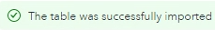
- Navigate to the Data Sources tab and search for the file in the directory.
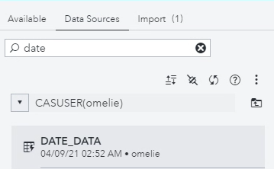
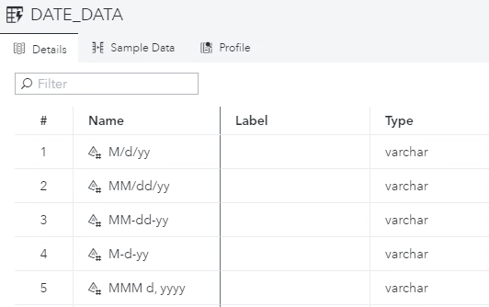
- Verify that the columns are of the correct data type by clicking on the table.

Although all the fields are dates or timestamps, SAS Viya imports all the fields as type VARCHAR.

- Verify that the contents of the file were loaded.
To do this, click on the “Sample Data” tab on the right.
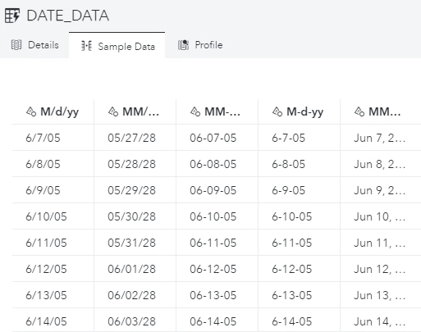
This process was duplicated for the indicated Date and Date Time Format files. The CSV formatting representations in Excel are shown below. NOTE: the formatting in the CSV file is critical for Teradata to correctly identify the variable data type for both dates and times.
Date Formats

Date Time Formats
These date formats do not work.
These date time formats do not work.

Part 3: Script for Loading Large CSV Files
For data sets with more than 1 million records, manipulating the data types would not be feasible. In order to load these larger data sets into the platform with the correct date and datetime formats, run the following script in Teradata.

CREATE MULTISET TABLE DAG_2021_I1A1.weather ,FALLBACK ,
NO BEFORE JOURNAL,
NO AFTER JOURNAL,
CHECKSUM = DEFAULT,
DEFAULT MERGEBLOCKRATIO,
MAP = TD_MAP1
(
station_id INTEGER,
"date" DATE FORMAT 'YY/MM/DD',
"hour" TIME(0) WITH TIME ZONE,
air_temp DECIMAL(21,16),
dew_point DECIMAL(21,16),
pressure DECIMAL(18,13),
wind_dir SMALLINT,
wind_spd DECIMAL(21,16),
sky_cond SMALLINT,
precip_1hr DECIMAL(21,16),
precip_6hr DECIMAL(21,16))
NO PRIMARY INDEX ;

Conclusion
In order to upload your dataset, you will need to use Teradata Studio or SAS Viya. Teradata Studio is accessible from the Walton Enterprise System virtual desktop – VMware. You can install VMware on your local desktop or use the browser version to access your virtual desktop. Either the downloaded VMware or browser version are acceptable and provide you with the same access. SAS Viya is accessible from the web browser on your personal device or on VMware.
- Refer to the document “VMware Guide via Windows Client” to view the tutorial on how to download, install, and use VMware on your computer.

- Refer to the document “VMware Guide via Browser” to view the tutorial on how to access VMware through your browser.

