Teradata Connection

This tutorial assumes you have access to the University of Arkansas VMWare client. To request access, go to the following web page: https://request.information-systems.uark.edu/login. The intent of this exercise is to extract KPI data from the WCOB_SAMS_SALES dataset to an Excel file in order to load the information into an application of your choice.

NOTE: the data used during this workshop should not be downloaded to your personal drives and should remain on the Remote Desktop S: drive provided by the University of Arkansas. This is due to our agreement with the data providers.

- From the Desktop or Start Menu, search for and open the software Teradata SQL Assistant. You will see a Windows similar to the below screenshot.
- Copy and paste the query below onto the Query window to access the WCOB SAMS SALES and click on the “footsteps” execute button

DATABASE WCOB_sams_sales;

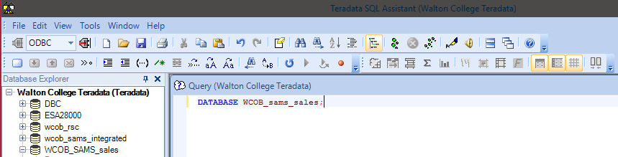

- A Select Data Source window will pop up to ask you the credentials to access the RSC database. Navigate to the Machine Data Source tab on top. Then double-click on Walton College Teradata (as shown to the right).

- Click OK

- Here you will see another pop-up window called Teradata Database Connect…

- Enter the Username: and Password: provided by your instructor. Click OK

- Congratulations! Now you are connected to the

WCOB_SAMS_SALES database and ready to extract the data needed for your assignment.

SQL Query to extract data

The WCOB_SAMS_SALES dataset has three tables with over a millions records for the ITEM_DESC table and over 6 billion records in the ITEM_SCAN table. We need to narrow the data extraction down to only the items we are interested in viewing. To do this, we will run a query to extract item description data from the ITEM_DESC table.

- Running the Query
  - Navigate to the query window and delete any current code
  - Copy and paste the SQL query below into the query window

select * from item_desc sample 3000;

9. Click the “footsteps” execute button on the menu bar.

- The final query should take approximately 2 seconds to run depending on the connection from your computer. Your result table should look like the picture below and the records can be verified on this screen.
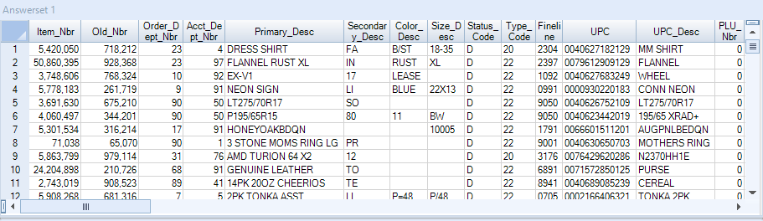

Export result table in a text file

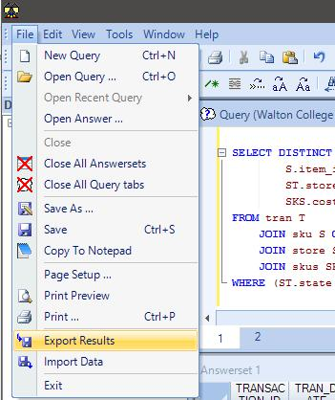
Now we will export to a file in order to provide access to the application of our choice

- Navigate to File on the top bar, and select Export Results…

12. Now click the “footsteps” execute button again
to have Teradata run the query again and export the result directly.

- You will now see a pop up window, prompting you for the location you want to save

- Select your desired location, the File name: and make sure you Save as type: Delimited Text [ANSI] (*.txt).

- IMPORTANT: after you click Save, Teradata will take a while to export everything. It will take about 3 minute or less depending on your computer, since there 3000 rows of data to be exported.

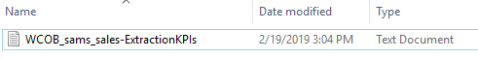
- After Teradata finishes saving the result table as txt file in your folder, go to the location that you saved it to make sure it exports successfully. In this example, the file has been named DillardsTUN-Export-KPIs.txt

Import Text file into Excel
- Open MS Excel.
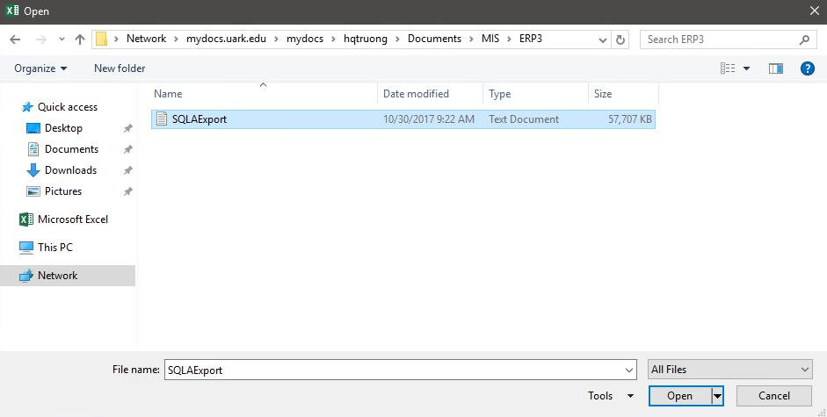
- Select File -> Open and Navigate to your.txt file folder

- Choose the file format as All Files (as shown below)

- Select your file

- Click Open.

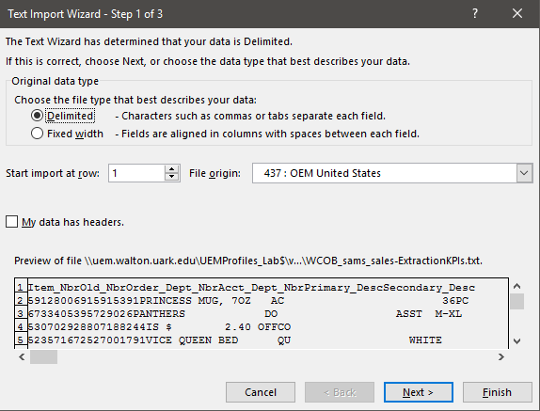
You will now see a window called Text Import Wizard, with different options of how you want to format your Excel file from a text file.

- Accept the default settings and click Finish to import the file.

- After couple seconds, you will now see the result is successfully imported into Excel. See next page for a screen shot.

- Save the Excel file after you are done reviewing the data as a .csv comma delimited excel file

