## **SASEG 0 Exercise – Accessing UA Resources**

## **SAS** **Enterprise Guide and Enterprise Miner Fundamentals - Getting Started**

Paul Cronan, Michael Gibbs, and Ron Freeze

(Fall 2017)

**Sources** (adapted with permission) **-**

T. P. Cronan, Michael Gibbs, Jeff Mullins, and David E. Douglas Course and Classroom Notes

Enterprise Systems, Sam M. Walton College of Business, University of Arkansas, Fayetteville

Microsoft Enterprise Consortium

IBM Academic Initiative

SAS® Multivariate Statistics Course Notes & Workshop, 2010

SAS® Advanced Business Analytics Course Notes & Workshop, 2010

Microsoft® Notes

Teradata® University Network

*For educational uses only - adapted from sources with permission. No part of this publication may be reproduced, stored in a retrieval system, or transmitted, in any form or by any means, electronic, mechanical, photocopying, or otherwise, without the prior written permission from the author/presenter.*

# VMWare – Accessing UA Resources

## **Instructions to access virtual desktop infrastructure:**

* **Open a browser and go to:** [**https://waltonlab.uark.edu**](https://waltonlab.uark.edu) (Firefox: Click “I understand the risks”, “Add Exception”, and “Confirm Security Exception”. For IE, simply “Continue”)

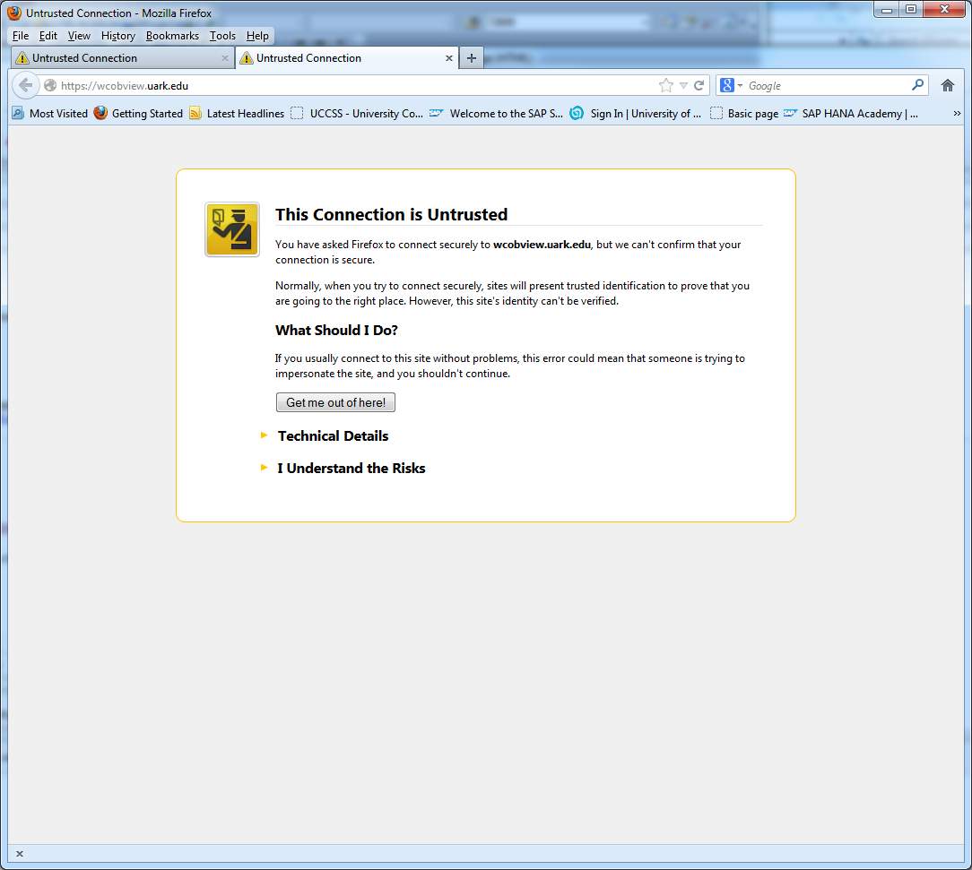

* Click **“Install VMWare Horizon Client for Windows”**

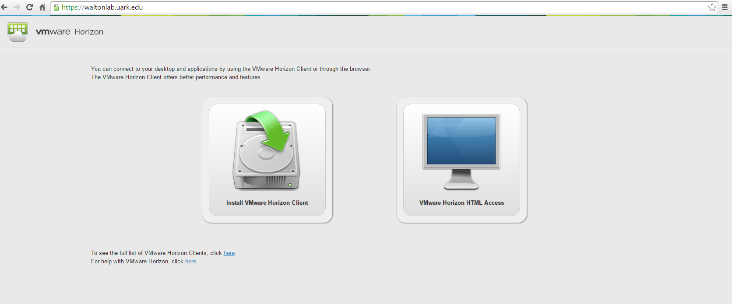

* Select the VM Client that corresponds to the machine you are using (Mac, Windows, IPad, etc.) by clicking on the **Product Downloads** tab (Note: For iPad users, it might be better to use the App Store, Search for VMWare)
* Click **“Go to Downloads”**

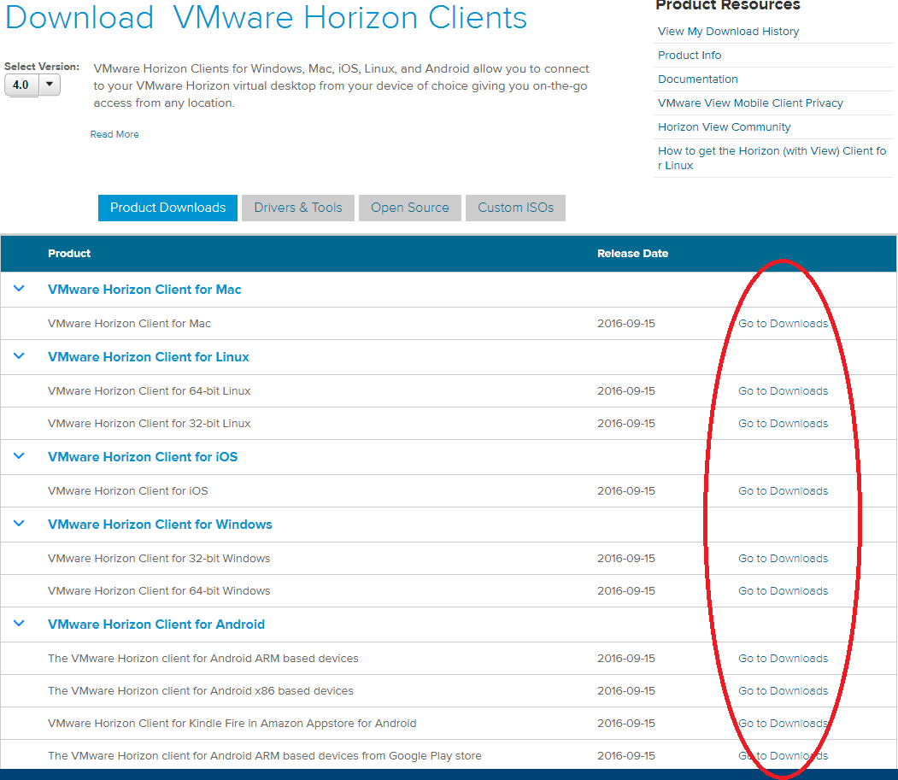

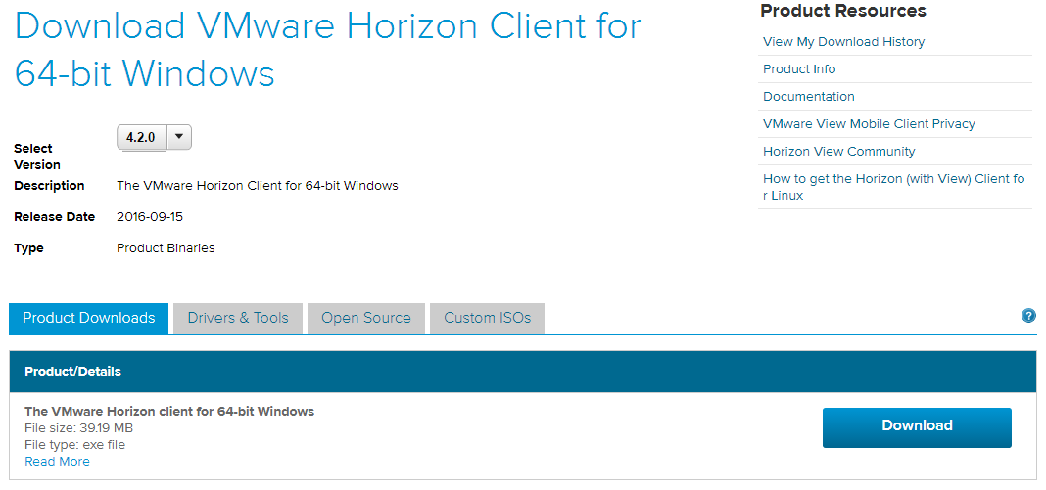

* Click **download**, and run the executable that is downloaded (In the case of Firefox, Save File, and then run)
* leave the **“Typical”** option checked and click on **“I Agree & Install”**

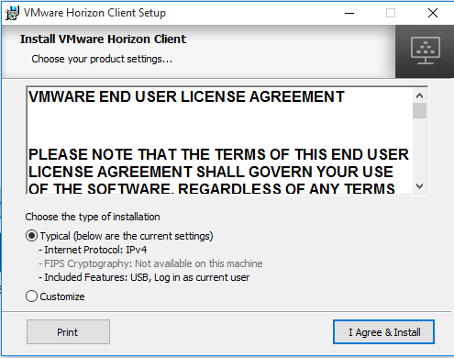

* Click **Finish**

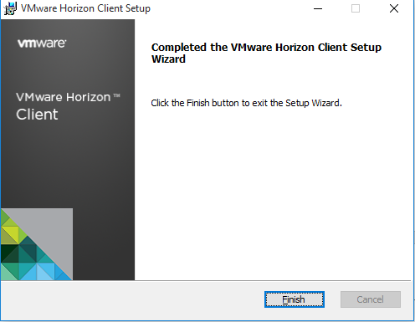

* Click **Yes** to restart the computer

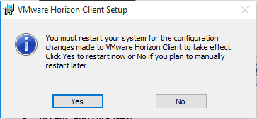

## **1.2 Run the VMWare Horizon Client**

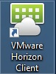

* Double-Click on Add Server

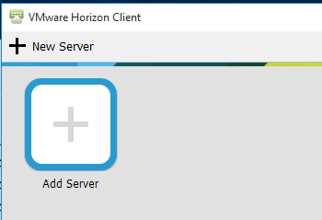

* Enter the name of the connection server as **“waltonlab.uark.edu”**

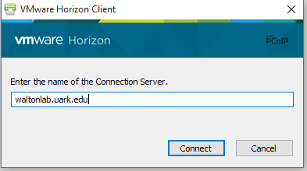

* Type in your user UARK name, password, and select Domain: GACL

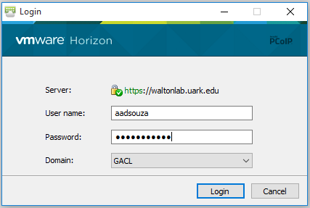

* **(OPTIONAL) Select the system you wish to connect to, and click Connect. NOTE: For most students, you will bypass this step and will automatically be connected to the desktop image for which you have been assigned.)**

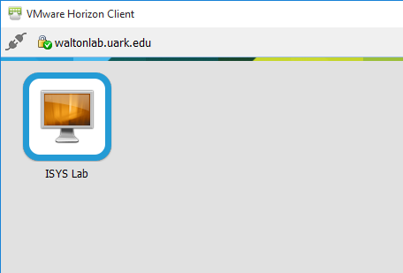

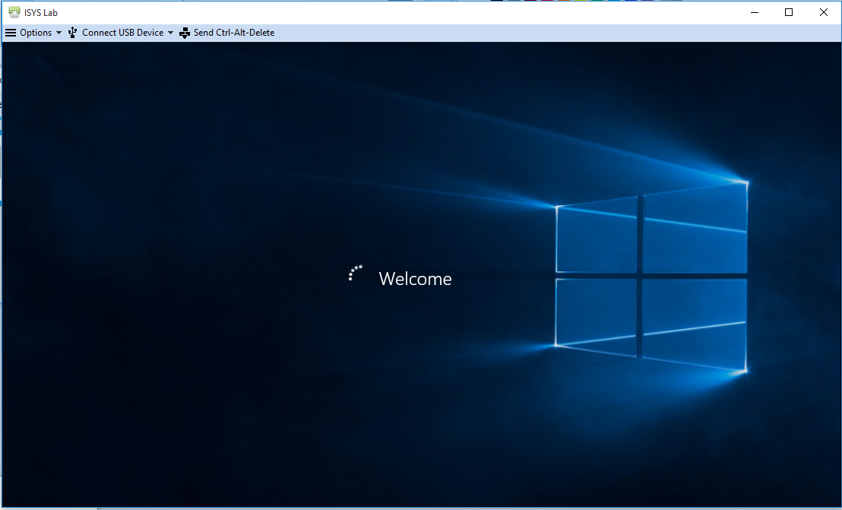

# SAS Enterprise Guide 7.1 Basics

## **Logging onto the SAS platform via SAS Enterprise Guide 7.1**

* Double-Click SAS Enterprise Guide 7.1

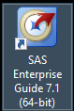

* If the icon does not exist on the desktop
* Go to Windows 🡪All Apps 🡪 Scroll down to the **SAS** Drop down 🡪 Scroll down to **SAS Enterprise Guide 7.1 (64-bit)**
* The Application will normally pass through your credentials for authentication.
* the screen below is the standard splash screen that can be used to select a task. If closed, a New Project will be created by default. For this example, **select New Project**

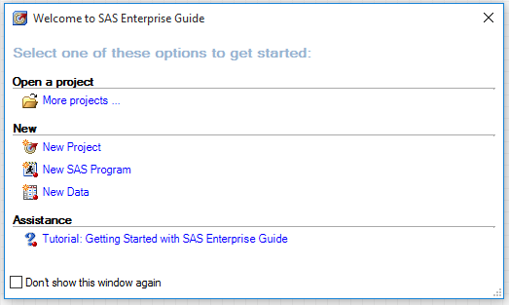

* 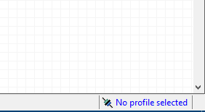you will need to Set Default Profile at the first login:
* Click on the profile link (“No profile selected”) on the bottom right corner
* Click on profiles and click on Add
* Enter details as follows
  1. Name: <any name for your profile>
  2. Server: sasms.walton.uark.edu (remote)
  3. Port: 8561
  4. Username: <your UARK username>
  5. Domain: GACL
* Select newly created profile and set as active.
* Once your profile loads, browse to **Servers > SASApp**

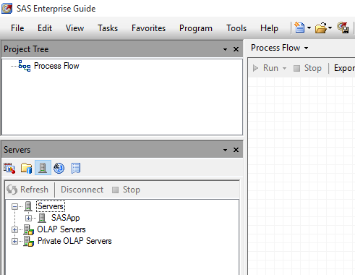

* Provide credentials when prompted for, as seen below

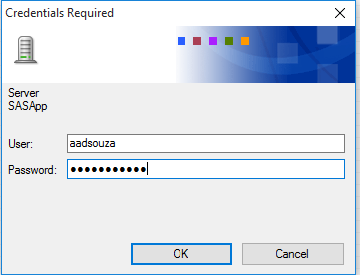

* In the Server List pane, Expand Servers🡪SASApp🡪Libraries.
* Ensure that you can expand libraries and see data as below:

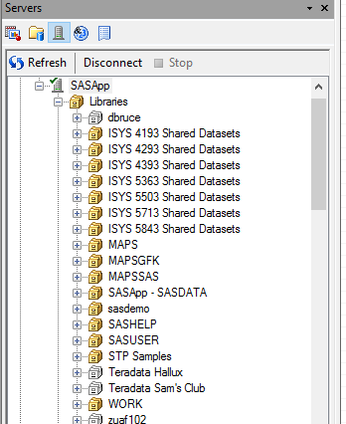

Libraries are simply “pointers” in the metadata that point to a physical location on the server or another system where data can be read or written to. In the case of your library (i.e. mtg002), data can both be read from and written to this location. However, other libraries, such as TeradataHallux, point to the UA_HALLUX database on the Teradata platform, and are explicitly read only.

## Creating and saving a project SAS Enterprise Guide 7.1

* Expand the **TeradataHallux** Library

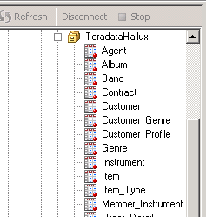

* Double click on the **“Customer_Profile”** dataset

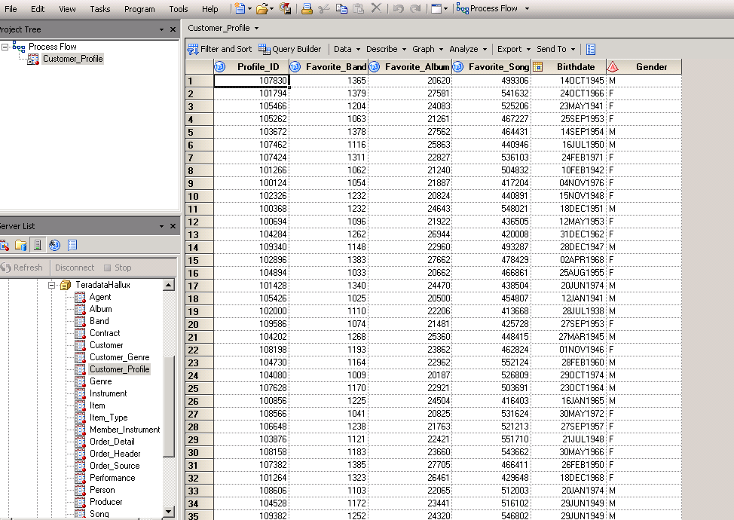

* This dataset is now part of your SAS project. Now, let’s create a few graphs to show favorite bands, sorted my gender. **Select Graph🡪Bar Chart**

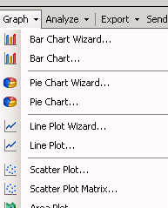

* Double-Click **“Vertical Color Bar”**

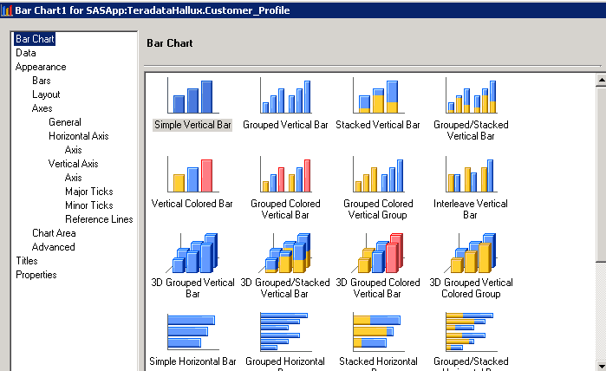

* Drag **“Favorite_Band”** to the empty **“Column to Chart”** box, and drag **“Gender”** ontothe **“Group charts by”** box

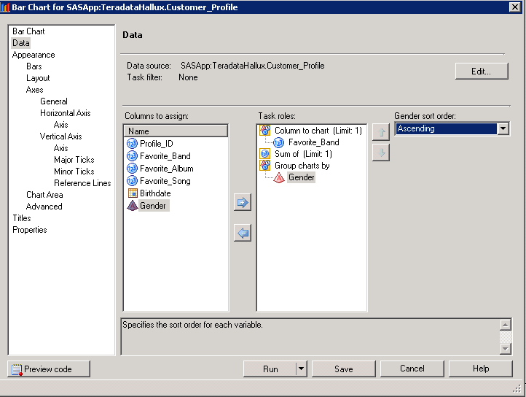

* Click **Run.** You should now see the graphs you requested (Scroll down to see the band code distribution for males)

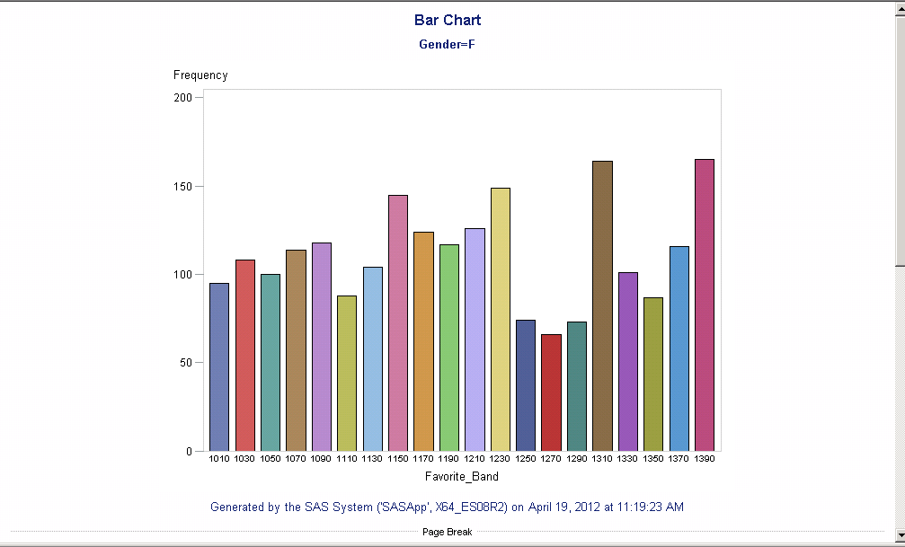

* Return to the Process Flow view

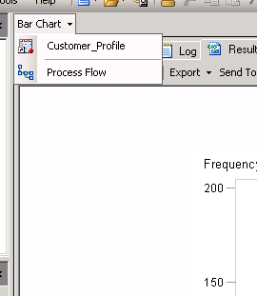

* Click on **File**🡪 **Save Project**

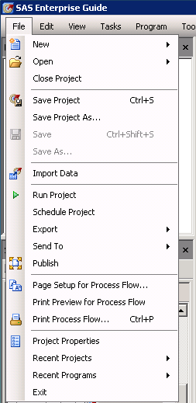

* Click on **SAS Folders**

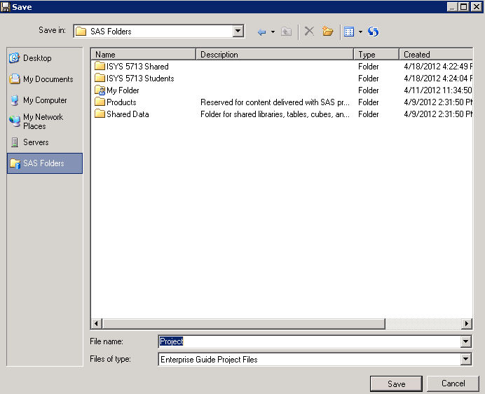

* Double Click **“My Folder”**🡪Give your project a name and click **Save.** Your project is now saved on the SAS platform, and can be retrieved at any time in any location where the SAS platform (SAS EG) is accessible. You can also save your project to a network share drive (i.e. S: drive) as a backup.

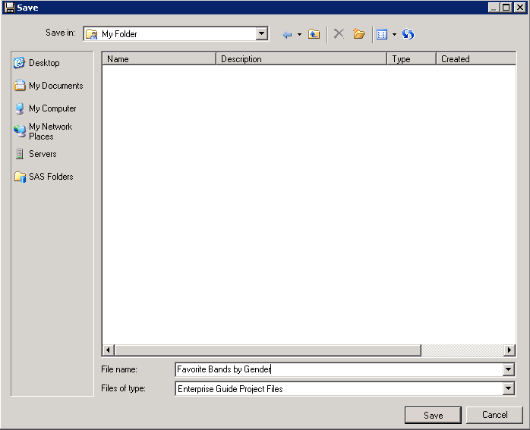

* To see your work, simply close out SAS Enterprise Guide, re-launch SAS EG (notice that you were not prompted for a login/password), and select **Open🡪Project**

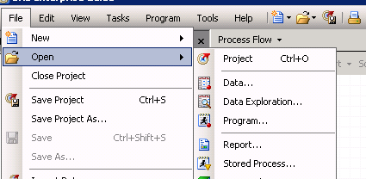

* Select **SAS Folders**, Double-Click My Folder, and select your project

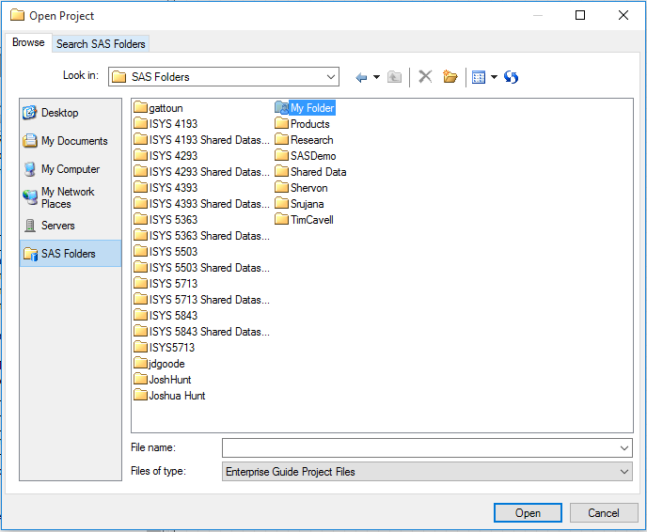

* You can now see the Process Flow view of your project, and make changes/modifications as needed

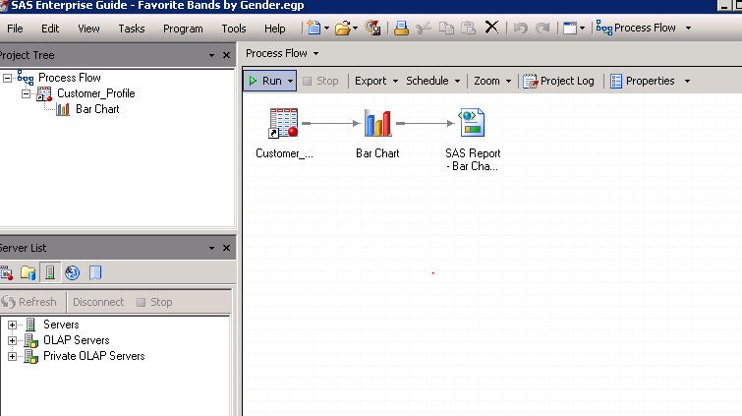

* **File > Exit** then **Start > Logoff**

# SAS Enterprise Miner – Getting Started

## Connecting to a Data Source

1. 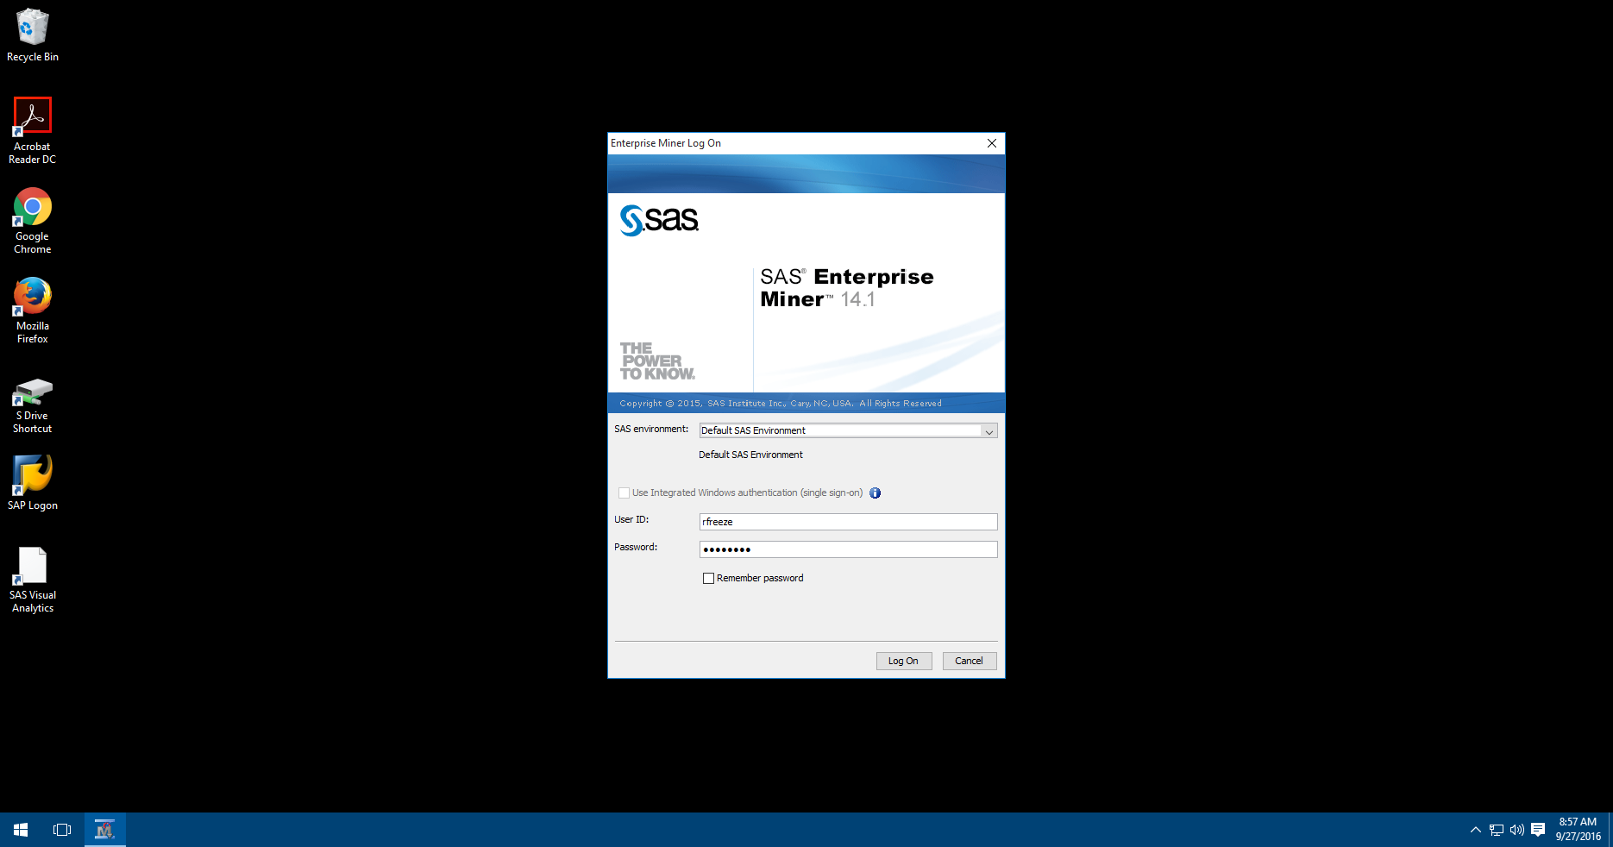Using SAS Enterprise Miner Client 14.1 from the Start Menu in VMware
2. Log in with your **UARK username** and **Password**
3. Select **New Project**
4. Select **Next**
5. Name your Project:
   1. **<Last Name>_Table_Example**
   2. **Freeze_Table_Example**
6. Select **Next**
7. Accept the default SAS Folder Location by selecting **Next**
8. Select **Finish**

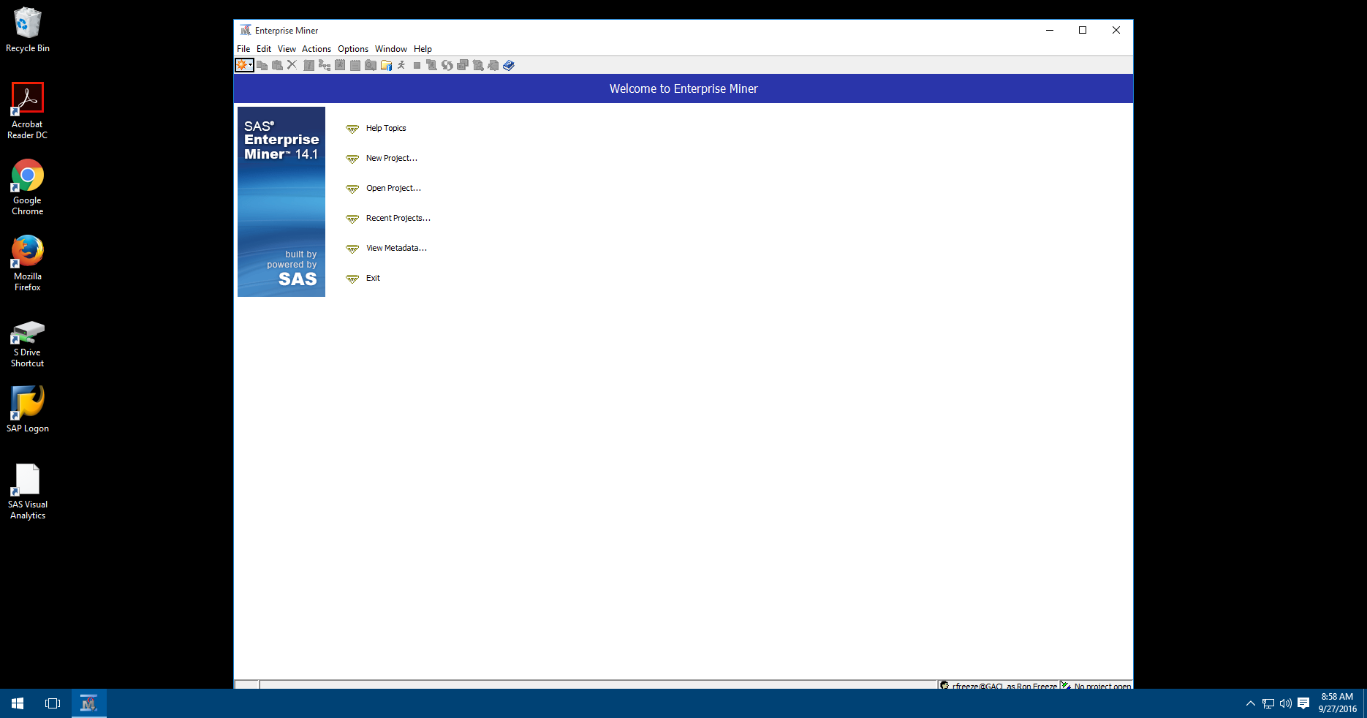

**Note the different sections of the Enterprise Miner Work area.**

* Main Menu
* Toolbar – commonly used tasks (modifiable
* Tasks Tree
* Context Sensitive Toolbar
* SEMMA tabs – (Sample, Explore, Modify, Model and Assess)
* Properties List
* Context Sensitive Toolbar
* Project Start Code
* Modeling Diagram Workspace – Greyed out until a new diagram is created

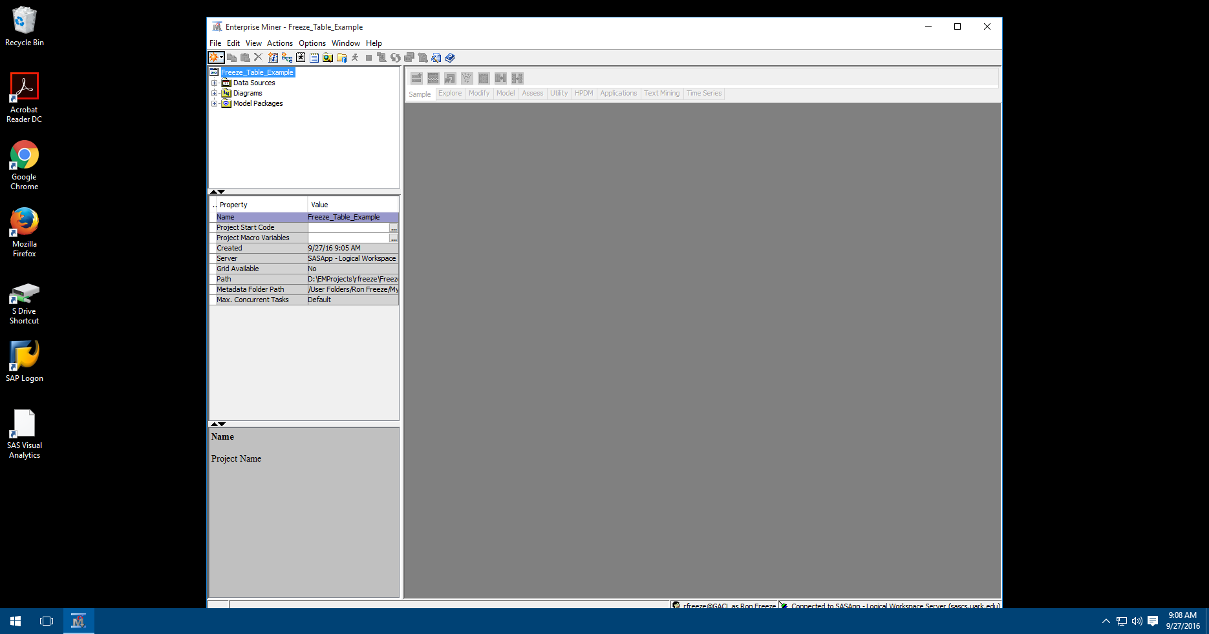

**Main Menu**

**Toolbar – commonly used tasks (modifiable)**

**Context sensitive Toolbar**

**Tasks Tree**

**Properties List**

**SEMMA tabs**

**Project Start Code**

**Model Diagramming Workspace – Grayed out until a new diagram is created**

## Linking a SAS Data Source to our project

**We now need to link a data source to our project**.

1. 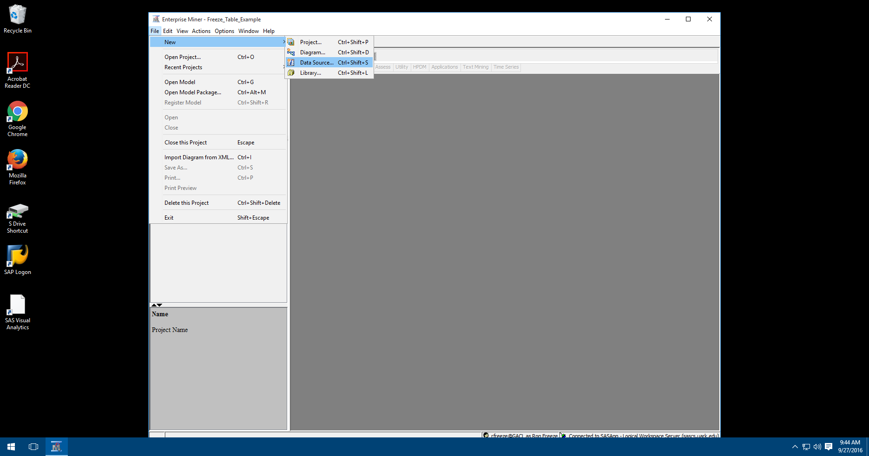Select File->New->Data Source
2. Select Next (Step 1 of 8)
3. Select Browse (Step 2 of 8)
   1. Navigate to your course number (SAS Libraries->ISYS xxxx)
   2. Select Pva97nk
   3. Select OK
4. Select Next (Step 2 of 8)
5. (Step 3 of 8) shows the Table Properties – Select Next
6. (Step 4 of 8) shows the Metadata Advisor Options – we will use the Basic options – Select Next
7. (Step 5 of 8) shows the Column Metadata – Select Next
8. (Step 6 of 8) allows you to create a Sample data set – This is useful for very large datasets – Do not create a sample data set – Make sure No is selected – Select Next
9. (Step 7 of 8) accept the defaults for the Data Source Attributes – Select Next
10. (Step 8 of 8) Review the Summary – Select Finish

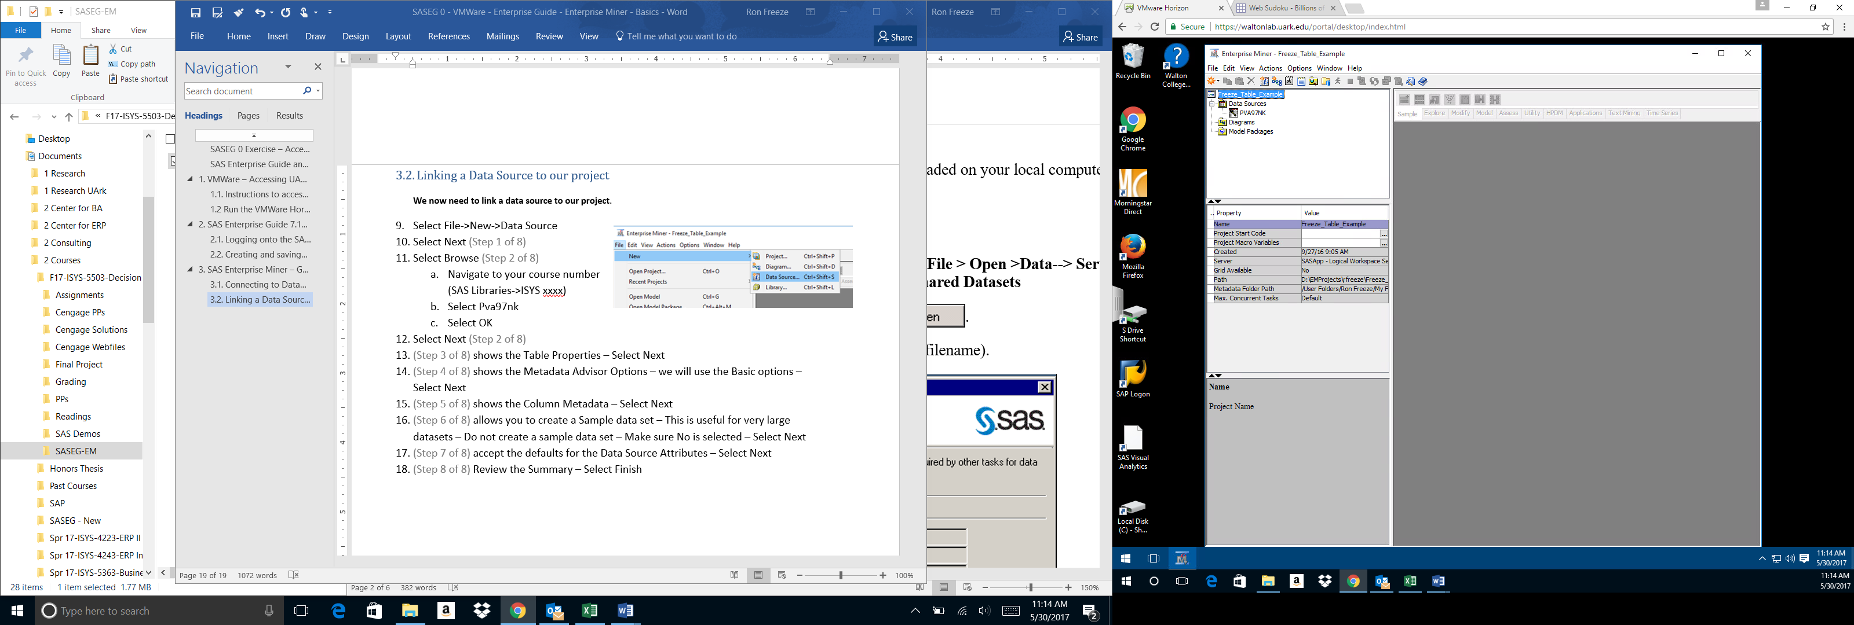You now have connected a SAS Data Source to your project. Select the plus (+) signs in the Task Tree. You will currently only show the Data Source(s) to which you are currently connected.