## SASEG 1A – Output Formats

(Spring 2016)

**Sources** (adapted with permission) **-**

Ron Freeze Course and Classroom Notes

Enterprise Systems, Sam M. Walton College of Business, University of Arkansas, Fayetteville

Microsoft Enterprise Consortium

IBM Academic Initiative

SAS® Multivariate Statistics Course Notes & Workshop, 2010

SAS® Advanced Business Analytics Course Notes & Workshop, 2010

Microsoft® Notes

Teradata® University Network

*For educational uses only - adapted from sources with permission. No part of this publication may be reproduced, stored in a retrieval system, or transmitted, in any form or by any means, electronic, mechanical, photocopying, or otherwise, without the prior written permission from the author/presenter.*

The purpose of this tutorial is to explore different formats of output provided by SASEG. Currently, the tool provides results in following formats:

* SAS Report
* HTML
* RTF
* PDF
* PowerPoint
* Excel
* Text Output

We can also set a default output format in which the results will be displayed every time we execute a query.

To explore the various output types, we will change the **Results** setting and run a query using a random SAS dataset.

Exploring Output Formats and Setting Default

1. Obtain and open **TESTSCORES** SAS Dataset.

**File > Open >Data--> Servers > SASApp-->Files > D:  > ISYS 5503--> ISYS 5503 Shared Datasets**

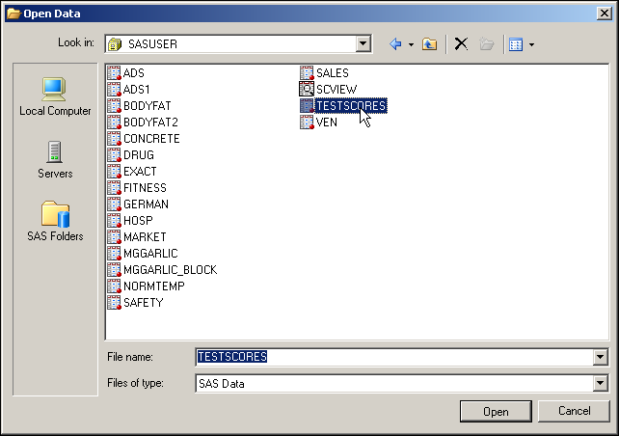

1. In the Toolbar Menu at the top, select **Tools** ⇨ **Options**

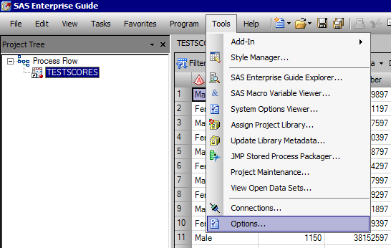

1. With **Results** ⇨ **Results General** selected on the left, check the boxes against the format you want to view the results in. In this tutorial, we have selected all the boxes.

In the same section, we can also set the Default output format in which the result will be displayed every time we execute a query. Choose SAS Report from the drop-down list.

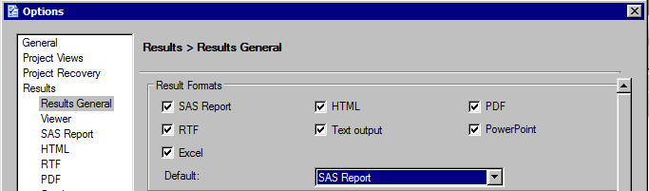

1. Click 

Now we will run a query in order to view various output formats generated by SASEG.

1. Above the data table, select **Describe** ⇨ **Summary Statistics**… from the drop-down menus.

**🖉** If you close the data table first, then you will have to click **Tasks** ⇨ **Describe** ⇨ **Summary Statistics…** from the top menu bar.

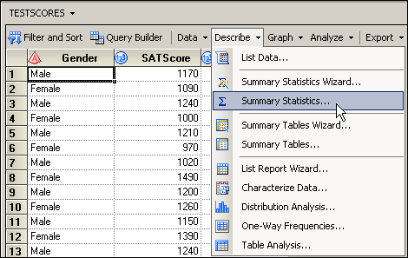

1. With **Data** selected on the left, drag the variable **SATScore** from the Variables to assign pane to the analysis variables role in the Task roles pane, as shown below:

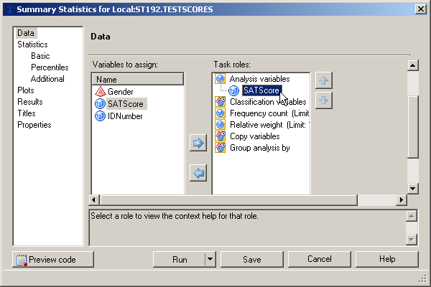

1. Click  to run the analysis.

We can see that SASEG displays the output in SAS Report format as we chose it to be the Default format.

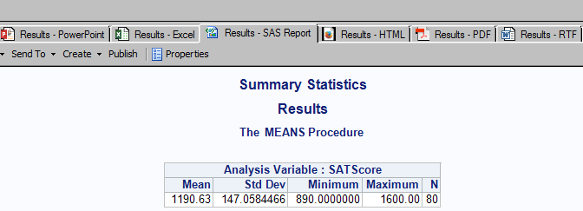

The other formats that we selected are:

1. **HTML:** Select 

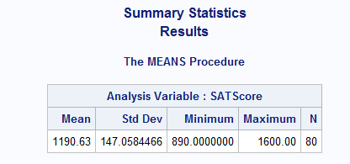

1. **RTF:** Select  and click 

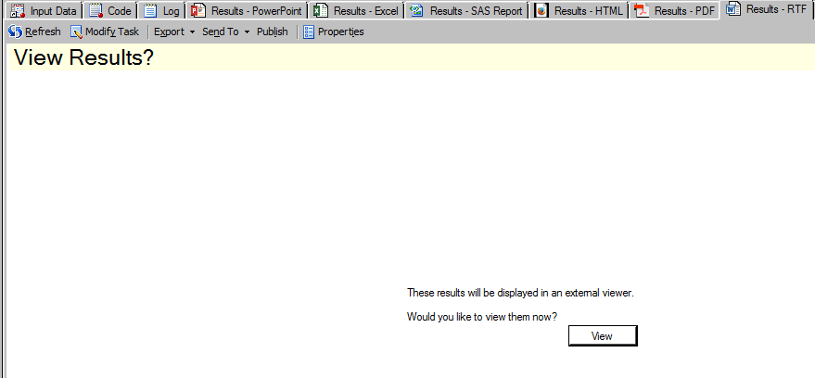

After clicking View, the results will be displayed in a Word Document. This format is useful if you want to copy and paste the tables, which is not possible in SAS Report and HTML format.

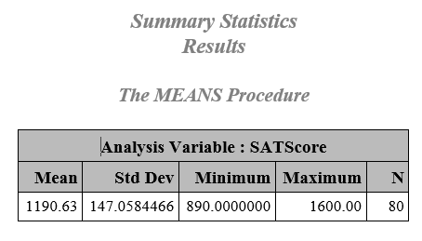

1. **PowerPoint:** Select  and click

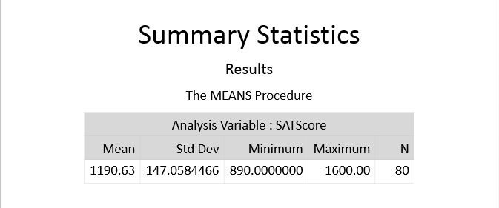

1. **PDF:** Select  and click

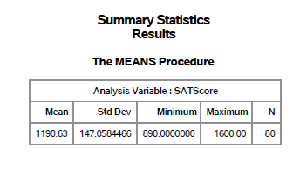

1. **Excel:** Select  and click

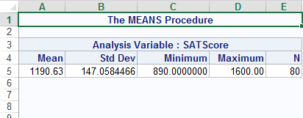

1. **Text:** Select 

