# SASEG – Sort and Filter

(Spring 2017)

**Sources** (adapted with permission) **-**

Ron Freeze Course and Classroom Notes

Enterprise Systems, Sam M. Walton College of Business, University of Arkansas, Fayetteville

Microsoft Enterprise Consortium

IBM Academic Initiative

SAS® Multivariate Statistics Course Notes & Workshop, 2010

SAS® Advanced Business Analytics Course Notes & Workshop, 2010

Microsoft® Notes

Teradata® University Network

*For educational uses only - adapted from sources with permission. No part of this publication may be reproduced, stored in a retrieval system, or transmitted, in any form or by any means, electronic, mechanical, photocopying, or otherwise, without the prior written permission from the author/presenter.*

Example:*Pelican Stores, a division of National Clothing, is a chain of women’s apparel stores operating throughout the country. The chain recently ran a promotion in which discount coupons were sent to customers of other National Clothing stores. Data collected for a sample of 100 in-store credit card transactions at Pelican Stores during one day while the promotion was running are contained in the file named Pelican Stores. The Proprietary Card method of payment refers to charges made using a National Clothing charge card. Customers who made a purchase using a discount coupon are referred to as promotional customers and customers who made a purchase but did not use a discount coupon are referred to as regular customers. Because the promotional coupons were not sent to regular Pelican Stores customers, management considers the sales made to people presenting the promotional coupons as sales it would not otherwise make. Of course, Pelican also hopes that the promotional customers will continue to shop at its stores. Pelican would like to know the significance of the variables on Net Sales.*

SASEG allows you to Filter and Sort data for ease of retrieving data based on certain variables which would allow us to analyze data based on our needs. We will be performing sort and filter operations that will present data that can help us how marital status influence shopping trends.

# C:\Program Files\PowerServ\CourseGraphics\demo_eye.jpgExercise – Sort and Filter

We want to filter the data from the pelican store dataset to find out the number of purchased items of customers based on their **Marital Status** and to understand its affinity to the type of customer and how they influence sales. We will Filter data by **Marital Status** andsort by number of **Items** in descending order to first see how they influence sales.

1. Open the **PelicanStores** SAS Dataset using the following path: **Servers > SASApp-->Files > D: > ISYS 5503--> ISYS 5503 Shared Datasets--> Pelican Stores**

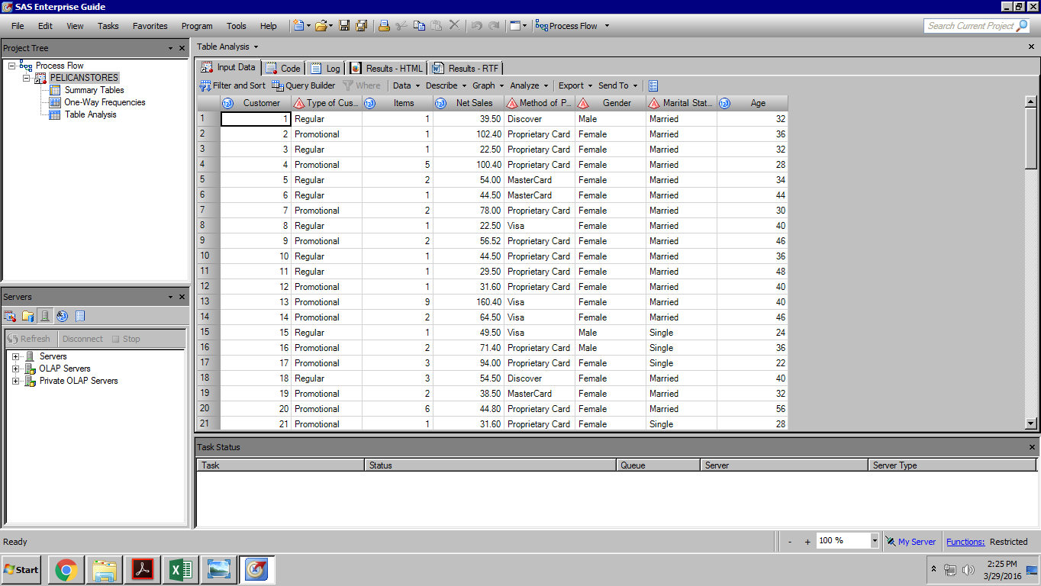

1. 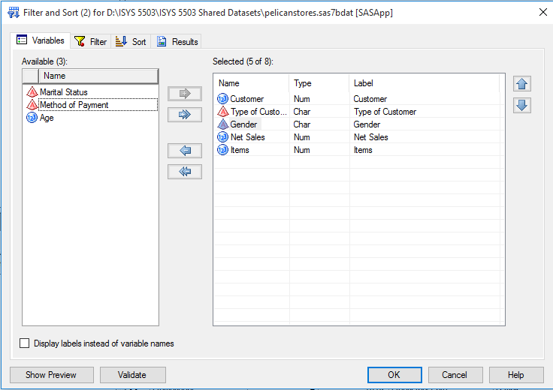Click on the **Filter and Sort** tab.
2. In the **Variables** Tab, drag the variables **Customer, Type of Customer, Gender, Net Sales** and **Items** into the selected fields.
3. In the **Filter** Tab, filter by **Marital Status** Equals to **Married** as shown below

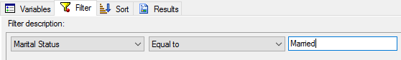

1. 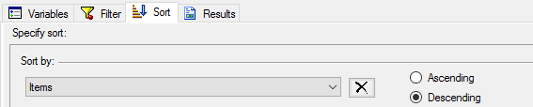Click on Sort Tab and sort by **Items > Descending**
2. Click **OK** and you see the data Filtered by **Marital Status** and sorted by **Items** in descending.

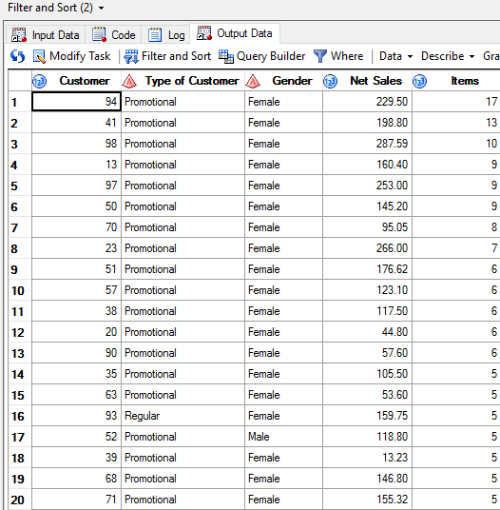

*The output that was retrieved did not clearly show what marital status of the customer the data was filtered on. We will need to modify the variable list to include this.*

1. In the **output data** tab where you see the results. Click on **Modify task**

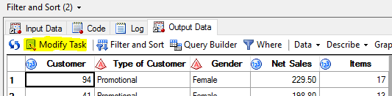

1. In the **Variables**, drag the variable “**Marital Status**” into the **Selected** field and click **ok**.

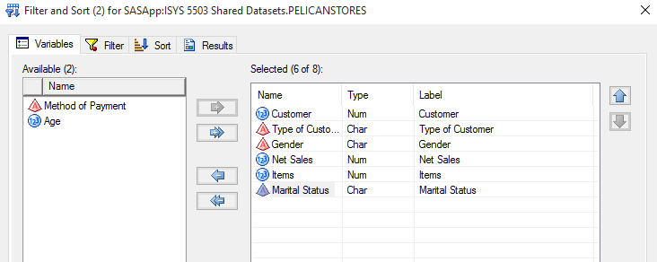

1. Click **Yes** in the pop up that appears where it asks if you want to replace the previous results. This will replace the previous results and output the new results as follows.

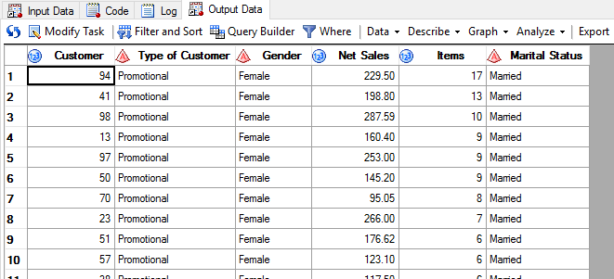

*We now want to further filter this data to see promotional type customers to see if marital status influences how customers shop.*

1. In the **output data** tab where you see the results. Click on **Modify task**



1. In the **Filter tab**, Select the **AND** operator in the drop box at the end of the first filter description and you will see another entry field appear below. Filter by **Type of Customer** equals to **Promotional**

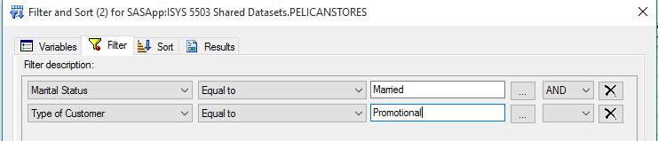

1. Click **Yes** in the pop up that appears where it asks if you want to replace the previous results. This will replace the previous results and output the new results as follows.



*We want to further sort this data by the net sales based on the no of items grouping, we will add another sorting criterion that sorts by Net Sales.*

1. In the **output data** tab where you see the results. Click on **Modify task**



1. In the **sort** tab, you will see an entry field labeled **“Then by”** after where the first sort condition was entered
2. Sort data by **Net Sales, Descending.**

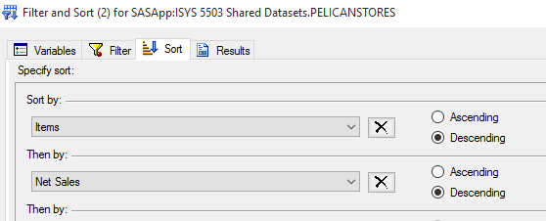

1. Click **Yes** in the pop up that appears where it asks if you want to replace the previous results. This will replace the previous results and output the new results as follows.

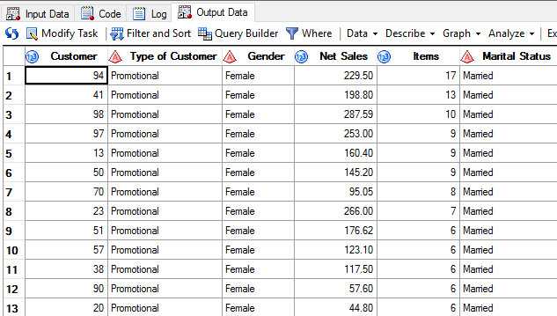

# C:\Program Files\PowerServ\CourseGraphics\demo_eye.jpgPractice exercise – Sort and Filter

*You now want to analyze data specific to the female gender and sort it by number of items (in descending). For now, you just need to see the customer ID, Gender and Items in the table.*

1. Create a filtering criteria on the pelican stores data set to filter by **Gender** and sort the data by the **Items** field.

The data you retrieved seems interesting, you now want to analyze the association of the female gender to type of customer.

1. Fetch output which includes the **Type of customer** field.

You see a trend in the association between data for type of customer and gender. You now want to filter data from the existing data only to the ones with the particular association.

1. Fetch output that further filters by **Type of Customer** equals to **Promotional**