## SASEM 2A Exercise

**Importing an Excel File into SAS Enterprise Miner**

(Fall 2017)

**Sources** (adapted with permission)**-**

Ron Freeze Course and Classroom Notes

Enterprise Systems, Sam M. Walton College of Business, University of Arkansas, Fayetteville

SAS® Text Analytics Using SAS® Text Miner Course Notes & Workshop, 2017

*For educational uses only - adapted from sources with permission. No part of this publication may be reproduced, stored in a retrieval system, or transmitted, in any form or by any means, electronic, mechanical, photocopying, or otherwise, without the prior written permission from the author/presenter.*

# Importing an External File

In SASEG0, you used Enterprise Miner to connect to a SAS Data Source. While this is the preferred method for connected data to Enterprise Miner, there may be times you wish to import data from an Excel file. First, make sure you know where the data file is loaded on your local computer. If you saved your project from SASEG0 section 3, you can open that project and the screen should look like the following.

In order to import a data file, you will first need to create a diagram.

## Creating a diagram

* 1. 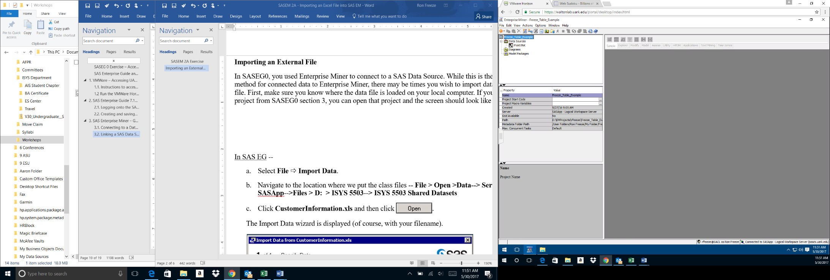Right click on diagram in the Task Tree
  2. Select **Create Diagram**
  3. Name your diagram as **Customer Information**
  4. **OK –** your diagram should be created with the **Customer Information** indicated at the top of the diagram

## Adding the Import Node

* 1. Where the SEMMA tabs are located, select the Sample tab if it is not already selected
  2. 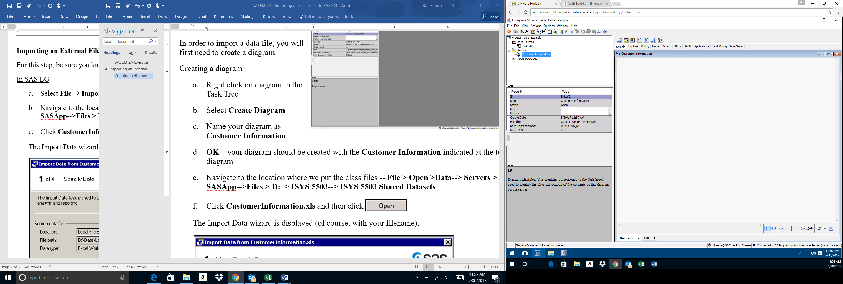Mouse over the icons to find the **File Import** node
  3. Drag and drop the **File Import** node to the diagram
  4. Note that the property panels on the left have five sections: **General**, **Train**, **Score**, **Report** and **Status**

## File Import

* 1. Under **Train**, select the **Import** **File** item and click on the properties indicated by the three dots.
  2. Select the **SAS** **Servers** radial button and **Browse**
  3. Go up one level and select the following path – **D:  > ISYS 5503--> ISYS 5503 Shared Datasets**
  4. Select **CustomerInformation**.**xls**
  5. Click **OK** and **OK**

## Rename your Node

* 1. Right click on the **Import** **File** node
  2. Select **Rename** and enter **Customer Information** as the node name

At this point, you can start your analysis of the data by dragging and dropping additional nodes. However, it is advisable to save your file as a SAS dataset in order to connect using the Data Sources in the Task Tree. This is accomplished with the Export node and has the following steps.

# Exporting to a SAS Dataset

* 1. Select the **Utility** tab immediately following the **SEMMA** tabs
  2. Drag and drop the **Save** **Data** node
  3. 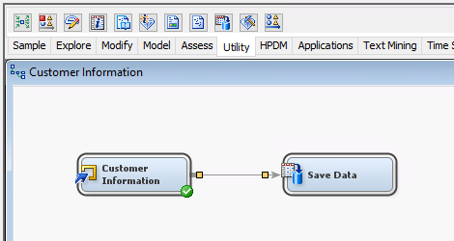Mouse over the front of the **Customer** **Information** node (**Import** **File** node) until a bar appears
  4. Click and hold
  5. Drag the arrow that appears to the **Save** **Data** node and release
  6. Rename the **Save** **Data** node to **Cust Info SAS Dataset**

## Create the SAS Dataset

* 1. In the property panel on the left, enter the following information
  2. **Train** -> **Output** **Options** -> Filename Prefix: CustInfo-<your First Name>
  3. **Train** -> **Output** **Format** -> SAS Library Name: SAS Libraries/ISYS5503/
  4. Right click on the **Cust** **Info** **SAS** **Dataset** and **Run** the path

## Using your SAS Dataset

You have now converted your excel file to a SAS Dataset. Connect to **Cust** **Info** **SAS** **Dataset** using the same method from SASEG0. You can now use the **Explore** feature once you have created your data source connection. Your project should look like the following.

