## SASEG 2 Exercise

**Importing an Excel File into SAS Enterprise Guide**

(Fall 2015)

**Sources** (adapted with permission)**-**

T. P. Cronan, Jeff Mullins, Ron Freeze, and David E. Douglas Course and Classroom Notes

Enterprise Systems, Sam M. Walton College of Business, University of Arkansas, Fayetteville

Microsoft Enterprise Consortium

IBM Academic Initiative

SAS® Multivariate Statistics Course Notes & Workshop, 2010

SAS® Advanced Business Analytics Course Notes & Workshop, 2010

Microsoft® Notes

Teradata® University Network

*For educational uses only - adapted from sources with permission. No part of this publication may be reproduced, stored in a retrieval system, or transmitted, in any form or by any means, electronic, mechanical, photocopying, or otherwise, without the prior written permission from the author/presenter.*

**Importing an External File**

For this step, be sure you know where the class data files are loaded on your local computer.

In SAS EG --

* 1. Select **File** ⇨ **Import Data**.
  2. Navigate to thelocation where we put the class files -- **File > Open >Data--> Servers > SASApp-->Files > D:  > ISYS 5503--> ISYS 5503 Shared Datasets**
  3. Click **CustomerInformation.xls** and then click .

The Import Data wizard is displayed (of course, with your filename).

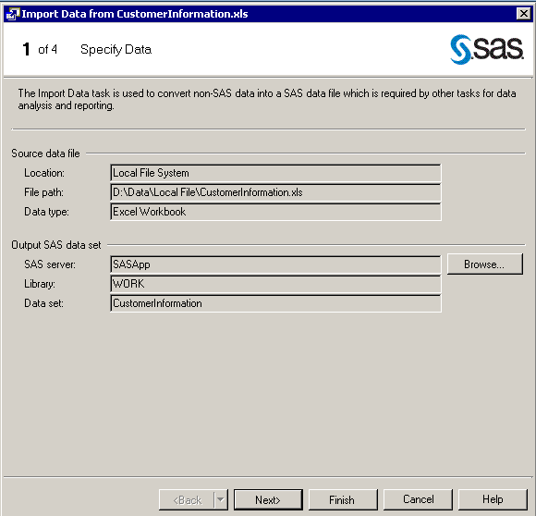

* 1. Accept the defaults for step 1 and click .
  2. Accept the defaults in step 2. (Note _ this will contain your file name and likely Sheet1)

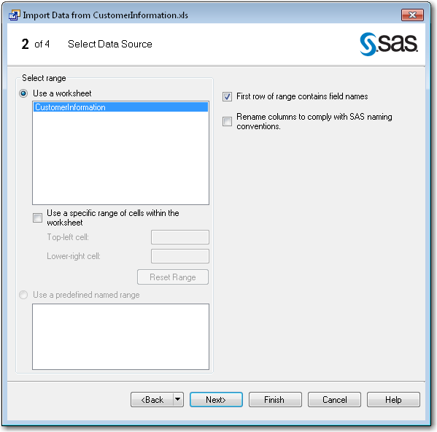

* 1. Click  to advance to step 3.

At this point, you can **Adjust a data field while importing** – but, I suggest this be accomplished prior to import. So, Click  to advance to step 4.

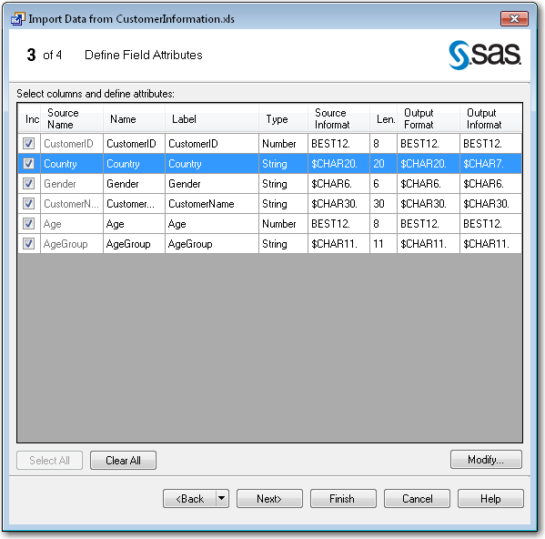

* 1. Accept the defaults for the step.

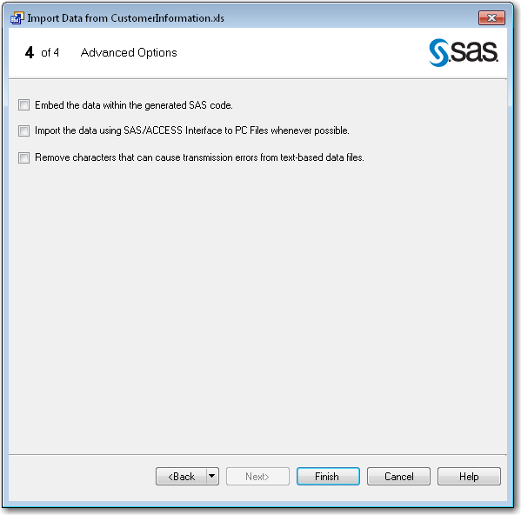

* 1. Click .

**The Import Data wizard processes and produces a SAS view of the data.**

**At this point you have a SAS dataset that you can work with.**

* **This may be a good time to save your newly created SAS Dataset.**
* **Get into the “Process Flow”**
* **Right click on the newly created SAS Dataset and choose Export > Export Imported Data from CustomerInformation.xls.**
* **Then, when the Window opens, rename your SAS Dataset to a shorter more appropriate name (CustomerInformation) and save it in your Library –** 
  + **Servers > SASApp--> Libraries > *<your name>* (this is your private library - where you would store your SAS datasets)**

**Note – when you want to access your SAS dataset - File > Open >Data--> Servers > SASApp--> Libraries > *<your name>* CustomerInformation(this is in you your private library)**