# SASEG – One Way Frequencies

(Spring 2017)

**Sources** (adapted with permission) **-**

Ron Freeze Course and Classroom Notes

Enterprise Systems, Sam M. Walton College of Business, University of Arkansas, Fayetteville

Microsoft Enterprise Consortium

IBM Academic Initiative

SAS® Multivariate Statistics Course Notes & Workshop, 2010

SAS® Advanced Business Analytics Course Notes & Workshop, 2010

Microsoft® Notes

Teradata® University Network

*For educational uses only - adapted from sources with permission. No part of this publication may be reproduced, stored in a retrieval system, or transmitted, in any form or by any means, electronic, mechanical, photocopying, or otherwise, without the prior written permission from the author/presenter.*

Example:*Pelican Stores, a division of National Clothing, is a chain of women’s apparel stores operating throughout the country. The chain recently ran a promotion in which discount coupons were sent to customers of other National Clothing stores. Data collected for a sample of 100 in-store credit card transactions at Pelican Stores during one day while the promotion was running are contained in the file named PelicanStores. The Proprietary Card method of payment refers to charges made using a National Clothing charge card. Customers who made a purchase using a discount coupon are referred to as promotional customers and customers who made a purchase but did not use a discount coupon are referred to as regular customers. Because the promotional coupons were not sent to regular Pelican Stores customers, management considers the sales made to people presenting the promotional coupons as sales it would not otherwise make. Of course, Pelican also hopes that the promotional customers will continue to shop at its stores. Pelican would like to know the significance of the variables on Net Sales.*

*SASEG allows to run tasks to describe one way frequencies to determine the frequency of occurrence for a particular variable in a table. A one-way table is the tabular equivalent of a bar chart. Like a bar chart, a one-way table displays categorical data in the form of frequency counts and/or relative frequencies.*

# C:\Program Files\PowerServ\CourseGraphics\demo_eye.jpgExercise – One Way Frequencies

*We want to check the frequency of occurrence by gender to analyze and check for relationship between gender and their affinity towards shopping. We will be finding the frequency of shopping by the gender and percentage of occurrence in comparison to the overall list of orders.*

1. Open the **PelicanStores** SAS Dataset using the following path: **Servers > SASApp-->Files > D: > ISYS 5503--> ISYS 5503 Shared Datasets--> Pelican Stores**

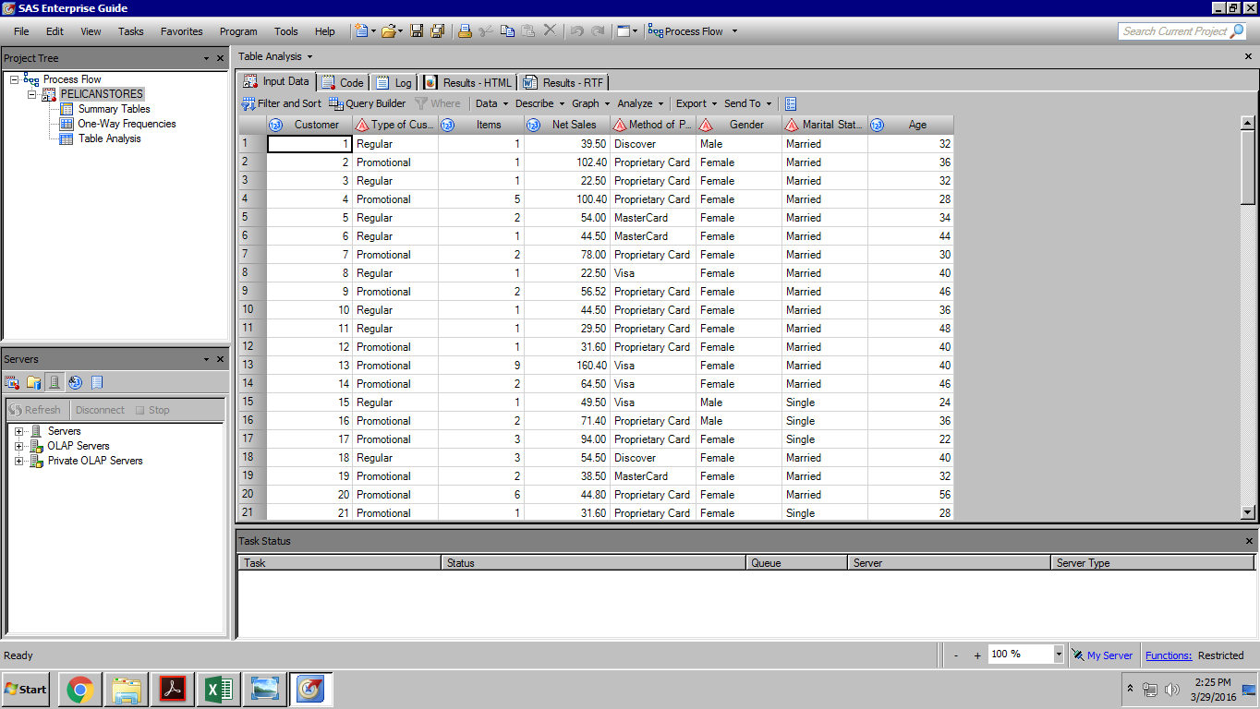

1. Click on the **Tasks** menu option.
2. 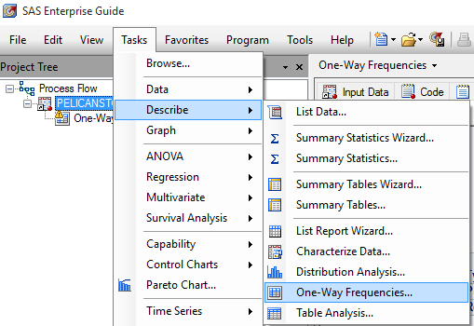Go to Describe > One-way Frequencies
3. In the **Data** option, drag the **Gender** variable to the analysis variable box as shown in the figure.

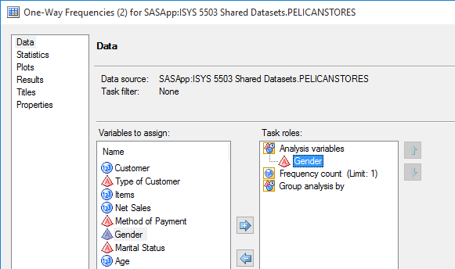

1. 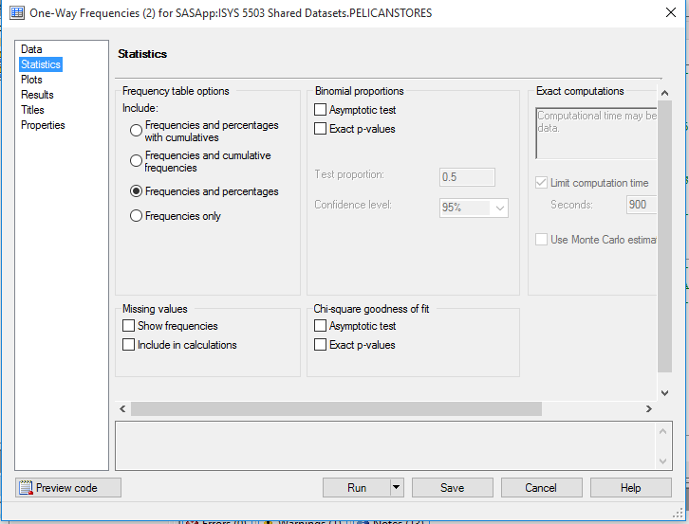Click on **Statistics**, select the **Frequencies and percentages** radio button and click run.
2. 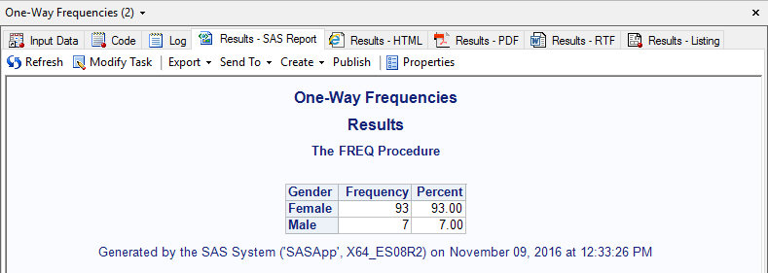The resultant output will be as below.
3. 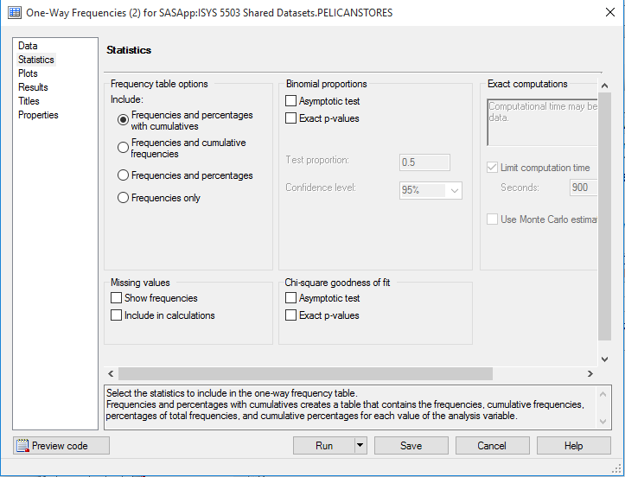We can modify the task to display cumulative frequencies and percentages as well by selecting the Modify Task option in the top ribbon of the result page.
4. Click on **Statistics**, Select the **Frequencies and percentages with cumulatives** radio button, click run
5. The 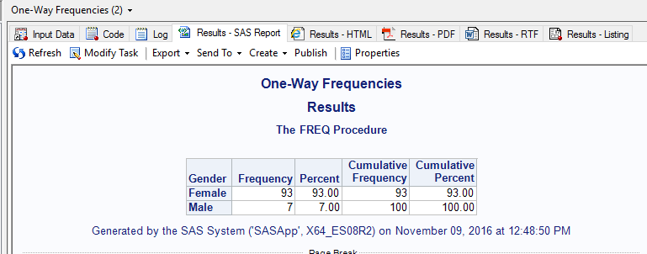Result will be as seen below.

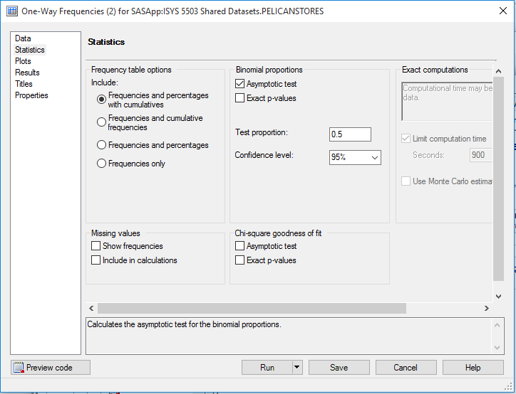

1. We can also check for Binomial Proportions based on confidence intervals.
2. We can modify the task to display cumulative frequencies and percentages as well by selecting the Modify Task option in the top ribbon of the result page.
3. Click on **Statistics**, select the **Asymptotic Test** check box, leave the values for **test proportions** and **Confidence levels** as default and click run.
4. 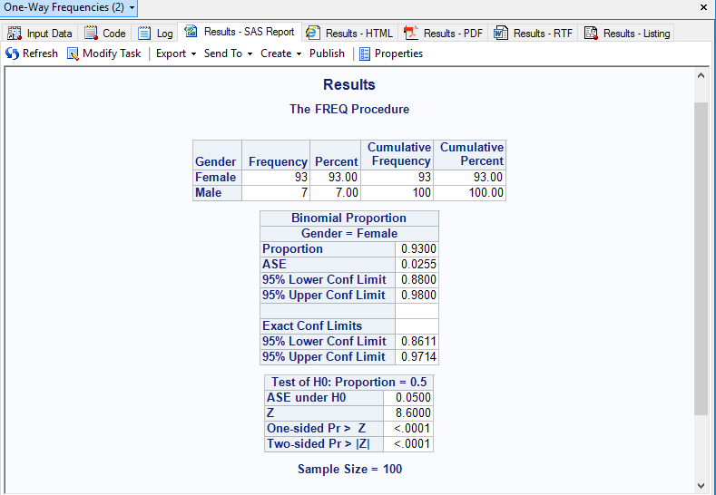The result will be as seen below
5. You will notice that the results are showing only binomial proportions for the **Female** gender. SASEG allows you to change the sorting order of results with a small change in the code.
6. We can modify the task to change the ordering of results, selecting the Modify Task option in the top ribbon of the result page.
7. Click on **Results**, scroll down and you should find the **order output data by** drop down.
8. 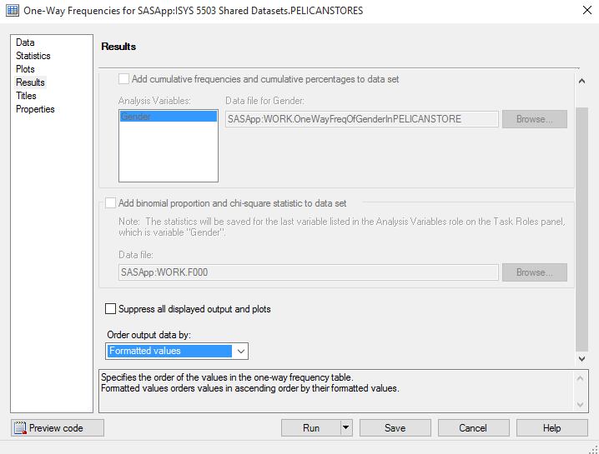You have four options to order the output
   * **Data Set order** - Data set order orders values according to their order in the input data set.
   * **Formatted values** - Formatted values orders values in ascending order by their formatted values.
   * **Descending Frequencies** - Descending frequencies orders values by descending frequency count.
   * **Unformatted values** - Unformatted values orders values by their unformatted values.
9. Note that none of these option allow to sort in descending order. There is a work around to edit the code to get the one-way frequency output for a specific value.
10. In the above case we want to see the binomial proportion output for the male gender.
11. In order to view the code, click on **Preview** **Code** in the lower left corner of the Results. In order to modify the code, you need to access the code by exiting the task and selecting the **Code** tab as shown below.

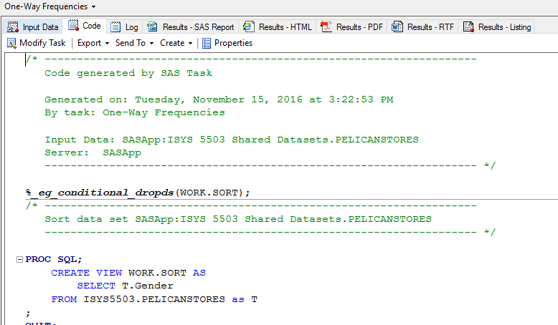

1. 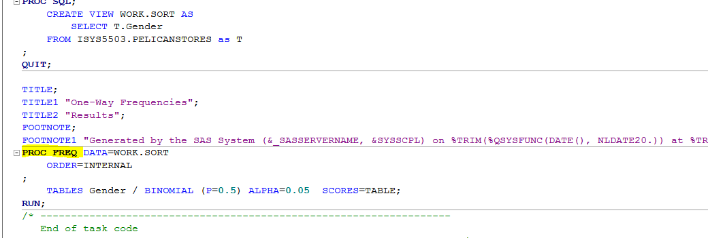Scroll down to the section where the frequency procedure (**PROC FREQ**) is defined.
2. We will be editing the code by adding a Level filter parameter while defining the binomial parameters.
3. 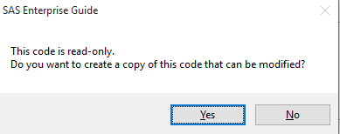Clicking on the code will enable the editor. Click on the code to edit and click yes when you see the following prompt.
4. Scroll down to Frequency procedure and add the **LEVEL=”Male”** parameter next to the p value parameter as shown below.
5. 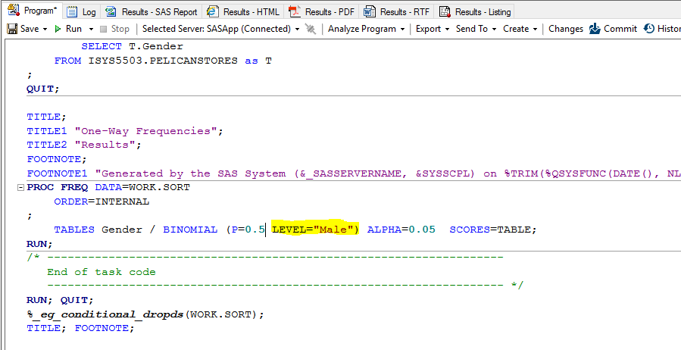Click **Run** (on the top tool bar) to execute the code. The result will now show you the binomial proportion results for the male gender.

