## SASEG 6B – Introduction to Analysis of Variance (ANOVA)

(Fall 2015)

**Sources** (adapted with permission)**-**

T. P. Cronan, Jeff Mullins, Ron Freeze and David E. Douglas Course and Classroom Notes

Enterprise Systems, Sam M. Walton College of Business, University of Arkansas, Fayetteville

Microsoft Enterprise Consortium

IBM Academic Initiative

SAS® Multivariate Statistics Course Notes & Workshop, 2010

SAS® Advanced Business Analytics Course Notes & Workshop, 2010

Microsoft® Notes

Teradata® University Network

*For educational uses only - adapted from sources with permission. No part of this publication may be reproduced, stored in a retrieval system, or transmitted, in any form or by any means, electronic, mechanical, photocopying, or otherwise, without the prior written permission from the author/presenter.*

## One-Way ANOVA





***Analysis of variance* (ANOVA) is a statistical technique used to compare the means of two or more groups of observations or treatments.** For this type of problem, you have a

* continuous dependent variable, or *response* variable
* discrete independent variable also called a *predictor* or *explanatory* variable.



**A *t*-test can be thought of as a special case of ANOVA**: if you analyze the difference between means using ANOVA, you get the same results as with a *t*-test. It just looks different in the output. Performing a two-group mean comparison test in the Linear Models task gives you access to different graphical and assessment tools than performing it in the t Test task.



When there are three or more levels for the grouping variable, a simple approach is to run a series of *t*‑tests between all the pairs of levels. For example, you might be interested in T-cell counts in patients taking three medications (including one placebo). You could simply run a *t*-test for each pair of medications. A more powerful approach is to analyze all the data simultaneously. The model is the same, but it is now called a one-way analysis of variance (ANOVA), and the test statistic is the *F* ratio, rather than the Student’s *t* value.







**Example:** *Christin and Nicole own Montana Gourmet Garlic, a company that grows garlic using organic methods. They specialize in hardneck varieties. Knowing a little about experimental methods, they design an experiment to test whether growth of the garlic is affected by the type of fertilizer used. They limit their experimentation to a Rocambole variety called Spanish Roja. They test three different organic fertilizers and one chemical fertilizer (as a control). They blind themselves to the fertilizer (in other words, they design the experiment in such a way that they do not even know which fertilizer is in which container) by using containers with numbers 1 through 4. One acre of farmland is set aside for the experiment. It is divided into   
32 beds. They randomly assign fertilizers to beds. At harvest, they calculate the average weight of garlic bulbs in each of the beds. The data is in the* ***MGGarlic*** *data set.*

The variables in the data set are

**Fertilizer** The type of fertilizer used (1 through 4)

**BulbWt** The average garlic bulb weight (in pounds) in the bed

**Cloves** The average number of cloves on each bulb

**BedID** A randomly assigned bed identification number

Exercise - Descriptive Statistics across Groups

Obtain summary statistics and a box and whisker plot for the **MGGARLIC** data set.

1. Open the **MGGARLIC** data set.

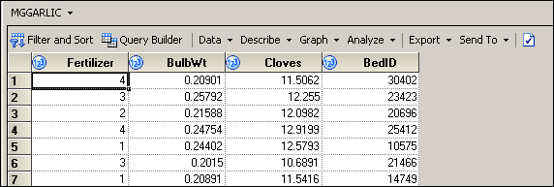

1. Select **Tasks** ⇨ **Describe** ⇨ **Summary Statistics…**.
2. Select **BulbWeight** as the analysis variable and **Fertilizer** as the classification variable.
3. Under Plots, check **Box and whisker**.

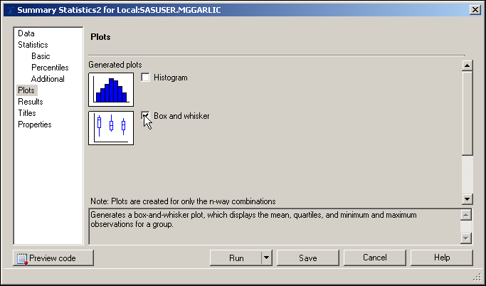

1. Change titles as desired and then click .

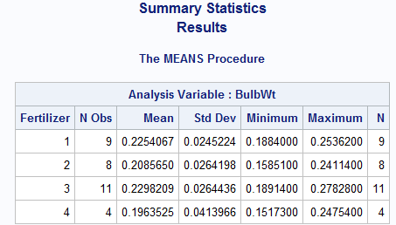

The means are somewhat different across **Fertilizer** values.

**🖉** The design is not *balanced*. In other words, the groups are not equally sized.

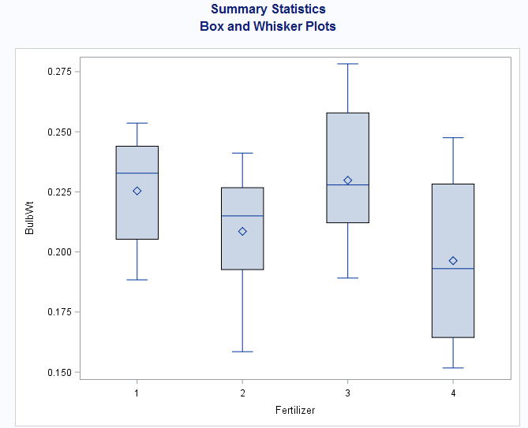

The box-and-whisker plots do not provide much additional information. There are simply too few observations per group for them to be very informative.



Small differences between sample means are usually present. The objective is to determine whether these differences are significant. In other words, is the difference more than what might be expected to occur by chance?

The assumptions for ANOVA are

* independent observations
* normally distributed error for each treatment
* equal error variances across treatments.



**In ANOVA, the corrected total sum of squares is partitioned into two parts, the Model Sum of Squares and the Error Sum of Squares.**

**Model Sum of Squares (SSM) the variability explained by the independent variable and therefore represented by the *between* treatment sums of squares.**

**Error Sum of Squares (SSE) the variability not explained by the independent variable. Also referred to as *within* treatment variability or residual sum of squares.**

**Total Sum of Squares (SST) the *overall* variability in the response variable.   
SST=SSM + SSE.**



As its name implies, analysis of variance analyzes the variances of the data to determine whether there is a difference between the group means. ANOVA compares the portion of variation in the response variable attributable to the grouping variable to the portion of variability left unexplained. Another way to say this is that ANOVA compares the sample variance under the null and alternative hypotheses.

Between Group Variation the weighted (by group size) sum of the squared differences between the mean for each group and the overall mean,. This measure is also referred to as the Model Sum of Squares (SSM).

Within Group Variation the sum of the squared differences between each observed value and the mean for its group,. This measure is also referred to as the Error Sum of Squares (SSE).

Total Variation the sum of the squared differences between each observed value and the overall mean,. This measure is also referred to as the   
Total Sum of Squares (SST).



The model, Yik = μ + τI + εik, is just one way of representing the relationship between the dependent   
and independent variables in ANOVA.

*Yik* the *k*th value of the response variable for the *i*th treatment.

μ the overall population mean of the response, for instance garlic bulb weight.

τ*i*the difference between the population mean of the *i*th treatment and the overall mean, μ. This   
is referred to as the *effect* of treatment *i*.

ε*ik*the difference between the observed value of the *k*th observation in the *i*th group and the mean   
of the *i*th group. This is called the *error term*.

**🖉** SAS uses a parameterization of categorical variables that will not directly estimate the values   
of the parameters in the model shown.

**🖉** The researchers are interested only in these four specific fertilizers. In some references this would be considered a *fixed effect*, as opposed to a *random effect*. Random effects are not covered in this course.

ANOVA Assumptions



The validity of the *p*-values depends on the data meeting the assumptions for ANOVA. Therefore, it is good practice to verify those assumptions in the process of performing the analysis of group differences.

Independence implies that the εijs in the theoretical model are uncorrelated. The independence assumption should be verified with good data collection. In some cases, residuals can be used to verify this assumption.

The errors are assumed to be normally distributed for every group or treatment.

One assumption of ANOVA is approximately equal error variances for each treatment. Although you can get an idea about the equality of variances by looking at the descriptive statistics and plots of the data, you should also consider a formal test for homogeneity of variances. The SAS code has a homogeneity of variance test option for one-way ANOVA.







The residuals from the ANOVA are calculated as (the actual value – the predicted value). These residuals can be examined with the Distribution Analysis task to determine normality. With a reasonably sized sample and approximately equal groups (balanced design), only severe departures from normality are considered a problem. Residual values sum to 0 in ANOVA. Their distribution approximates the distribution of error in the model.

In ANOVA with more than one predictor variable, homogeneity of variance test options are unavailable. In those circumstances, you can plot the residuals against their predicted values to verify that the variances are equal. The result will be a set of vertical lines equal to the number of groups. If the lines are approximately the same height, the variances are approximately equal. Descriptive statistics can also be used to determine whether the variances are equal.

Exercise - The Linear Models task

**Perform ANOVA to test whether the mean bulb weight of garlic is different across different fertilizers.**

1. Click the **Input Data** tab of the task flow to expose the **MGGARLIC** data set.

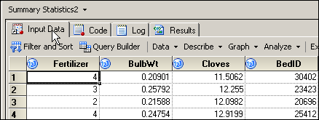

1. Select **Tasks** (or **Analyze)** ⇨ **ANOVA** ⇨ **Linear Models…**.
2. Under Data, assign **BulbWeight** and **Fertilizer** to the task roles of dependent variable and classification variable, respectively.

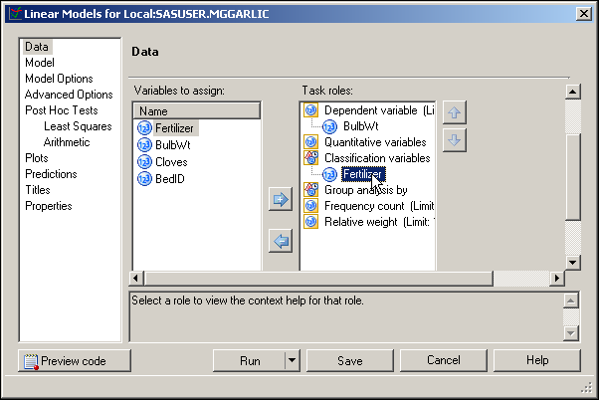

1. Under Model, click **Fertilizer** and then click .

**🖉** The Class and quantitative variables pane was populated by the selection   
of task roles.

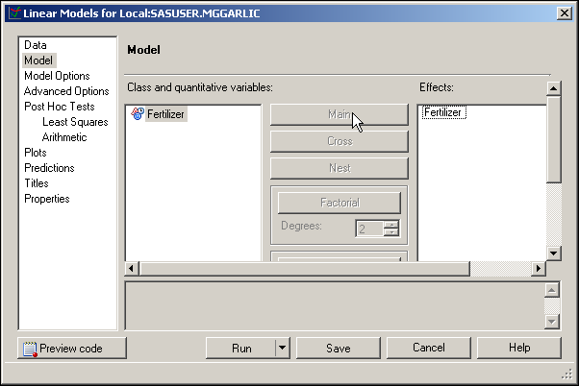

1. Under Model Options, uncheck **Type I** and **Show parameter estimates**.

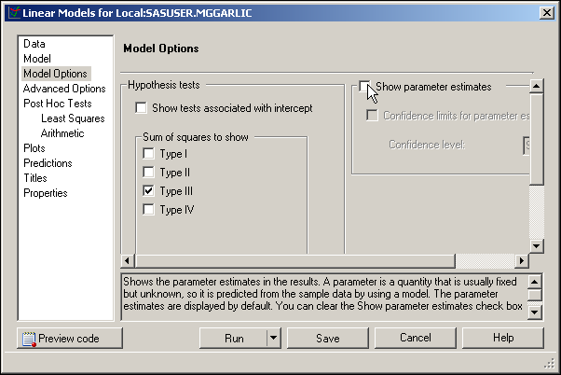

1. Click .

Turn your attention to the first page of the output, which specifies the number of levels and the values of the class variable, and the number of observations read versus the number of observations used. These values are the same because there are no missing values for any variable in the model. If any row **has missing data** for a predictor or response variable, that row is **dropped** from the analysis*.*

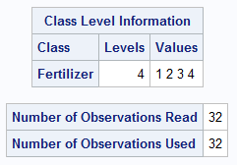The second page of the output contains all of the information that is needed to test the equality of the treatment means. It is divided into three parts:

* the analysis of variance table
* descriptive information
* information about the class variable in the model

Look at each of these parts separately.

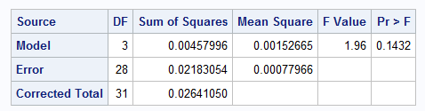

In general, *degrees of freedom* (DF) can be thought of as the number of independent pieces of information.

* Model DF is the number of treatments minus 1.
* Corrected total DF is the sample size minus 1.
* Error DF is the sample size minus the number of treatments (or the difference between the corrected total DF and the Model DF.

*Mean squares* are calculated by taking sums of squares and dividing by the corresponding degrees of freedom. They can be thought of as variances.

* Mean square for error (MSE) is an estimate of σ2, the constant variance assumed for all treatments.
* If μi = μj, for all i ≠ j, then the mean square for the model (MSM) is also an estimate of σ2.
* If μi ≠ μj, for any i ≠ j, then MSM estimates σ2 plus a positive constant.
* .

**🖉** *Variance is the traditional measure of precision. Mean Square Error (MSE) is the traditional measure of accuracy used by statisticians. MSE is equal to variance plus bias-squared. Because the expected value of the sample mean  equals the population mean (μ), MSE equals the variance.*

Based on the above, if the *F* statistic is significantly larger than 1, it supports rejecting the null hypothesis, concluding that the treatment means are not equal.

The *F* statistic and corresponding *p*‑value are reported in the analysis of variance table. Because the reported *p*‑value (0.1432) is greater than 0.05, you conclude that there is **no** statistically significant difference between the means.



The *coefficient of determination*, R2, denoted in this table as R-Square, is a measure of the proportion of variability explained by the independent variables in the analysis. This statistic is calculated as 

The value of R2 is between 0 and 1. The value is

* close to 0 if the independent variables do not explain much variability in the data
* close to 1 if the independent variables explain a relatively large proportion of variability in the data.

Although values of R2 closer to 1 are preferred, judging the magnitude of R2 depends on the context of the problem.

The coefficient of variation (denoted Coeff Var) expresses the root MSE (the estimate of the standard deviation for all treatments) as a percent of the mean. It is a unitless measure that is useful in comparing the variability of two sets of data with different units of measure.

The BulbWt Mean is the mean of all of the data values in the variable **BulbWt** without regard to **Fertilizer**.

Some interpret the R2 value as the “proportion of variance accounted for by the model”. Therefore, one might say that in this model, **Fertilizer** explains about 17% of the variability of **BulbWt**.

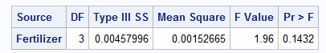

For a one‑way analysis of variance *(only one classification variable)*, the information about the class variable in the model is an exact duplicate of the model line of the analysis of variance table.

**🖉** *It is good practice to look at your diagnostic plots to check for the validity of your ANOVA assumptions. The rest of the output is dedicated to verifying those statistical assumptions for inference tests.*

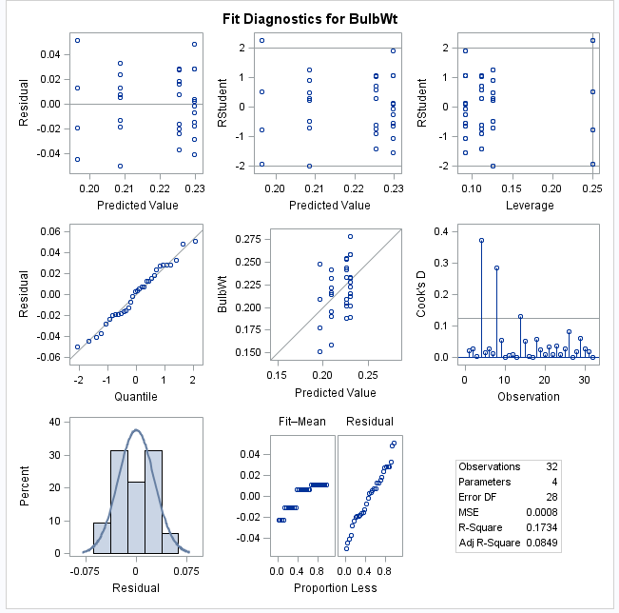

The graph above is a mosaic of plots having to do with residuals from the ANOVA model. You will focus on the left three in this analysis.

The plot at the upper left is a Residual by Predicted plot. Essentially, you are looking for a random scatter within each group. Any patterns or trends in this plot can indicate model assumption violations.

To check the normality assumption, look at the Quantile-Quantile plot at center left. There appears to be no severe departure from normality because the observations all lie close to the diagonal reference line. This conclusion is not contradicted by the residual histogram at the lower left.



Another Exercise

1. **Analyzing Data in a Completely Randomized Design**

Consider an experiment to study four types of advertising: local newspaper ads, local radio ads, in‑store salespeople, and in‑store displays. The country is divided into 144 locations, and 36 locations are randomly assigned to each type of advertising. The level of sales is measured for each region in thousands of dollars. You want to see whether the average sales are significantly different for various types of advertising.

The **ads** data set contains data for these variables:

**Ad** type of advertising

**Sales** level of sales in thousands of dollars

* 1. Examine the data using the Summary Statistics task. What information can you obtain from looking at the data?
  2. Test the hypothesis that the means are equal. Be sure to check that the assumptions of the analysis method you choose are met. What conclusions can you reach at this point in your analysis?