## SASEG 6C – Two Way ANOVA

(Fall 2015)

**Sources** (adapted with permission)**-**

T. P. Cronan, Jeff Mullins, Ron Freeze and David E. Douglas Course and Classroom Notes

Enterprise Systems, Sam M. Walton College of Business, University of Arkansas, Fayetteville

Microsoft Enterprise Consortium

IBM Academic Initiative

SAS® Multivariate Statistics Course Notes & Workshop, 2010

SAS® Advanced Business Analytics Course Notes & Workshop, 2010

Microsoft® Notes

Teradata® University Network

*For educational uses only - adapted from sources with permission. No part of this publication may be reproduced, stored in a retrieval system, or transmitted, in any form or by any means, electronic, mechanical, photocopying, or otherwise, without the prior written permission from the author/presenter.*

## 

## Two-Way ANOVA with Interactions



In the previous section, you considered the case where you had one categorical predictor and a blocking variable. In this section, consider a case with two categorical predictors. In general, any time you have more than one categorical predictor variable and a continuous response variable, it is called *n*-way ANOVA. The *n* can be replaced with the number of categorical predictor variables.

The analysis for a randomized block design is actually a special type of *n-*way ANOVA.



Data was collected in an effort to determine whether different dose levels of a given drug have an effect on blood pressure for people with one of three types of heart disease.



Y*ijk* the observed **BloodP** for each subject

μ the overall base level of the response, **BloodP**

α*i*the effect of the *i*th **Disease**

β*j* the effect of the *j*th **DrugDose**

(αβ)ij the effect of the interaction between the *i*th **Disease** and the *j*th **DrugDose**

εijk error term, or residual

In the model it is assumed that the:

* observations are independent
* data are normally distributed for each treatment
* variances are equal across treatments

**🖉** Verifying ANOVA assumptions with more than two variables is covered in Statistics II: ANOVA and Regression.



An interaction occurs when a change in the level of one factor results in a change in the difference between levels of the other factor.

The average blood pressure change over different doses were plotted in mean plots and then connected for disease A and B.

In the left plot above, different types of disease show the same change across different levels of dose.

In the right plot, however, as the dose increases, average blood pressure **increases** in those with disease A, but **decreases** for those with disease B. This indicates an interaction between the variables **DrugDose** and **Disease**.

When you analyze an *n*-way ANOVA with interactions you should first look at any tests for interaction among factors.

If there is no interaction between the factors, the tests for the individual factor effects can be interpreted   
to determine their significance/non-significance.

If an interaction exists between any factors, the tests for the individual factor effects might be misleading, due to masking of these effects by the interaction. This is especially true for unbalanced data.

In the previous section, you used a blocking variable and a categorical predictor as effects in the model.   
It is generally assumed that blocks do not interact with other factors. In this section, there are just two separate factors. An interaction between the two might be hypothesized and tested.



When the interaction is not statistically significant, the main effects can be analyzed with the model as originally written. This is generally the method used when analyzing designed experiments.

However, even when analyzing designed experiments, some statisticians suggest that if the interaction   
is nonsignificant, then the interaction effect can be deleted from the model and then the main effects are analyzed. This increases the power of the main effects tests.

Neter, Kutner, Wasserman, and Nachtsheim (1996) suggest the following guidelines for when to delete the interaction from the model:

* there are fewer than 5 degrees of freedom for the error, **and**
* the F Value for the interaction term is < 2.
* When you analyze data from an observational study, it is more common to delete the   
  non-significant interaction from the model and then analyze the main effects.

## Two-Way ANOVA with InteractionC:\Program Files\PowerServ\CourseGraphics\demo_eye.jpgs

Perform a two-way ANOVA using the DRUG data set.

The **Drug** data set contains the following variables:

**DrugDose** dosage level of drug (Placebo, 100 mg, 200 mg, 500 mg)

**Disease** heart disease category

**BloodP** change in diastolic blood pressure after 2 weeks treatment

Before conducting an analysis of variance, you should explore the data.

Presume that the initial data exploration was completed (output not shown here) and that no particular concerns were noted about unusual data values or the distribution of the data. During this exploration, you determine that the sample sizes for all treatments are not equal. The researchers recruited 240 patients   
(80 per heart disease category), but only 170 were randomized into the trial.

1. Open the **DRUG** data set.

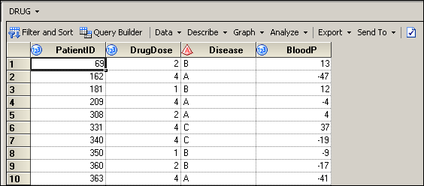

Negative values for **BloodP** mean that diastolic blood pressure was reduced by that amount. Positive values mean that the **BloodP** increased.

1. Use the summary statistics task, choosing **BloodP** for the analysis variables role and **Disease** and **DrugDose** for the classification variables role.

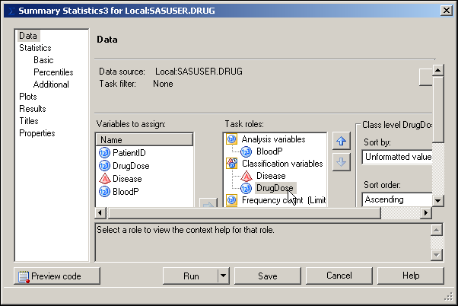

*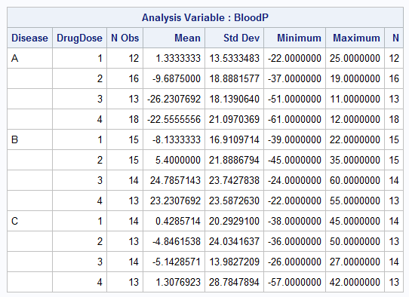*

*The means do seem to vary from group to group. However, it is not obvious if there is a consistent trend across different levels of* ***DrugDose****. It seems that the trend of* ***BloodP*** *across levels of* ***DrugDose*** *may be different from disease to disease.*

To test the hypothesis that effect of **DrugDose** differs across diseases, perform a 2-way ANOVA with   
an interaction.

1. Select **Tasks** (or **Analyze**) ⇨ **ANOVA** ⇨ **Linear Models…**.
2. Under Data, assign **Bloodp** to the dependent variable task role and **Disease** and **DrugDose**   
   to the classification variables role.

**🖉** **DrugDose** is saved in SAS as numeric and could have been assigned to the quantitative variables role. However, the scale of measurement of the variable is not continuous, but rather ordinal, so it should be added as a classification variable.

1. Select **Model** at the left and highlight both **Disease** and **DrugDose** in the Class and quantitative variables pane (by clicking on one and then holding down the CTRL key   
   on the keyboard and then clicking on the other variable).

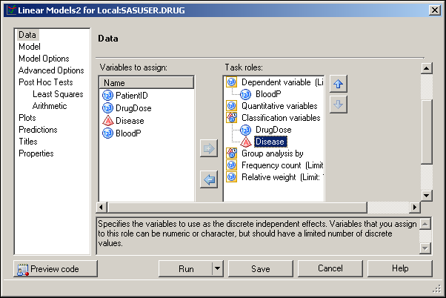

1. Click  and see the terms, **DrugDose**, **Disease** and **DrugDose**\***Disease** displayed in the Effects pane.

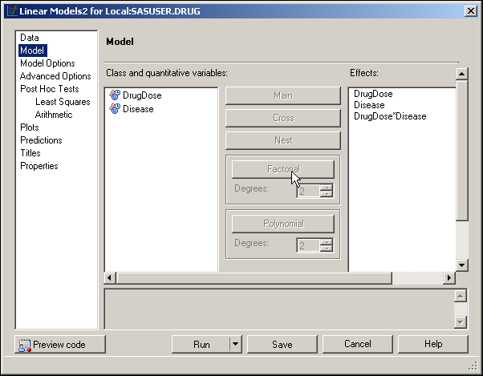

1. Under Model Options, deselect **Show parameter estimates**.

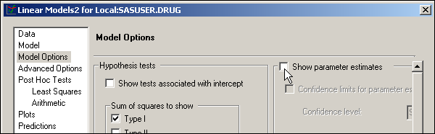

1. Click  at the bottom of the window.
2. You will now see a window showing the SAS code created by the t Test task. This window is where you can directly edit the Code generated by SAS Task.
3. Select the Show custom code insertion points and…

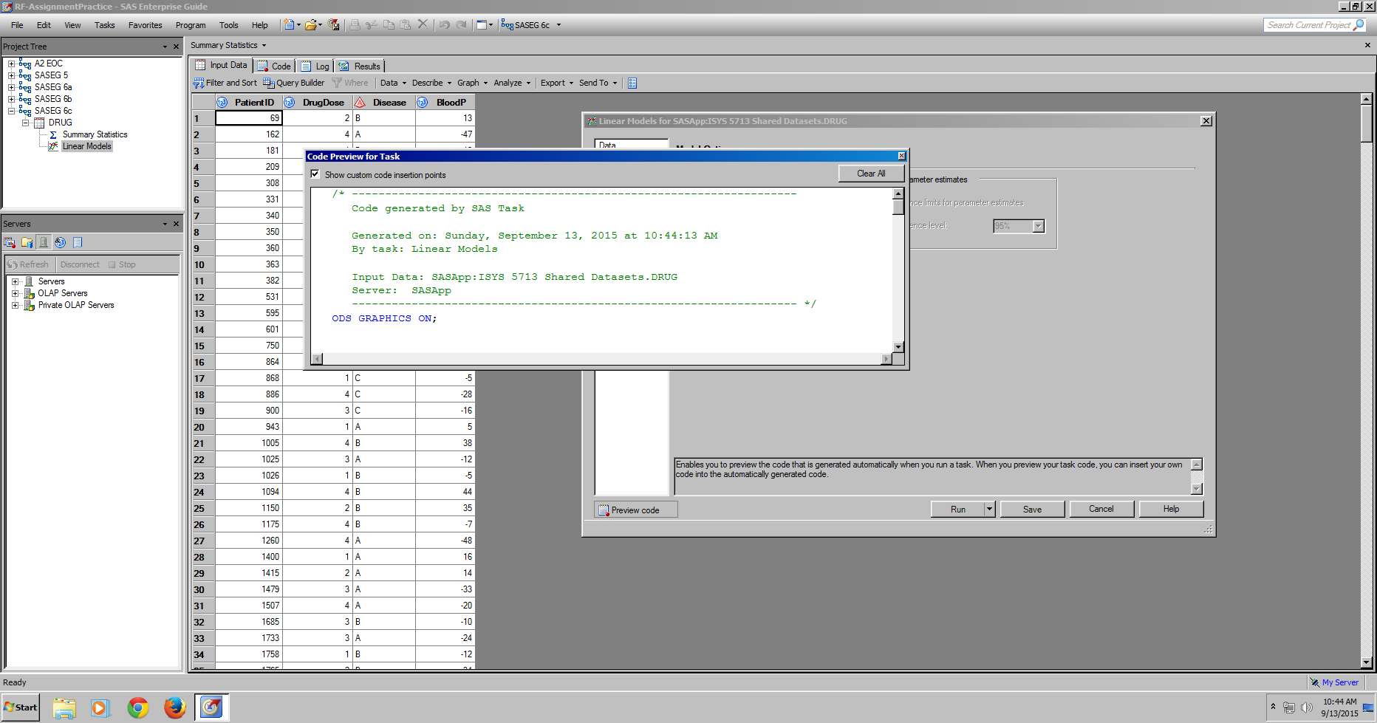

1. Scroll down in the code to just under the words **PLOTS(ONLY)=ALL**.
2. Click on the <insert custom code here> in the area just after **PLOTS(ONLY)=ALL**
3. Type **INTPLOT**. *This is the option to produce an interaction plot.*
4. Uncheck the Show custom code insertion points. The code should look like the following.

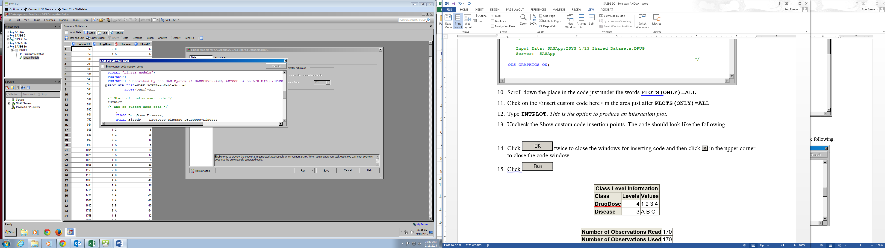

1. Close the window by clicking  in the upper right corner.
2. Click .

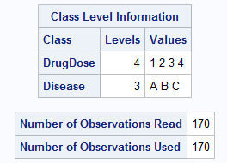

The next part of the output, below, shows the source table with the *F* test for the overall model. This tests the null hypothesis that none of the effects in the model are statistically different, in other words, that there are no differences among the 12 group means (one for each **DrugDose** \* **Disease** combination).

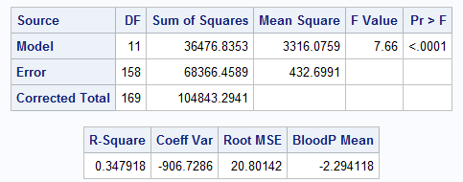

The descriptive statistics indicate that the average blood pressure change for all observations is -2.294118. The R2 for this model is 0.347918.

The *p*-value given is <0.0001. Presuming an alpha equal to 0.05, you reject the null hypothesis and conclude that at least one treatment mean is different from one other treatment mean. Which factor(s) explain this difference?

The next part of the output shows tests of the main effects and the interaction.

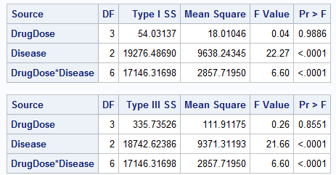

**The Type I SS are model-order dependent**; each effect is adjusted only for the preceding effects in the model. They are known as *sequential sums of squares*. They are useful in cases where the marginal (additional) effect for adding terms in a specific order is important. An example is where X, X\*X, and X\*X\*X are in the model statement. Each term is only tested controlling for a lower order term. The TYPE I SS values are additive. They sum to the Model Sum of Squares for the overall model.

The Type III SS are commonly called *partial sums of squares*. The Type III sum of squares for a particular variable is the increase in the model sum of squares due to adding the variable to a model that already contains all the other variables in the model. Type III sums of squares, therefore, do not depend on the order in which the explanatory variables are specified in the model. The Type III SS values are not generally additive (except in a completely balanced design). The values do not necessarily sum to the Model SS.

Look at tests using the Type III SS.

You should consider the test for the interaction first, because if there is an interaction, then by definition that means that the effect of each main effect is different at each level of the other main effect. The *p*‑value for **DrugDose\*Disease** is <0.0001. Presuming an alpha of 0.05, you reject the null hypothesis. You have sufficient evidence to conclude that there is an interaction between the two factors. As shown in the graph, the effect of the level of drug changes for different disease types.

You get an interaction plot, as well as a diagnostics plot.

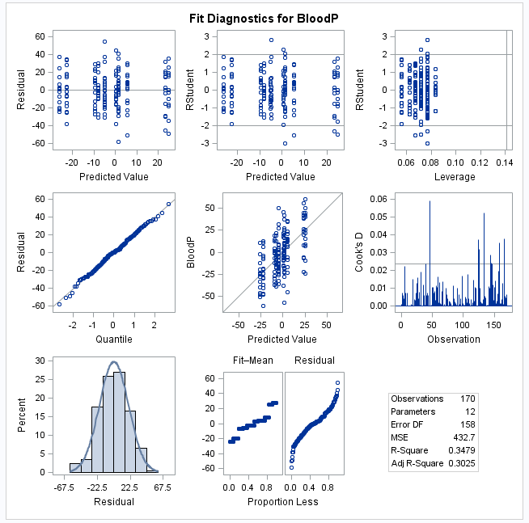

The Quantile-Quantile plot of the residuals indicates no great departure from normality. The Residual   
by Predicted Value plot shows no pattern in the residuals and the variability of the Residual seems fairly similar across all values of the Predicted Value.

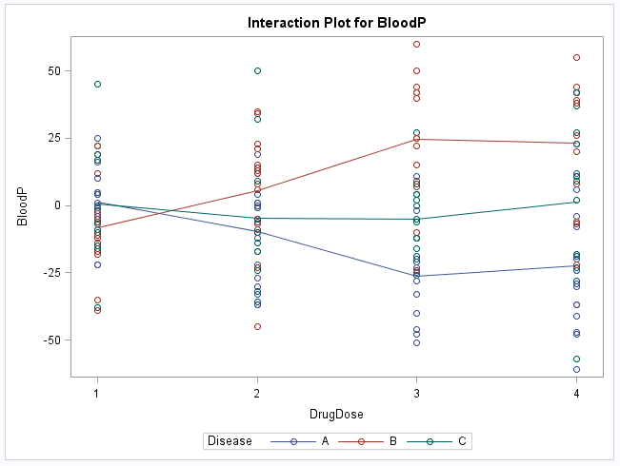

*This plot shows the interaction. Drug A shows a pattern of lower blood pressure at higher doses. Drug B shows the opposite pattern. Drug C displays a fairly constant effect across all doses.*

Because of the interaction, you do not know the significance of the **DrugDose** effect at any particular level of **Disease**. (If we were to go further, the LSMEANS tests could be used to test the effect of **DrugDose** at each level of **Disease**.)

*Given all of this information, it seems that one would want to aggressively treat blood pressure in people with disease A with high doses of the drug. For those with disease B (perhaps caused by a traumatic event), treating with the drug at all would be a mistake. For those with Disease C, there seems to be no effect on blood pressure.*

## Block Design ExercisesC:\Program Files\PowerServ\CourseGraphics\exer_arrow.jpg

1. **Analyzing Data in a Randomized Block Design**
   1. Test the hypothesis that the **Sales** means are equal. Include all of the variables in your MODEL statement. What can you conclude from your analysis? Was adding the blocking factor **Area** into the design and analysis detrimental to the test of **Ad**?

Perform an ANOVA on the **Ads1** data set to look for differences in sales across advertisement mode, controlling for **Area**, which is the blocking variable in the design. Check for normality of the residuals.

* + 1. Open the data table **Ads1**.
    2. Select **Tasks** ⇨ **ANOVA** ⇨ **Linear Models…**.
    3. Under Data, assign **Sales** to the dependent variable task role and **Ad** and **Area** to the classification variable role.
    4. Under Model, click **Ad** and **Area** and then click .

*Note that there is NO interaction with the Block design.*

* + 1. Under Model Options, uncheck **Type I** and **Show parameter estimates**.
    2. Click .

Partial Output

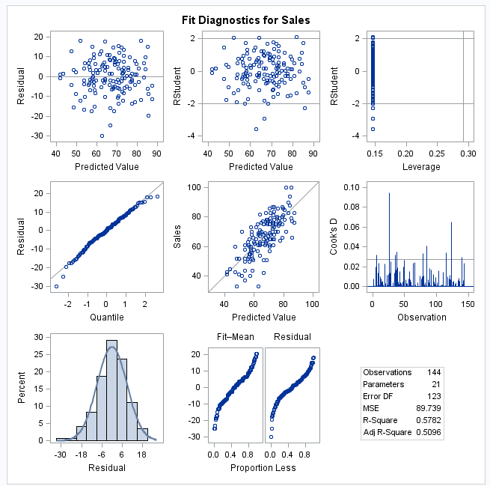

The QQ Plot of Residuals indicates that the normality assumption for ANOVA is met.

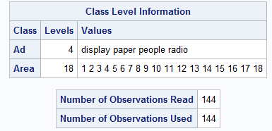

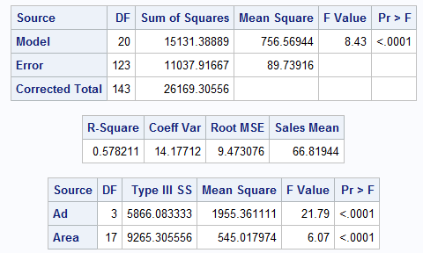

*The p-value for* ***Ad*** *(<.0001) indicates that there was a difference in sales among the advertising campaign types, when controlling for* ***Area****.*

*The large (statistically significant) F-Value for* ***Area*** *gives evidence that area of the country was a useful factor to block on. It was definitely not detrimental.*

## Post Hoc Pairwise Comparison

1. **(optional exercise) Post Hoc Pairwise Comparisons – where is the difference?**

Conduct pairwise comparisons with an experimentwise (use the Tukey adjustment) error rate of α=0.05.

* Re-open the previous Linear Models task by right-clicking the icon for it and selecting **Modify…** from the drop-down menu.
* Select **Least Squares** under **Post Hoc Tests** and then click  under the white space for Effects to estimate.
* A 0 line will appear and the Options for means tests area will be populated with several options. Click **False** next to **Ad** from the Options for means tests and then click  that appears next to it. Change this value to **True** by scrolling to that value and clicking on it.
* In a similar fashion, under comparisons, change the Show p-values for differences option from None to **All pairwise differences**. The Adjustment method for comparison can be selected as **Tukey** or left at **Default** because Tukey is the default method used when **All pairwise differences** is chosen above.
* Click  under the white space for Effects to estimate and effect 1 will appear. Choose **Ad** again as the Class effects to use variable. This time the choice for Show p-values for differences should be **Control using first level**. The default Adjustment method will be **Dunnett** and the default control group will be **display**.
* Click  and do not replace the previous results.
  1. Which types of advertising are significantly different?

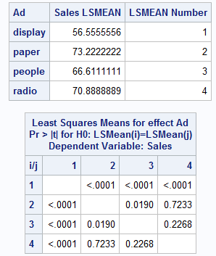

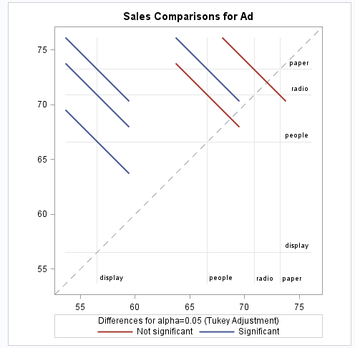

The Tukey comparisons show significant differences between **display** and all other types of advertising and between paper and people (p=0.0190).

* 1. Use **display** as the control group and do a Dunnett comparison of all other advertising methods to see if those methods improved sales over just display ads in stores.

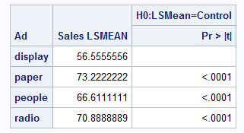

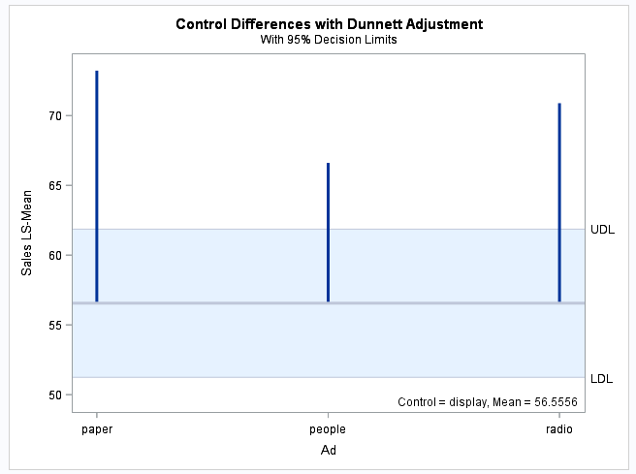

All other advertising campaigns resulted in significantly better average sales (statistically significant) than **display**.

## Another Example - Two-Way ANOVA (if you want more practice)

Test the hypothesis that the means are equal, making sure to include an interaction term.   
What conclusions can you reach?

* Open the **Concrete** data set.
* Use the summary statistics task, choosing **Strength** for the analysis variables role and **Brand**   
  and **Additive** for the classification variables role.
* Run the task.

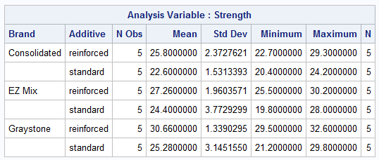

The means do seem to vary from group to group. However, it is not obvious if there is a consistent difference between additives across different levels of **Brand**. The differences between **reinforced** and **standard** range from about 3 for Consolidated and EZ Mix and 5 for Graystone.

To test the hypothesis that effect of **Additive** differs across brands, perform a 2-way ANOVA with an interaction.

* + Select **Tasks** ⇨ **ANOVA** ⇨ **Linear Models…**.
  + Under Data, assign **Strength** to the dependent variable task role and **Brand** and **Additive** to the classification variables role.
  + Select **Model** at the left and highlight both **Brand** and **Additive** in the Class and quantitative variables pane (by clicking on one and then holding down the CTRL key on the keyboard and then clicking on the other variable).
  + Click  and see the terms, **Brand**, **Additive** and **Brand**\***Additive** displayed in the Effects pane.
  + Under Model Options, deselect **Show parameter estimates** and **Type I**.
  + Click .
  + You will now see a window showing the SAS code created by the t Test task. This window is where you can directly edit the Code generated by SAS Task.
  + Select the Show custom code insertion points and…
  + Scroll down in the code to just under the words PLOTS(ONLY)=ALL.
  + Click on the <insert custom code here> in the area just after PLOTS(ONLY)=ALL
  + Type INTPLOT. This is the option to produce an interaction plot.
  + Uncheck the Show custom code insertion points and close the window by clicking  in the upper corner.
  + Click .

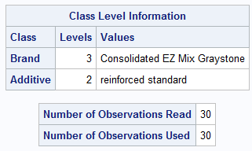

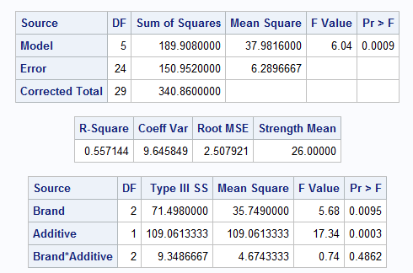

*There is no significant interaction between* ***Additive*** *and* ***Brand****, even though the plot shows slightly different slopes among the two additives. At this point, you may choose to remove the interaction term from the model and, if still significant, conclude that there is a difference in additive types.*