SASEG 7 - Introduction to Regression Analysis

Datasets – Fitness; NewFitness; BodyFat2; AbdomenPred

(Fall 2015)

Sources (adapted with permission)-
T. P. Cronan, Jeff Mullins, Ron Freeze, and David E. Douglas Course and Classroom Notes
Enterprise Systems, Sam M. Walton College of Business, University of Arkansas, Fayetteville
Microsoft Enterprise Consortium
IBM Academic Initiative
SAS® Multivariate Statistics Course Notes & Workshop, 2010
SAS® Advanced Business Analytics Course Notes & Workshop, 2010
Microsoft® Notes
Teradata® University Network

For educational uses only - adapted from sources with permission. No part of this publication may be reproduced, stored in a retrieval system, or transmitted, in any form or by any means, electronic, mechanical, photocopying, or otherwise, without the prior written permission from the author/presenter.

Simple Linear Regression
In the previous section, you used correlation analysis to quantify the linear relationships between continuous response variables. Two pairs of variables can have the same correlation, but very different linear relationships. In this section, you use simple linear regression to define the linear relationship between a response variable and a predictor variable.
The response variable is the variable of primary interest.
The predictor variable is used to explain the variability in the response variable.

In simple linear regression, the values of the predictor variable are assumed fixed. Thus, you try to explain the variability of the response variable given the values of the predictor variable.

The analyst noted that the running time measure has the highest correlation with the oxygen consumption capacity of the club members. Consequently, she wants to further explore the relationship between Oxygen_Consumption and RunTime.
She decides to run a simple linear regression of Oxygen_Consumption versus RunTime.
The relationship between the response variable and the predictor variable can be characterized
by the equation Y = β₀ + β₁X + ε
where
Y response variable
X predictor variable
β₀ intercept parameter, which corresponds to the value of the response variable when the predictor
is 0
β₁ slope parameter, which corresponds to the magnitude of change in the response variable given
a one unit change in the predictor variable
- error term representing deviations of Y about β₀ + β₁X.
Because your goal in simple linear regression is usually to characterize the relationship between the response and predictor variables in your population, you begin with a sample of data. From this sample, you estimate the unknown population parameters (β₀, β₁) that define the assumed relationship between your response and predictor variables.
Estimates of the unknown population parameters β₀ and β₁ are obtained by the method of least squares. This method provides the estimates by determining the line that minimizes the sum of the squared vertical distances between the observations and the fitted line. In other words, the fitted or regression line is as close as possible to all the data points.
The method of least squares produces parameter estimates with certain optimum properties. If the assumptions of simple linear regression are valid, the least squares estimates are unbiased estimates of the population parameters and have minimum variance (efficiency). The least squares estimators are often called BLUE (Best Linear Unbiased Estimators). The term best is used because of the minimum variance property.
Because of these optimum properties, the method of least squares is used by many data analysts to investigate the relationship between continuous predictor and response variables.
With a large and representative sample, the fitted regression line should be a good approximation of the relationship between the response and predictor variables in the population. The estimated parameters obtained using the method of least squares should be good approximations of the true population parameters.
To determine whether the predictor variable explains a significant amount of variability in the response variable, the simple linear regression model is compared to the baseline model. The fitted regression line in a baseline model is a horizontal line across all values of the predictor variable. The slope of the regression line is 0 and the intercept is the sample mean of the response variable, ($\bar{Y}$).
In a baseline model, there is no association between the response variable and the predictor variable. Therefore, knowing the value of the predictor variable does not improve predictions of the response over simply using the mean of the response variable for everyone.
To determine whether a simple linear regression model is better than the baseline model, compare the explained variability to the unexplained variability.
Explained variability is related to the difference between the regression line and the mean of the response variable. The model sum of squares (SSM) is the amount of variability explained by your model. The model sum of squares is equal to $\sum{(}{\hat{Y}}_{i}−\bar{Y})^{2}$.
Unexplained variability is related to the difference between the observed values and the regression line. The error sum of squares (SSE) is the amount of variability unexplained by your model. The error sum of squares is equal to $\sum{(}Y_{i}−{\hat{Y}}_{i})^{2}$.
Total variability is related to the difference between the observed values and the mean of the response variable. The corrected total sum of squares is the sum of the explained and unexplained variability. The corrected total sum of squares is equal to $\sum{(}Y_{i}−\bar{Y})^{2}$.
 The plot shows a seemingly contradictory relationship between explained, unexplained
and total variability. Contribution to total variability for the data point is smaller than contribution to explained and unexplained variability. Remember that the relationship of
total=unexplained + explained holds for sums of squares over all observations and not
necessarily for any individual observation.
If the estimated simple linear regression model does not fit the data better than the baseline model,
you fail to reject the null hypothesis. Thus, you do not have enough evidence to say that the slope of the regression line in the population is not 0 and that the predictor variable explains a significant amount
of variability in the response variable.
If the estimated simple linear regression model does fit the data better than the baseline model, you reject the null hypothesis. Thus, you do have enough evidence to say that the slope of the regression line in the population is not 0 and that the predictor variable explains a significant amount of variability in the response variable.
One of the assumptions of simple linear regression is that the mean of the response variable is linearly related to the value of the predictor variable. In other words, a straight line connects the means of the response variable at each value of the predictor variable.
The other assumptions are the same as the assumptions for ANOVA: the error terms are normally distributed, have equal variances, and are independent.
 The verification of these assumptions is discussed in a later chapter.

Performing Simple Linear Regression with SAS EG

Because there is an apparent linear relationship between Oxygen_Consumption and RunTime, perform a simple linear regression analysis with Oxygen_Consumption as the response variable.
- With the Fitness data set selected, click Tasks ð Regression ð Linear Regression….
- Drag Oxygen_Consumption to the dependent variable task role and RunTime to the explanatory variables task role.
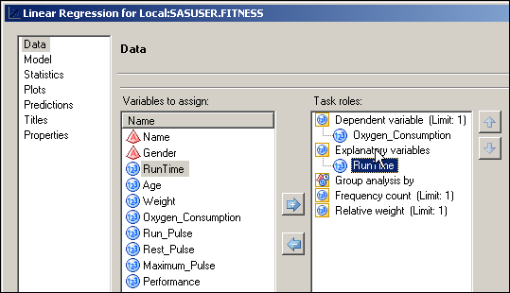
- With Plots selected at the left, select Custom list of plots under Show plots for regression analysis. In the menu that appears, uncheck the box for Diagnostic plots and check the box for Scatter plot with regression line.
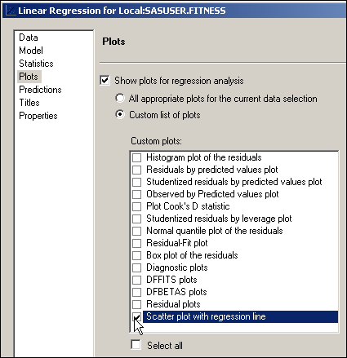
- Change the title, if desired.
- Click .
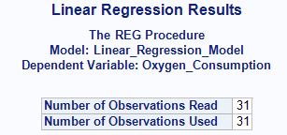

The Number of Observations Read and the Number of Observations Used are the same, indicating that
no missing values were detected for Oxygen_Consumption and RunTime.
The Analysis of Variance (ANOVA) table provides an analysis of the variability observed in the data
and the variability explained by the regression line.
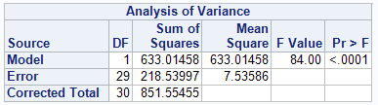
The ANOVA table for simple linear regression is divided into six columns.
Source labels the source of variability.
Model is the variability explained by your model (Between Group).
Error is the variability unexplained by your model (Within Group).
Corrected Total is the total variability in the data (Total).
DF is the degrees of freedom associated with each source of variability.
Sum of Squares is the amount of variability associated with each source of variability.
Mean Square is the ratio of the sum of squares and the degrees of freedom. This value corresponds to the amount of variability associated with each degree of freedom for each source of variation.
F Value is the ratio of the mean square for the model and the mean square for the error. This ratio compares the variability explained by the regression line to the variability unexplained by the regression line.
Pr > F is the p-value associated with the F value.
The F value tests whether the slope of the predictor variable is equal to 0. The p-value is small (less than .05), so you have enough evidence at the .05 significance level to reject the null hypothesis. Thus, you can conclude that the simple linear regression model fits the data better than the baseline model. In other words, RunTime explains a significant amount of variability of Oxygen_Consumption.
The third part of the output provides summary measures of fit for the model.
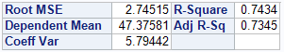
R-Square the coefficient of determination also referred to as the R² value. This value is
- between 0 and 1.
- the proportion of variability observed in the data explained by the regression line. In this example, the value is 0.7434, which means that the regression line explains 74% of the total variation in the response values.
- the square of the multiple correlation between y and the x’s.
 Notice that the R-square is the squared value of the correlation you saw earlier between RunTime and Oxygen_Consumption (0.86219). This is no coincidence. For simple regression, the R-square value will be the square of the value of the bivariate Pearson correlation coefficient.
Root MSE the root mean square error is an estimate of the standard deviation of the response variable at each value of the predictor variable. It is the square root of the MSE.
Dependent the overall mean of the response variable, $\bar{Y}$.
Mean
Coeff Var the coefficient of variation is the size of the standard deviation relative to the mean. The coefficient of variation is
- calculated as $\left(\frac{\text{Root}\text{MSE}}{\bar{Y}}\right)∗\text{100}$
- a unitless measure, so it can be used to compare data that has different units of measurement or different magnitudes of measurement.
Adj R-Sq the adjusted R² is adjusted for the number of parameters in the model. This statistic is useful in multiple regression and is discussed in a later section.

The Parameter Estimates table defines the model for your data.

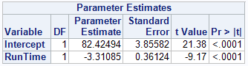

DF represents the degrees of freedom associated with each term in the model.
Parameter Estimate is the estimated value of the parameters associated with each term in the model.
Standard Error is the standard error of each parameter estimate.
t Value is the t statistic, which is calculated by dividing the parameter estimates by their corresponding standard error estimates.
Pr > |t| is the p-value associated with the t statistic. It tests whether the parameter associated with each term in the model is different from 0. For this example, the slope for the predictor variable is statistically different from 0. Thus, you can conclude that the predictor variable explains a significant portion of variability in the response variable.

Because the estimate of β_{o}=82.42494 and β₁=-3.31085, the estimated regression equation is given by
Predicted Oxygen_Consumption = 82.42494 - 3.31085 *(RunTime).

Interpretation
The model indicates that an increase of one unit for Runtime amounts to a 3.31085 decrease in Oxygen_Consumption. However, this equation is appropriate only in the range of values you observed for the variable RunTime.
The parameter estimates table also shows that the intercept parameter is not equal to 0. However, the test for the intercept parameter only has practical significance when the range of values for the predictor variable includes 0. In this example, the test could not have practical significance because RunTime=0 (running at the speed of light) is not inside the range of observed values.
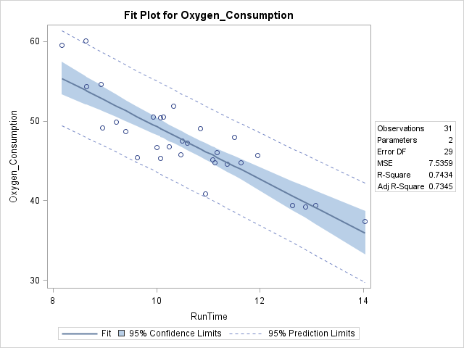
The Fit Plot produced by ODS Graphics shows the predicted regression line superimposed over a scatter plot of the data. You will learn more about this plot next.
To assess the level of precision around the mean estimates of Oxygen_Consumption, you can produce confidence intervals around the means. This is represented in the shaded area in the plot.
- A 95% confidence interval for the mean says that you are 95% confident your interval contains the population mean of Y for a particular X.
- Confidence intervals become wider as you move away from the mean of the independent variable. This reflects the fact that your estimates become more variable as you move away from the means of X and Y.
Suppose that the mean Oxygen_Consumption at a fixed value of Performance is not the focus. If you are interested in establishing an inference on a future single observation, you need a prediction interval around the individual observations. This is represented by the area between the broken lines in the plot.
- A 95% prediction interval is one that you are 95% confident will contain a new observation.
- Prediction intervals are wider than confidence intervals because single observations have more variability than sample means.

Regression Lines with Confidence Intervals

Return to the output from the last demonstration and open the Fit Plot.

The Confidence Interval for the mean is represented by the shaded region. The Prediction Interval for observations is the area between the dotted lines. Model statistics are reported in the inset by default.

One objective in regression analysis is to predict values of the response variable given values of the predictor variables. You can obviously use the estimated regression equation to produce predicted values, but if you want a large number of predictions, this can be cumbersome.

Producing Predicted Values

Produce predicted values of Oxygen_Consumption when Performance is 9, 10, 11, 12, or 13.
- Modify the previous Linear Regression task in the project.
- Uncheck the box for Show plots for regression analysis.
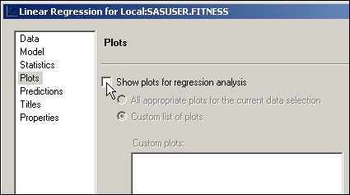
- With Predictions selected at the left, check the box for Additional data and Prediction limits (to generate prediction Confidence Intervals.
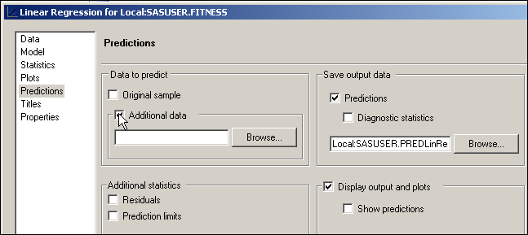
- Click .
- When the next window opens, select the NewFitness data set from the SASUSER library. Either double-click the name of the data set or highlight it and click .
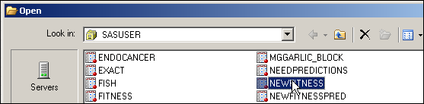
- Under Save output data, with Predictions checked, click .
- With that window open, overtype the default file name with NEWFITNESSPRED.
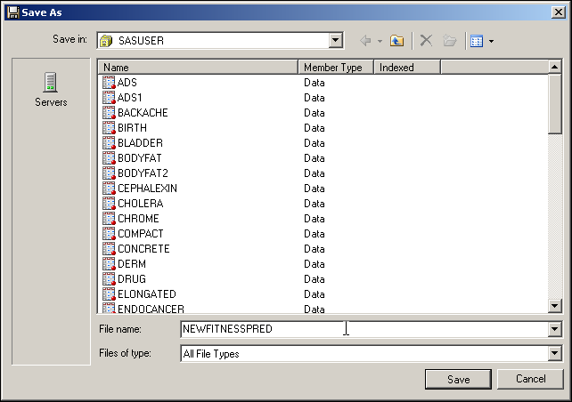
- Click to close that window.
- Click .
In the workspace, you will now see a tab for the newly created data set, NEWFITNESSPRED.
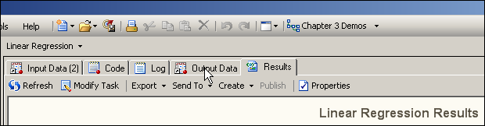
- Click that tab to reveal the data.
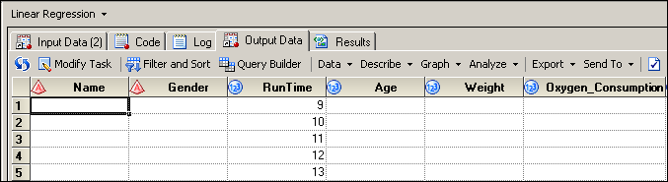
- Scroll all the way to the right to see the predictions column.
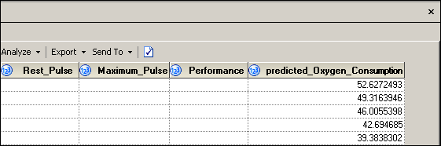
 The new data set contains columns for all variables in the analysis data set, but the values of each record are set to missing for those variables that either were missing or did not exist in the scoring data set. Also, note the 95% confidence limit for the prediction.
 Choose only values within or near the range of the predictor variable when you are predicting new values for the response variable. For this example, the values of the variable RunTime range from 8.17 to 14.03 minutes. Therefore, it is unwise to predict the value of Oxygen_Consumption for a RunTime of 18. The reason is that the relationship between the predictor variable and the response variable might be different beyond the range of your data.

An Additional Exercise

- Fitting a Simple Linear Regression Model
Use the BodyFat2 data set (the one created in the previous exercise) for this exercise.
  - Perform a simple linear regression model with PctBodyFat2 as the response variable and Abdomen as the predictor. Produce regression plots with confidence and prediction intervals.
    - What is the value of the F statistic and the associated p-value? How would you interpret this with regards to the null hypothesis?
    - Write out the predicted regression equation.
    - What is the value of the R² statistic? How would you interpret this?
  - Produce predicted values for PctBodyFat2 when Abdomen is 80, 100 and 120. The AbdomenPred data set in SASUSER contains the 3 observations needed.
    - What are the predicted values?
    - Is it appropriate to predict PctBodyFat2 when Abdomen is 140?

Fitting a Simple Linear Regression Model
  - Perform a simple linear regression model with PctBodyFat2 as the response variable and Abdomen as the predictor. Produce regression plots with confidence and prediction intervals.
- With the BodyFat2 data set selected, click Tasks ð Regression ð Linear Regression….
- Drag PctBodyFat2 to the dependent variable task role and Abdomen to the explanatory variables task role.
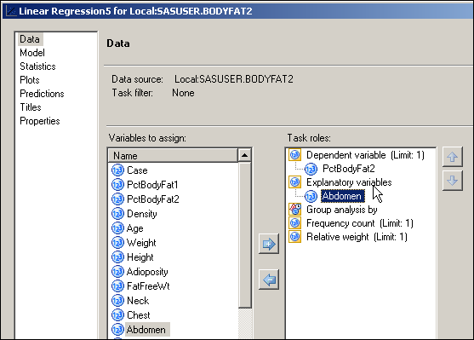
- With Plots selected at the right, select Custom list of plots under Show plots for regression analysis. From the menu that appears, uncheck the box for Diagnostic plots and check the box for Scatter plot with regression line.
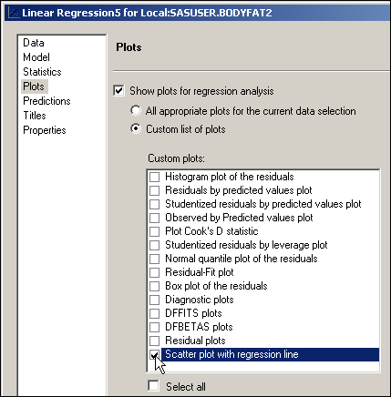

- Change the title, if desired.
- Click .

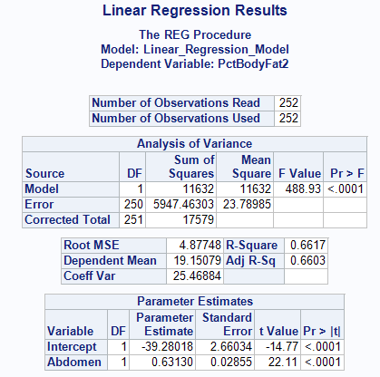

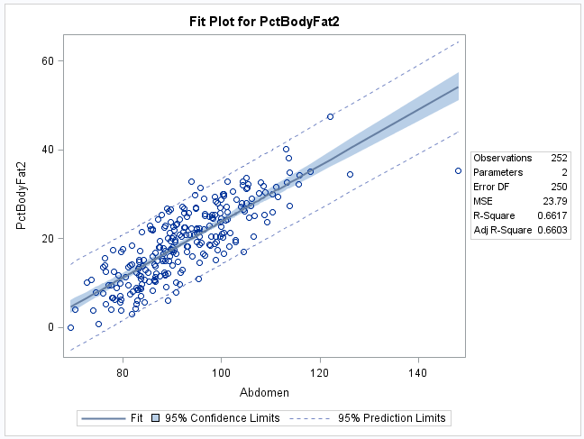
    - What is the value of the F statistic and the associated p-value? How would you interpret this with regards to the null hypothesis?
The F value is 488.93 and the p-value is <.0001. You would reject the null hypothesis
of no relationship.
    - Write out the predicted regression equation.
From the parameter estimates table, the predicted value of
PctBodyFat2 = -39.28018 + 0.63130 * Abdomen.
    - What is the value of the R² statistic value? How would you interpret this?
The R² value of 0.6617 can be interpreted to mean that 66.17% of the variability
in PctBodyFat2 can be explained by Abdomen.

  - Produce predicted values for PctBodyFat2 when Abdomen is 80, 100 and 120.
The AbdomenPred data set in SASUSER contains the 3 observations needed.
- Modify the previous Linear Regression task in the project.
- Uncheck the box for Show plots for regression analysis.
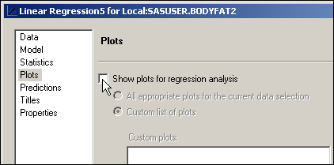
- With Predictions selected at the left, check the box for Additional data and Prediction limits.
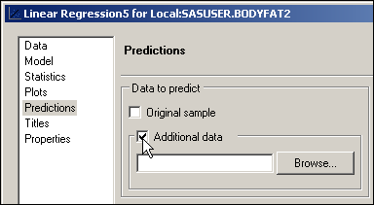
- Click .
- When the next window opens, select the AbdomenPred data set from the SASUSER library. Either double-click the name of the data set or highlight it and click .
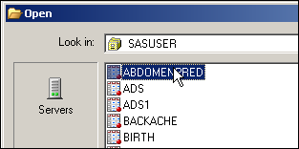
- Under Save output data, with Predictions checked, click .
- With that window open, overtype the default File name: with BODYFATPRED.
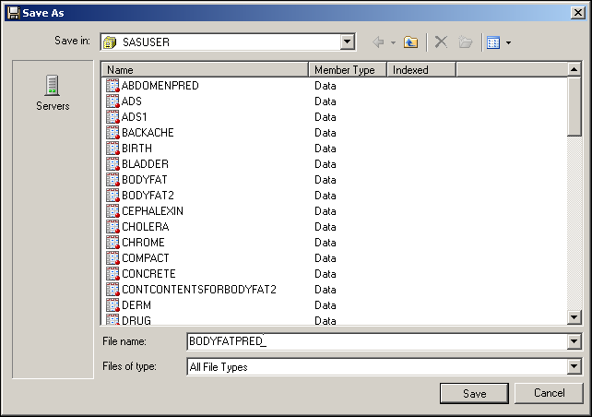
- Click to close that window.
- Click .
- In the workspace, you will now see a tab for the newly created data set. Click the tab to open the data table.
- Scroll to the right to see the predicted values for PctBodyFat2.
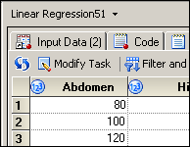…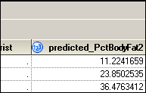
    - What are the predicted values?
The predicted values at Abdomen=80, 100 and 120, are 11.22, 23.85 and 36.48, respectively.
    - Is it appropriate to predict PctBodyFat2 when Abdomen is 160?
No, because there are no data in the model data set with Abdomen greater than 148.1. You should not predict beyond the range of your data.

