**Appending Tables in Teradata**

(2/5/2023)

**Sources**

Steve Nolan, Ron Freeze, Elizabeth Keiffer, Michael Gibbs, Matias Delay, Jorge Moreda, Ian Wegh

Enterprise Systems, Sam M. Walton College of Business, University of Arkansas, Fayetteville

Copyright © 2018 *For educational uses only - adapted from sources with permission. No part of this publication may be reproduced, stored in a retrieval system, or transmitted, in any form or by any means, electronic, mechanical, photocopying, or otherwise, without the prior written permission from the author/presenter.*

# Appending Tables in Teradata

Appending Tables in this set of instructions is not to be confused with the SQL commands **Join** or **union** which form atemporary link between sets of tables to retrieve desired associated information**.** This set of instructions moves all rows in a table and inserts them into a second table. The end result is one table that contains all rows from both tables. You must have been provided access to the University of Arkansas VMware system desktop and the credentials for Teradata to complete this tutorial.

Once logged into VMware, open the Start menu and type “Teradata Studio” in the search bar. Click open or press enter to start Teradata Studio.

**Step 1: Open Teradata Studio**

1. **Select:** Start Menu
2. **Type:** “Teradata Studio”
3. **Click:** Teradata Studio under Best match

## **Method 1: The Drag and Drop**

### **Step 1: Check Data Types and Total Rows.**

This method is found in the “Data Transfer tab” in the upper right of the screen.

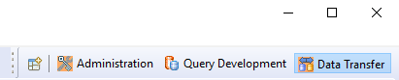

### **Step 2: Data Types**

Before you get started, open the columns file folder below each table you are going to add together. If the number of columns and data types do not match the system will show an error.

### **Step 3: Check current rows in your destination table**

1. **Right Click:** Destination Table

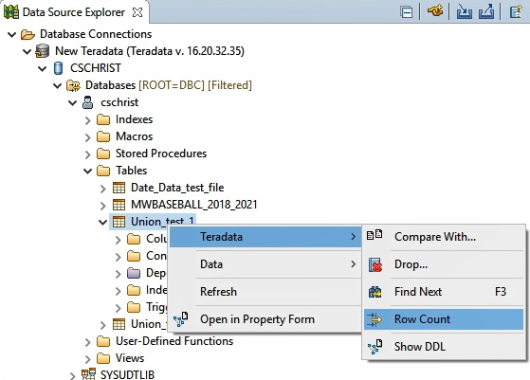

1. **Select:** Teradata > Row Count

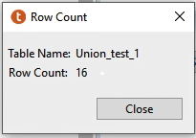The following Message will appear.

### **Step 4: Click and Drag**

1. **Select:** Desired File
2. **Drag:** To the file you want to add data
3. **Release:** On the file

In the example below, the Union_Test_4 is being added to the Union_Test_1.

### **Step 5: Copy Object Wizard**

The window that opens is an acknowledgement of **what table you are moving from** and to **what table you are moving to. Be sure to check if this is the right direction of transfer.**

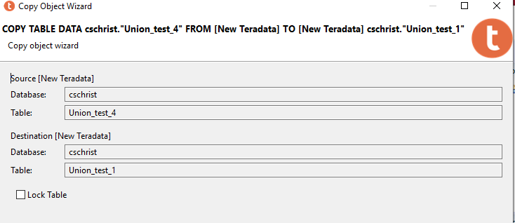

1. **Click:** Next if correct

### **Step 6: Column Specification Wizard**

If your columns do not match up between tables you can change the destination of the data in the name/type drop down menu, the select source allows value manipulation but it is important to remember the Data types must be the same to append the two tables.

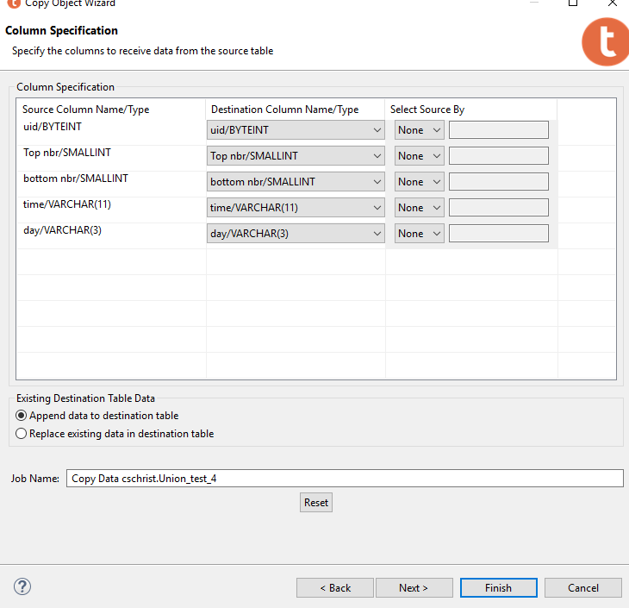The radio buttons under Existing Destination Table Data, either Append or Replace. Once data is replaced it is not recoverable.

1. **Click:** Finish

1. **Select:** OK

### **Step 7: Trouble Shooting errors**

In the transfer history view you will see if the job is successful with a status of “complete”. A status of Failure stopped the process at the first error.

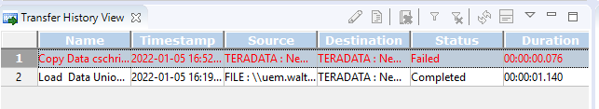



1. **Hover:** over this icon:

This icon is the “Show Job Output for the selected entry,” which produces (mostly) easy to interpret messages to fix transfer errors.

Example:

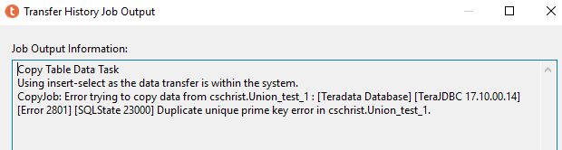

### **Step 8: Final Result**

Following the same operation in Step 1, Check current rows, and confirm there has been an appropriate increase in rows in the destination

## **Method 2: External Data Sources**

To update a table on Teradata with an external file from your Desktop, Network, or accessible drive (inside VMWare), there is a “Load” command to start the process.

This method is found in the “Data Transfer tab” in the upper right of the screen.



### **Step 1: Data Type and Row Count**

Data Types

1. **Open:** “column” in destination table

If the number of columns and data types do not match the table you are uploading, the database will throw an error.

****Row Count

1. **Right Click:** Destination Table
2. **Select:** Teradata > Row Count

The following Message will appear.



### **Step 2: Load Data**

1. **Right Click:** Destination Table
2. **Click:** Data
3. **Click:**  Load Data

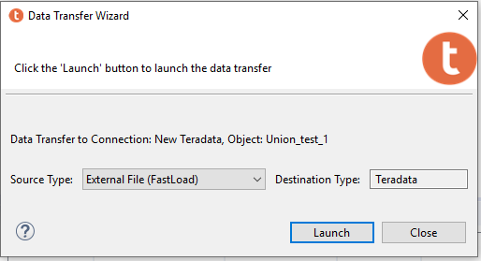The Data Transfer Wizard Will open

1. **Select Type:** External File (Fast Load)
2. **Click:** Launch

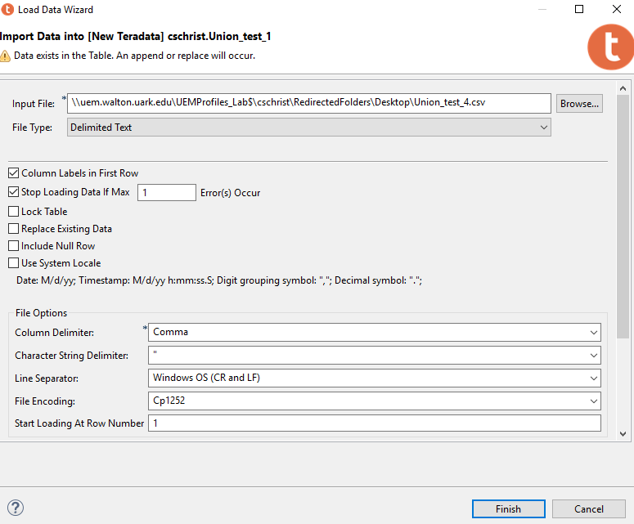Input File: use the browse button to locate the table you are appending to the destination file.

Check the Column labels in first row if labels are in the file you are appending.

Stop loading Data if Max [ 1 ] errors occur. If data is clean this works well, if not Teradata will point out data errors in the Transfer history view.

3. **Click:** Finish

### **Step 3: Trouble Shooting errors**

In the transfer history view you will see if the job is successful with a status of “complete”. A status of Failure stopped the process at the first error.



1. **Hover:** over this icon:

This icon is the “Show Job Output for the selected entry,” which produces (mostly) easy to interpret messages to fix transfer errors.

Example:



### **Step 4: Final Result**

Following the same operation in Step 1, Check current rows, and confirm there has been an appropriate increase in rows in the destination table.