Connecting MS Excel to Teradata

(2/5/2023)

Sources
Steve Nolan, Ron Freeze, Elizabeth Keiffer, Michael Gibbs, Matias Delay, Jorge Moreda, Ian Wegh
Enterprise Systems, Sam M. Walton College of Business, University of Arkansas, Fayetteville

Copyright © 2018 For educational uses only - adapted from sources with permission. No part of this publication may be reproduced, stored in a retrieval system, or transmitted, in any form or by any means, electronic, mechanical, photocopying, or otherwise, without the prior written permission from the author/presenter.

Connecting Excel to Teradata
Check with your instructor for the correct username and password to Teradata. You must have been provided access to the University of Arkansas VMware system desktop and the credentials for Teradata and Excel to complete this connection. Open the VMware client prior to step 1.

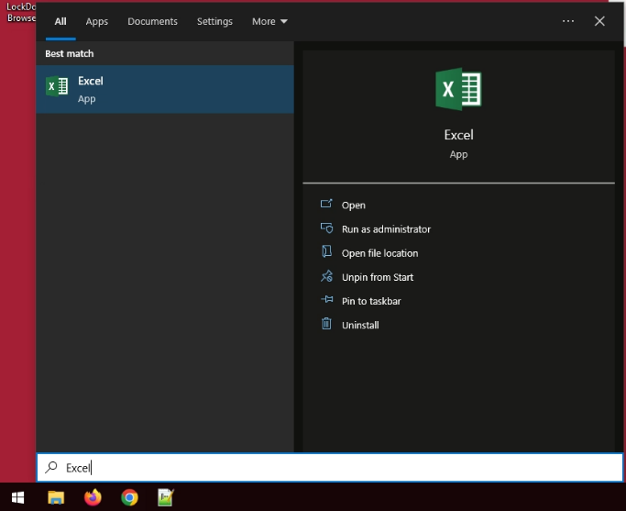
Step 1: Open Excel
- Select: Start menu
- Type: “Excel”
- Click: Excel under Best match

Step 2: Create Blank Workbook
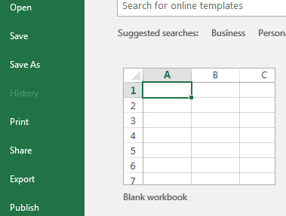

Step 2: In the ribbon Tabs Select “Data”

Step 3: Select “Get Data” Drop down menu
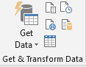

Step 4: Select From Database from the Dropdown Menu > From Teradata Database
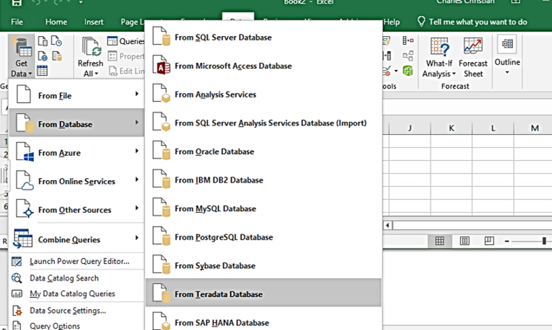

Step 5: Server Connection
- Server: ufoaifx.walton.uark.edu
- Click: OK

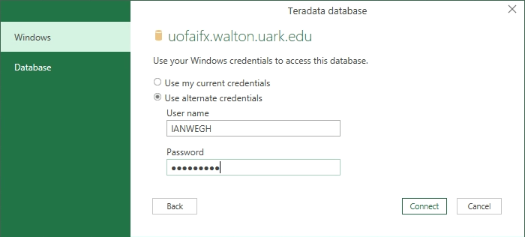
Step 6: Authentication Window
- Enter: Teradata Username
- Enter: Teradata Password

- Click: Connect

Step 7: Selecting Tables
Highlight the table you wish to open under the navigator menu. A sample of the data will appear on the right. In this example, we will be using the WCOB_RSC database and Batch_Production_Fact table.
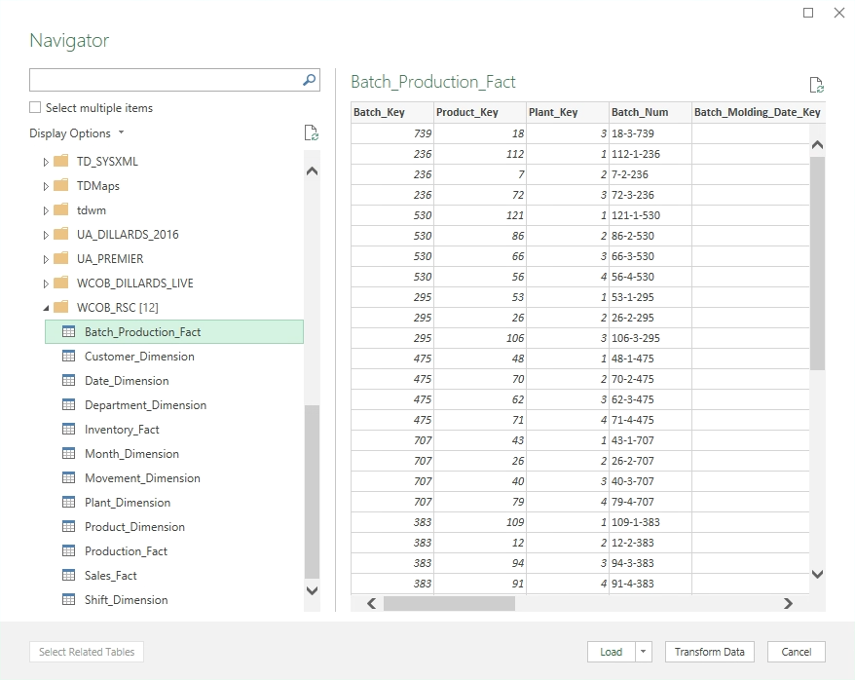
- Select: Load

Step 8: View End Results and Notes
If you used the Batch_Production_Fact table, your view should look identical. (!) Using Excel is not viable for larger data sets, but it can be used to create visuals or pivot tables for a snapshot of the data.
