Connecting Power BI to Teradata

(2/5/2023)

Sources
Steve Nolan, Ron Freeze, Elizabeth Keiffer, Michael Gibbs, Matias Delay, Jorge Moreda, Ian Wegh
Enterprise Systems, Sam M. Walton College of Business, University of Arkansas, Fayetteville

Copyright © 2018 For educational uses only - adapted from sources with permission. No part of this publication may be reproduced, stored in a retrieval system, or transmitted, in any form or by any means, electronic, mechanical, photocopying, or otherwise, without the prior written permission from the author/presenter.

Connecting Power BI to Teradata
You must have been provided access to the University of Arkansas VMware system desktop and the credentials for Teradata and Power BI to complete this connection. You must be in VMware prior to completing step 1.

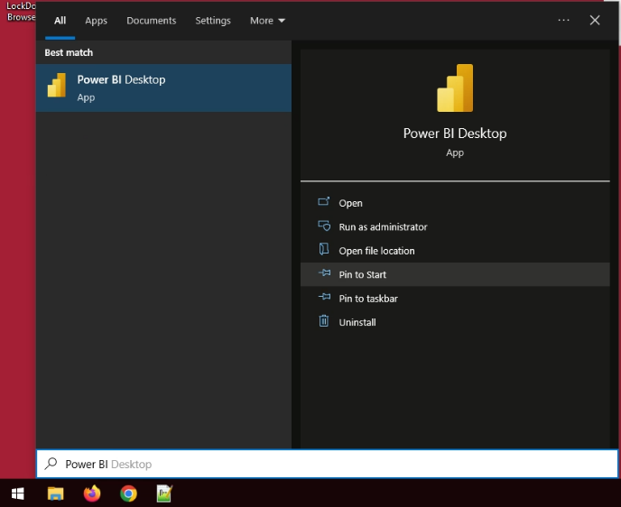
Step 1: Open Power BI
- Select: Start menu
- Type: “Power BI”
- Click: Power BI Desktop under
Best match

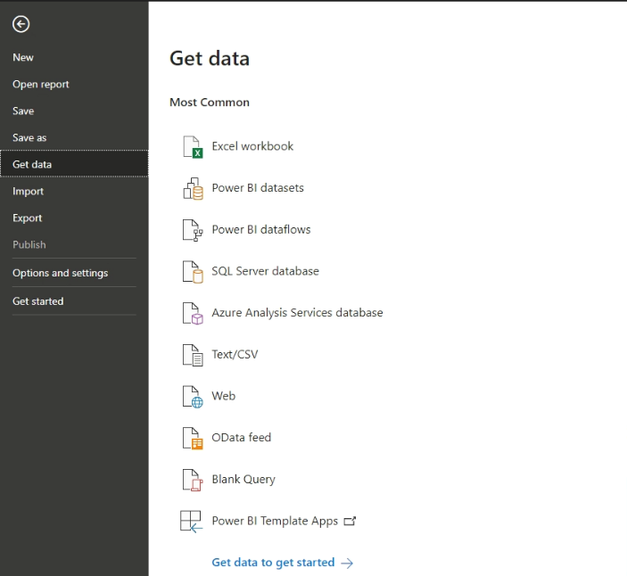
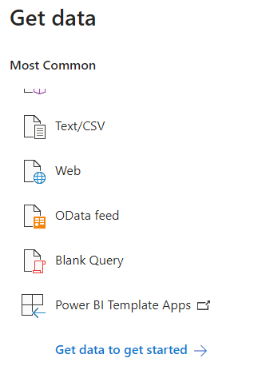
Step 2: “Get Data” Window
- Select: File

- Select: Get data

- Select: Get data to get started

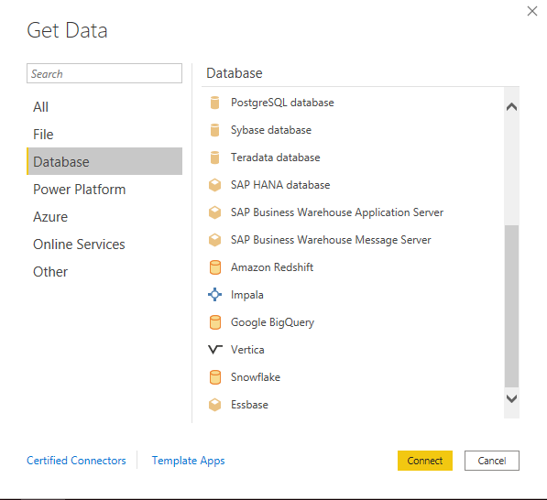
From the Database menu,
- Select: Database

- Select: Teradata Database

- Select: Connect

Step 3: Connecting to Teradata
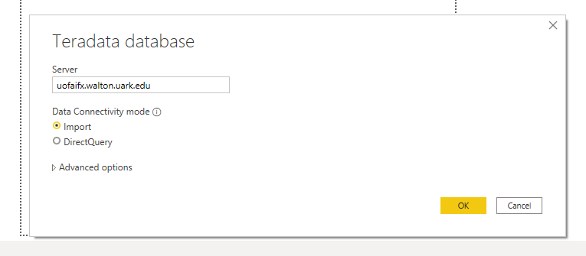
Fill in the following authentication information in the Teradata database window
- Server: uofaifx.walton.uark.edu
Choose your Data Connectivity Mode
Import: Pulls all data locally.
Direct Query: Works by leaving Data on the Teradata server and pulling data when needed for modeling.

- Click: OK

Step 4: Authentication Credentials
Windows Menu: This Window builds a connection profile.
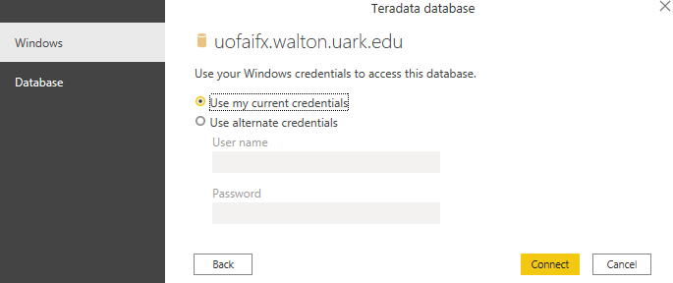
- Click: Database

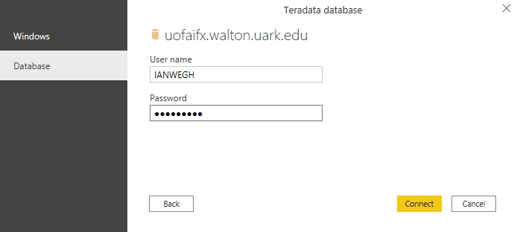
Data Base Menu: Teradata Credentials
- Username: Teradata username
- Password: Teradata password

- Click: Connect

Step 5: Navigator Window
If all credentials are correct the Navigator Window opens:
In this example, we will be using the WCOB_RSC database and Batch_Production_Fact table.
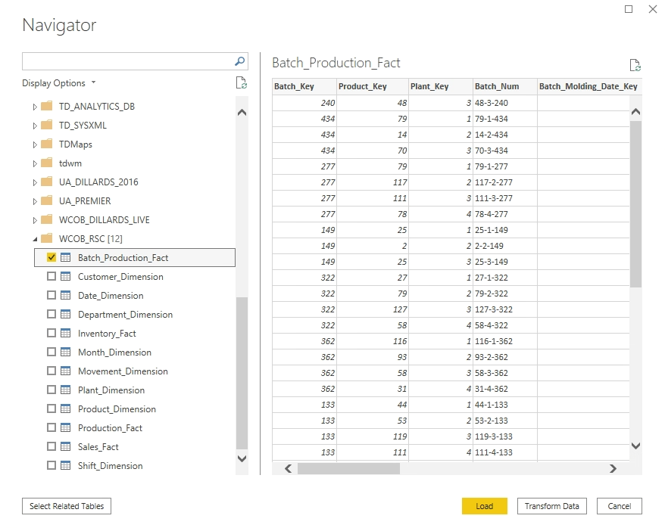
- Select: Batch_Production_Fact
- Select: Load

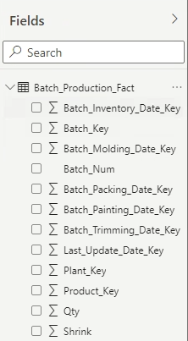
Step 6: End Results
Data loaded to the application can be seen
in the Fields Pane on the right side of the workspace.
Variables can be selected by checking the Variable.

