Connecting SAS_EG to Teradata

(2/5/2023)

Sources
Steve Nolan, Ron Freeze, Elizabeth Keiffer, Michael Gibbs, Matias Delay, Jorge Moreda, Ian Wegh
Enterprise Systems, Sam M. Walton College of Business, University of Arkansas, Fayetteville

Copyright © 2018 For educational uses only - adapted from sources with permission. No part of this publication may be reproduced, stored in a retrieval system, or transmitted, in any form or by any means, electronic, mechanical, photocopying, or otherwise, without the prior written permission from the author/presenter.

Connecting SAS_EG to Teradata
You must have been provided access to the University of Arkansas VMware system desktop and the credentials for Teradata and SAS_EG to complete this connection. You must be in VMware to complete this connection.

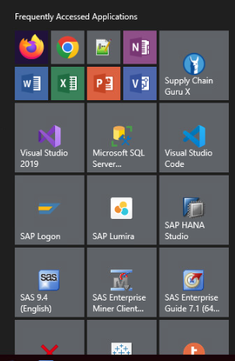
Step 1: Open SAS_EG
- Select: Windows start menu
- Select: SAS Enterprise Guide 7.1.

Step 2: Create Project Library
- Open: Tools menu
- Select: Assign Project Library

Step 3: Library Wizard 1 of 4
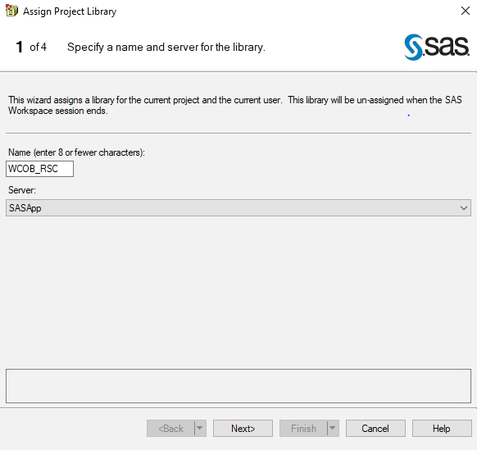
- Name: 8 characters
- Select: Server Drop down
- Select: SASApp
- Click: Next

In this example, I named the project Library WCOB_RSC because that is the database we will be dealing with.

Step 4: Library Wizard 2 of 4
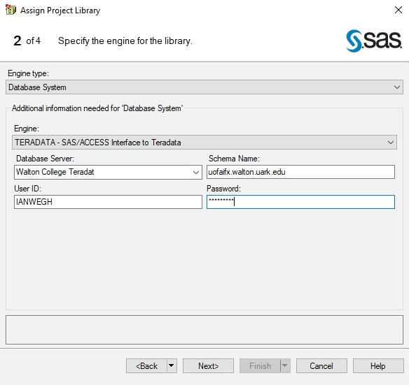
- Click: Engine type drop-down list
- Select: Database System
- Click: Engine drop-down list
- Select: Teradata-SAS/Access to Teradata
- Click: Database Server drop-down list
- Select: Walton College Teradata
- Schema Name: Database connection name
- User_ID: Teradata User ID
- Password: Teradata password
- Click: Next

Step 5: Library Wizard 3 of 4
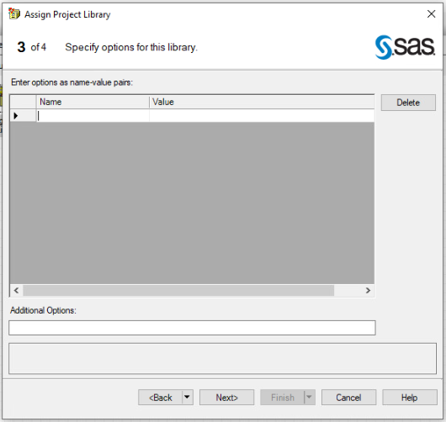
- Click: Next

Step 6: Library Wizard 4 of 4
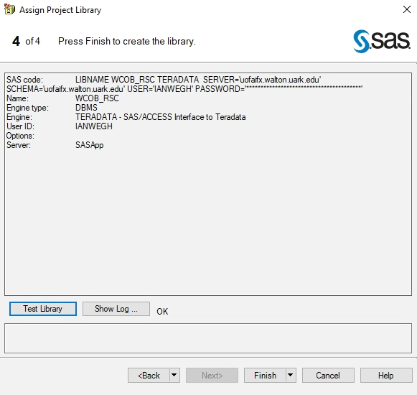
- Select: Test Library

“OK” will appear if the connect works.
- Click: Finish
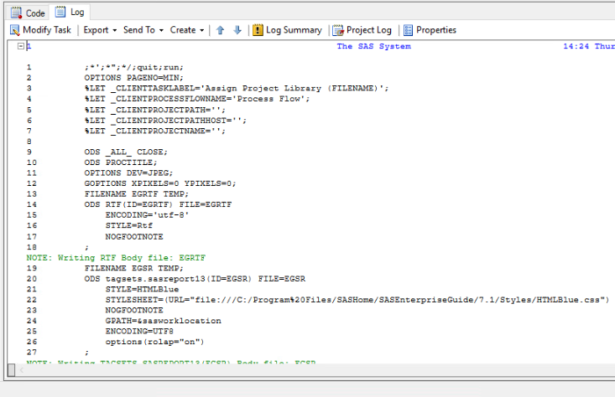

SAS_EG will run the following script.

Step 7: Finding the library Connection
To Change the SAS Folders menu to Servers Menu,
- Select: Server icon
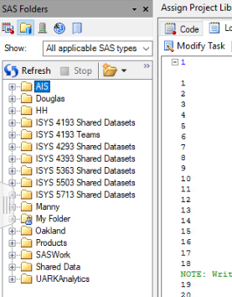
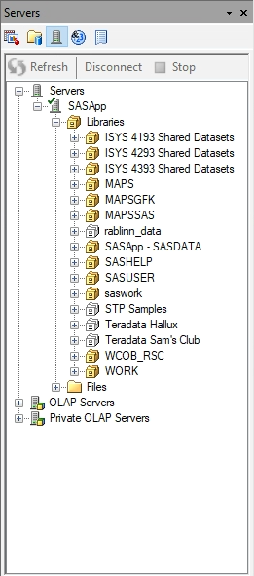

The file directory WCOB_RSC that was created in step 3 should be viewable after clicking the server icon.

