Connecting SAS_Viya to Teradata

(2/5/2023)

Sources
Steve Nolan, Ron Freeze, Elizabeth Keiffer, Michael Gibbs, Matias Delay, Jorge Moreda, Ian Wegh
Enterprise Systems, Sam M. Walton College of Business, University of Arkansas, Fayetteville

Copyright © 2018 For educational uses only - adapted from sources with permission. No part of this publication may be reproduced, stored in a retrieval system, or transmitted, in any form or by any means, electronic, mechanical, photocopying, or otherwise, without the prior written permission from the author/presenter.

Connecting SAS_Viya to Teradata
You must have been provided access to the University of Arkansas VMware system desktop and the credentials for Teradata and SAS Viya to complete this connection.
Once logged on to VMware, open Google Chrome and enter the following URL: https://viya.walton.uark.edu/SASDrive

Step 1: SAS_Viya Log on
- User ID: UARK provided ID
- Password: UARK Password

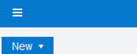
Step 2: Connecting to Teradata
To retrieve Data from the Teradata server you must create a connection to Teradata. Once authenticated,
- Select: The 3 white lines in the top left corner

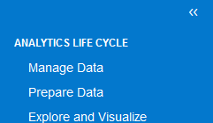
- Select: Manage Data

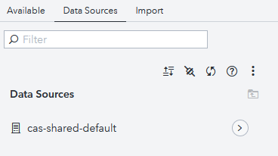
- Select: Data Sources
- Select: The ”connect” Icon:

After selecting the “connect” icon, you will be directed to the Connection Settings Window. For this example, we are connecting to the first database submitted for Article 1 in Issue 1. Each field that needs to be filled is in the picture. NOTE: The database and Schema name must be the same.
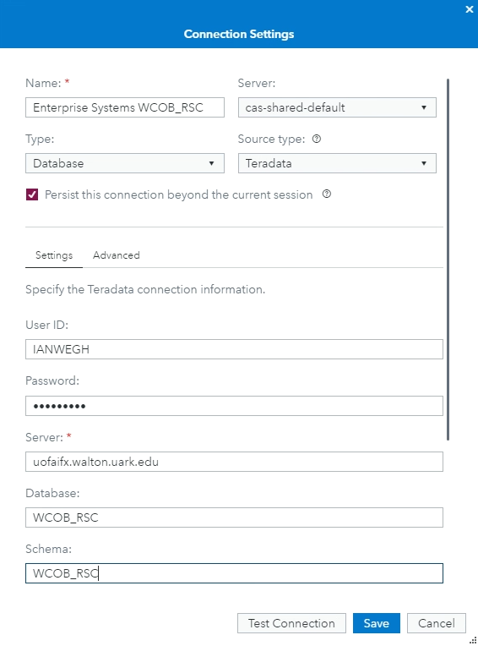
- Name: Enterprise Systems WCOB_RSC
- Server: cas-shared-default
- Type: Database
- Source Type: Teradata
- Persist Connection: Saves for next logon
- Advanced: No advanced changes
- User ID: Teradata logon name
- Password: Teradata password
- Server: uofaifx.walton.uark.edu
- Database name: WCOB_RSC
- Schema: WCOB_RSC

- Click: Test Connection
A successful connection will have the following message at the top of the window:
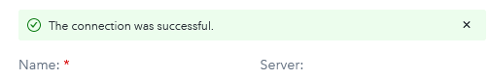

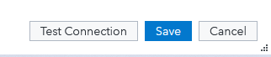
Save the connection
- Select: Save

Step 3: Accessing the Data
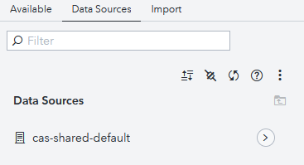
You have now created a connection to the database located in Teradata. In order to create reports and analyze the data, you will need to navigate to your connection and lift the data into the SAS VIYA memory. Your connection was created in the cas-shared-default CASLib. Navigate to your connection.
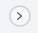
- Select: Data Sources tab and the arrow icon next to cas-shared-default
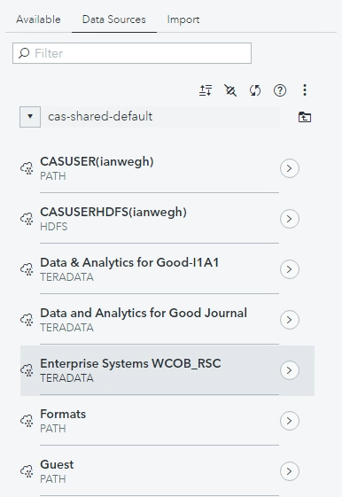
A menu directory will open. Remember what you created was a connection to Teradata. The data does not reside in SAS VIYA until you load the data into memory.
- Open: By clicking the
arrow next to your database.

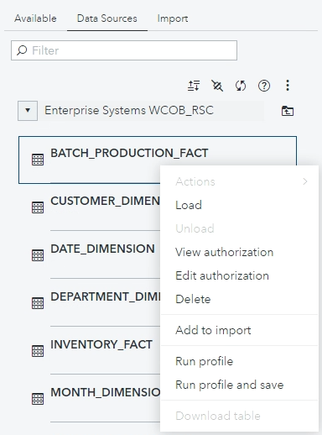
Step 4: Viewing Data
In order to load the data into SAS VIYA memory, you will need to find your desired table. For this example, I1A1 has 6 tables. We will select the HIVE table in order to load the table In-Memory.
- Right Click: Batch_Production_Fact
- Select: Load

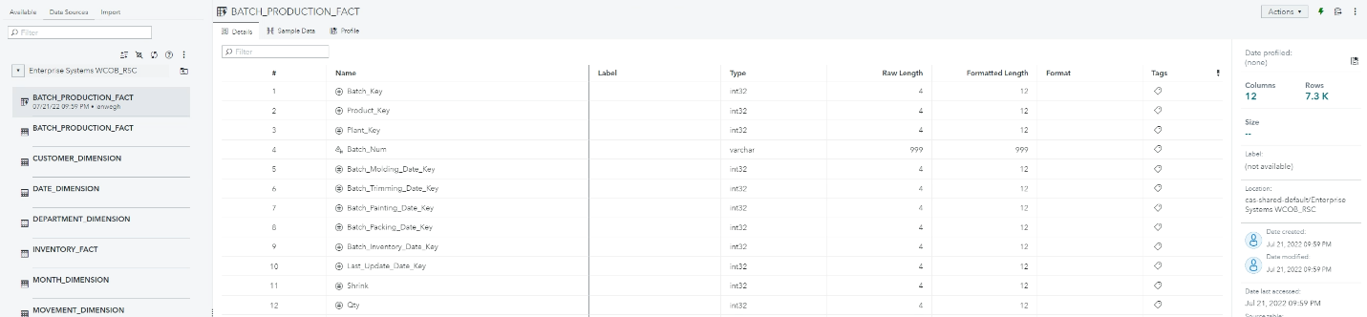
You can tell your table has been successfully loaded into memory if you see the lightning bolt. You will also see 2 instances of your table. One with a lightning bolt and one without. Once your table (BATCH_PRODUCTION_FIRST) has been loaded In-Memory, you will be able to see how many records are in your table. In this example, HIVE has 2,100 rows. You are now ready to begin creating reports on your data.

