Connecting Tableau to Teradata

(2/5/2023)

Sources
Steve Nolan, Ron Freeze, Elizabeth Keiffer, Michael Gibbs, Matias Delay, Jorge Moreda, Ian Wegh
Enterprise Systems, Sam M. Walton College of Business, University of Arkansas, Fayetteville

Copyright © 2018 For educational uses only - adapted from sources with permission. No part of this publication may be reproduced, stored in a retrieval system, or transmitted, in any form or by any means, electronic, mechanical, photocopying, or otherwise, without the prior written permission from the author/presenter.

Connecting Tableau to Teradata
You must have been provided access to the University of Arkansas VMware system desktop and the credentials for Teradata to complete this connection. In this example, you will be shown how to connect to your personal database in Teradata from Tableau. You must be in VMware before completing step 1.

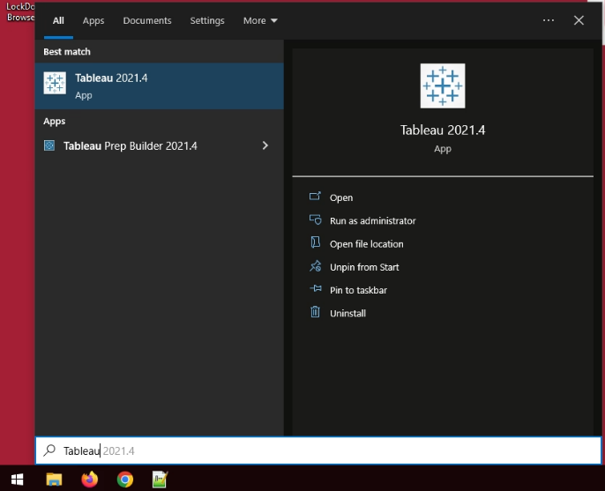
Step 1: Open Tableau
- Select: Start menu
- Type: “Tableau”
- Click: Tableau under Best match

Step 2: Find Teradata
- Select: “More…>” under to a server
- Select: Teradata
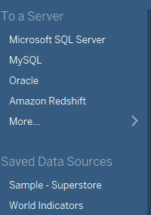

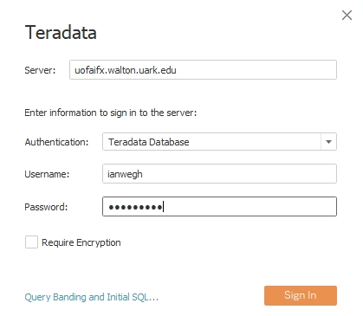
Step 3: Connecting to Teradata
Fill in the following authentication information:
- Server: uofaifx.walton.uark.edu

- Username: Teradata username
- Password: Teradata password

- Select: Sign In

Step 4: Retrieving Tables
If your connection to the server is successful, it will appear in the Connection’s menu and in the work area to the right of the menu.
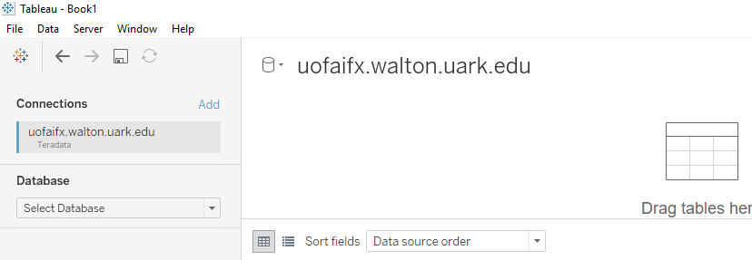
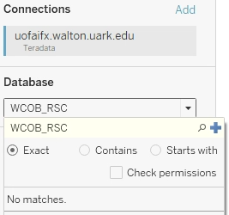
- Select: Select Database drop-down menu
- Enter: Database connection name
In this case, the database connection name is WCOB_RSC
- Select: when done

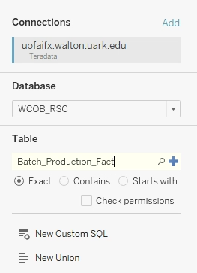
The “Table” selection pane will appear below the “Connections” selection pane.
- Enter: Table name within database
In this case, the table name is Batch_Production_Fact
- Select: when done

Step 5: Live or Extract
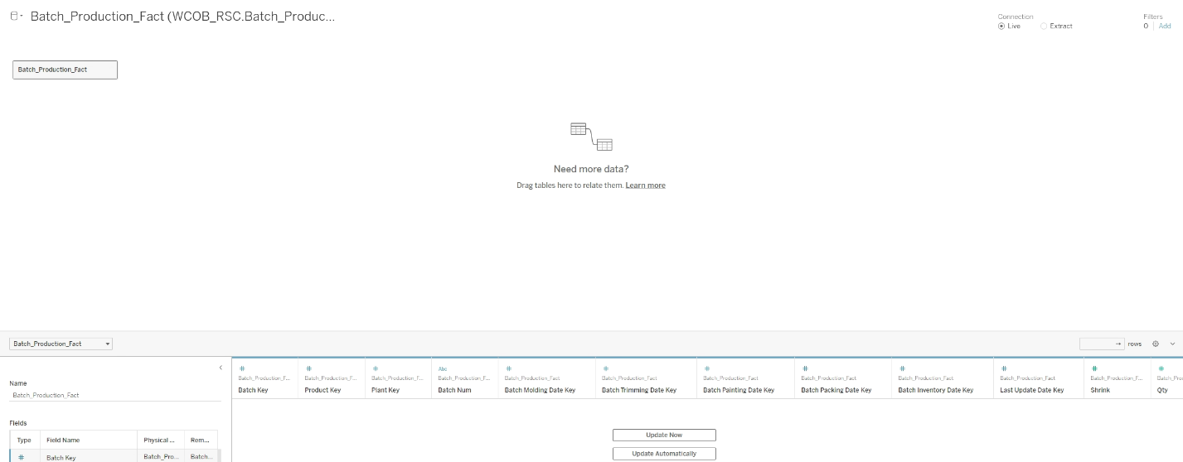
After clicking the Blue Plus sign, the tables will be loaded

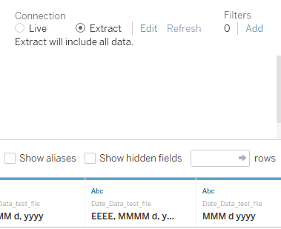
Live Data is working with Data housed on the Teradata server. This is useful/necessary when modeling Large Data Sets. It is important to note that your connection may time out while spending hours in the data set with a live connection. Just reconnect from Tableau to continue.
Extract Data is working with data you move to your local machine (local Virtual Desktop). It is faster to work with and portable, but larger data sets can crash Tableau used in this way. If you select extract, Tableau will prompt you to save the data locally when you select Sheet 1 to begin modeling.

Step 6: End View Results
Remember: Tableau is a modeling tool; it does not change the original data on Teradata. Any calculated fields created will remain inside the Tableau work sheet.
