Connecting to Teradata

(8/25/2022)

Sources
Steve Nolan, Ron Freeze, Elizabeth Keiffer, Michael Gibbs, Matias Delay, Jorge Moreda, Ian Wegh
Enterprise Systems, Sam M. Walton College of Business, University of Arkansas, Fayetteville

Copyright © 2018 For educational uses only - adapted from sources with permission. No part of this publication may be reproduced, stored in a retrieval system, or transmitted, in any form or by any means, electronic, mechanical, photocopying, or otherwise, without the prior written permission from the author/presenter.

Access to Teradata.
You must have been provided access to the University of Arkansas VMware system desktop. It is important that you have the correct login credentials and that you understand your level of provided access before starting this tutorial. To begin, open Teradata Studio and log into the server.

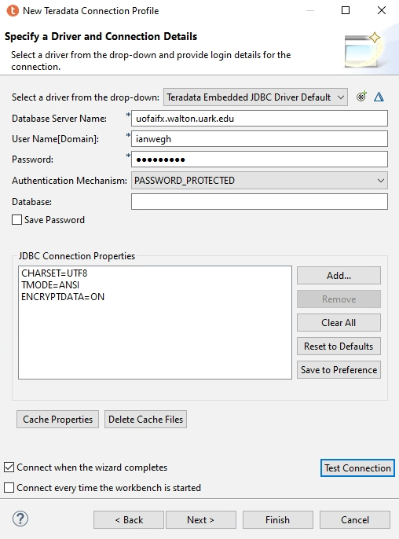
Step 1: Opening Teradata Studio
Open Teradata Studio from your Start menu in VMware or through the virtual desktop access in your browser. To log into the server, we must create a new connection profile first.
- Click:
- Database Server Name: uofaifx.walton.uark.edu
- User Name(Domain): Teradata username
- Password: Teradata password

- Click: Test Connection

- Press: Finish (if connection successful)

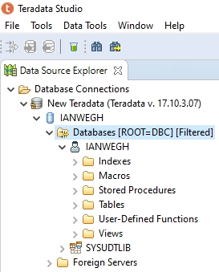
Your view of Teradata should be similar to image on the left. Depending on the level of access, you may see many more folders other than your personal database sets. The view to the right is an example to get you through the connection tutorials.

