Database Connection & Joining Tables

Use Case – RSC
Rubber Squeezy Chickens (RSC) is fictional company created by the Walton College of Business to mimic a real manufacturing company. The database contains 12 tables and over 4,000 rows of data to work with, focusing on production of rubber squeezy chickens. Below is the ERD model for the WCOB_RSC dataset.
The purpose of this tutorial is to learn how to connect to the Teradata server as well as joining two tables from the WCOB_RSC dataset in SAS Viya. By joining, you are combining the columns of two tables into a new table. It is built from a common variable (primary &/or foreign key) that is present in both tables.
The assumption is that you have the credentials to connect to SAS Viya and Teradata. The tutorial starts once you log into Viya.

SAS Viya:
A tutorial on how to log in can be found here: https://walton.uark.edu/enterprise/exercises-usecases-labs/index.php
Under the SAS Viya section, select “VIYA VA 01 – Logging_into_the_system.docx”

The ERD model below shows all the tables contained in the WCOB_RSC dataset. For this tutorial’s purpose, we are only going to be looking at two of the tables (Sales_Fact and Customer_Dimension). There are many combinations of joins that could be made.
Sources
Ron Freeze, Bowen Kinsey
Enterprise Systems, Sam M. Walton College of Business, University of Arkansas, Fayetteville
SAS® VIYA 8.2 Release V03

Copyright © 2021 For educational uses only - adapted from sources with permission. No part of this publication may be reproduced, stored in a retrieval system, or transmitted, in any form or by any means, electronic, mechanical, photocopying, or otherwise, without the prior written permission from the author/presenter.

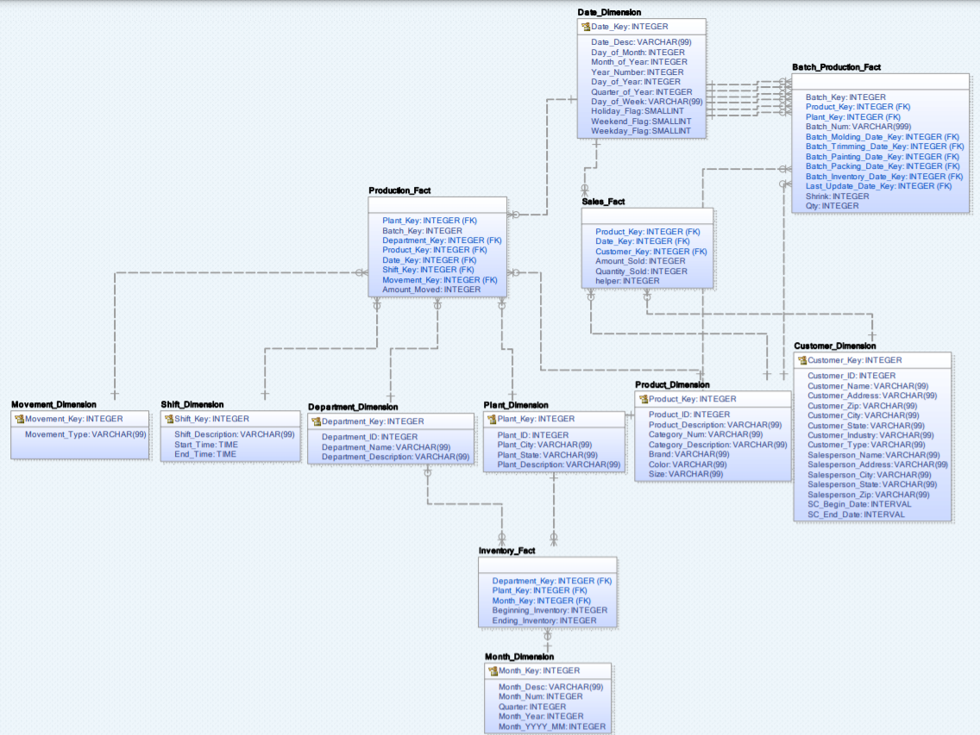
Connecting to WCOB_RSC
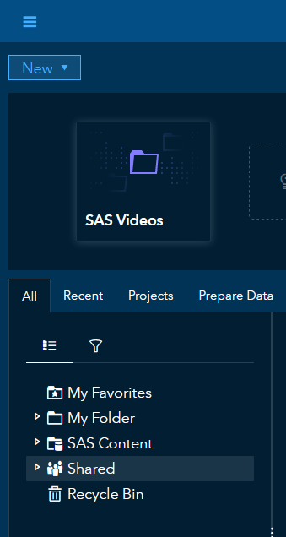
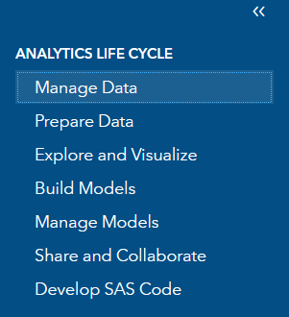
1

Step 1: Get to Data Source
- Open up your “manage data”
- Click on “Data Sources”
- Open “cas-shared-default”
- Click on the “connect” option
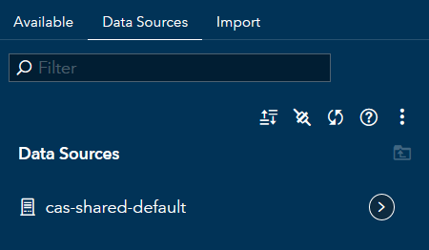
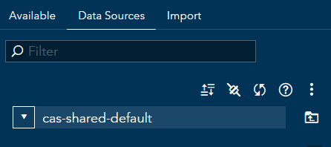
2
3
4

Step 2: Enter Instructor Provided Data
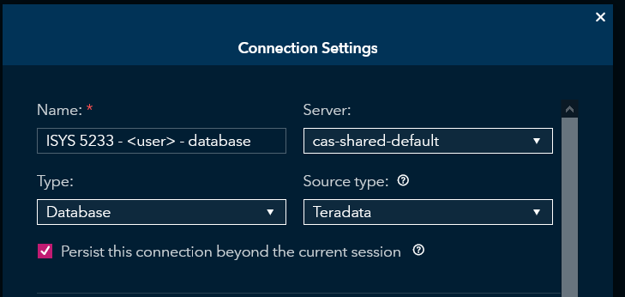
Name: ISYS 5233 - <youruser name> - yourdatabase name
- Server: cas-shared-default
- Type: Database
* (you must select “Database” first or the “Teradata” option will not be available under source type) *

- Source Type: Teradata
- Persist…: Check the box to persist your connection
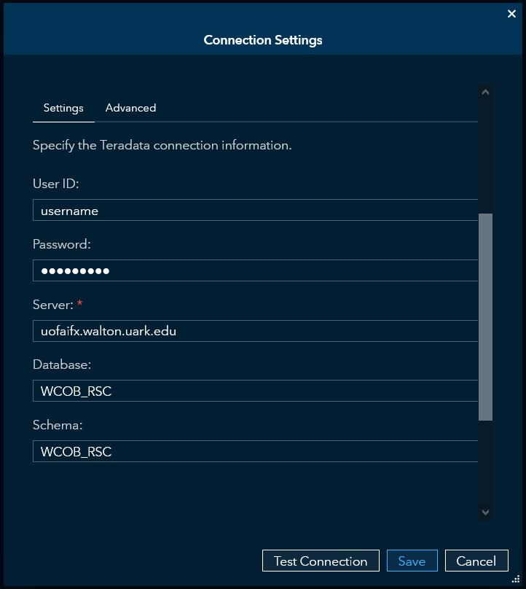

- User ID: <your username>
- Password: your password
- Server: uofaifx.Walton.uark.edu
- Database: WCOB_RSC
- Schema: WCOB_RSC
Database and Schema need to be exactly the same

Step 3: Test Connection
At the bottom, click test connection
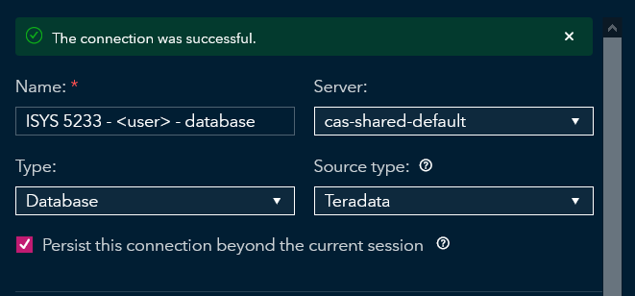
If everything was entered correctly you should see the following message:

If successful, hit save. If unsuccessful, double check all the information entered for spelling errors.

Using the Connection
Now that we have made the connection, we will be stepping forward with report creation to look at the outcome of the join.

Step 1: Load Sales_Fact into Memory
- Select the drop-down menu located in the top left
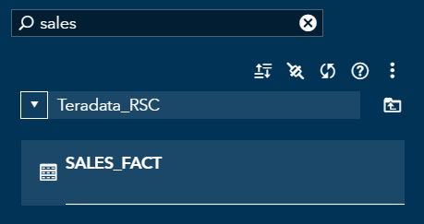
- Select “Manage Data” from the menu

- Use the filter to find the “Sales_Fact” table

- In the top right, select the lightning bolt to load it into memory. After this is done the actions drop down should become available

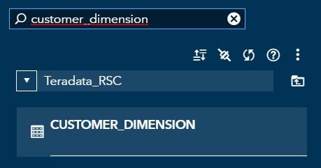
Step 2: Load Customer_Dimension into Memory
- Use the filter to find the “Customer_Dimension” table

- In the top right, select the lightning bolt to load it into memory. After this is done the actions drop down should become available

Step 3: Set up the Join
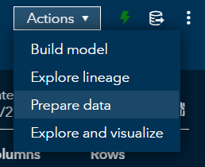
- Select the “SALES_FACT” table from your loaded data (the one with lightning bolt) and on the right side of the screen, select “Prepare Data” from the “Actions” drop down menu
Note: Sales_Fact is the primary table, meaning we need to attach customers to each sales fact. One customer will be attached to multiple sales facts.

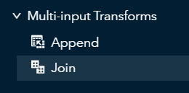
- Double click the “Join” option under the “Multi-input Transforms” section

- Select the following icon by Table T2

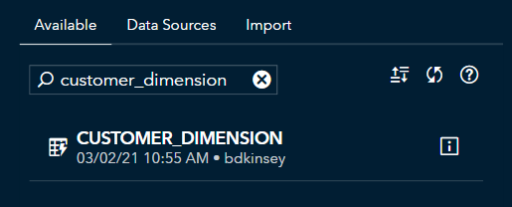
- Use the filter to find the “CUSTOMER_DIMENSION” loaded data set (with the lightning bolt) and hit the “OK” button in the bottom right

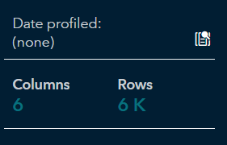
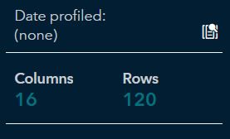
Note: When looking at the “SALES_FACT” table and “CUSTOMER_DIMENSION” table, note that sales fact has 6K rows and customer dimension has 120 rows. When the tables are joined, you should have 6K rows in your new table.
SALES_FACT table
CUSTOMER_DIMENSION table

Step 4: Variable Selections
- The join table should look like the image below. At the bottom of the section, select the “OK” option to continue to the next step
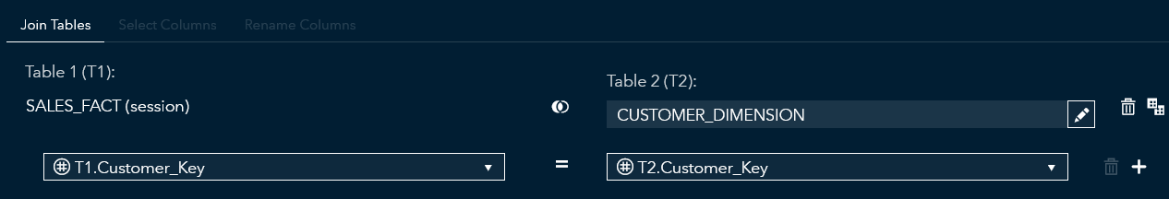
The two keys being joined are “Customer_Key” from “SALES_FACT” and “Customer_Key” from “CUSTOMER_DIMENSION”

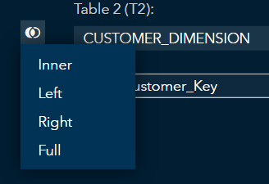
Note 1: What type of join you select next to “CUSTOMER_DIMENSION” (Inner, Left, Right, or Full) will determine how much of the data from each table is brought into the join. Sales_Fact is the primary table and represented by the filled circle on the left side of the join. A left join was chosen to join customer information (2nd table) to the appropriate sales facts (1st table) while keeping all the sales fact data.
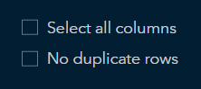
Note 2: You can also select specific variables in each table when joining the two tables. First, deselect the “select all columns” option. Then at the top, you can click on “Select Columns” to choose which variables you would want. For this tutorial we are selecting all columns.
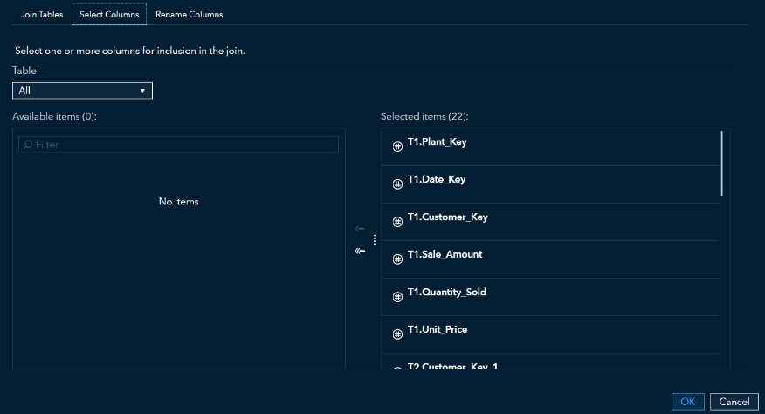

From here, you can select which variables you want to add into the join.

Step 5: Run the Join
- Select “Run” to join the tables
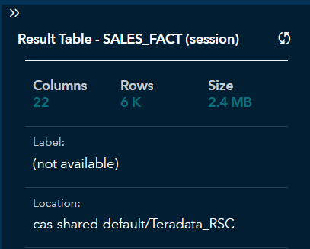
If done successfully, the number of columns should be the total of both tables columns added together (in this case 6 from sales fact and 16 from customer dimension) and the number of rows in the resulting table should be the same number of rows as the “SALES_FACT” table

Congratulations! You have joined two tables in SAS Viya

