

Data Mining with IBM SPSS Modeler 14.2
University of Arkansas
David Douglas

Association Analysis
Notes on Association Analysis using IBM SPSS Modeler 14.2

Association Rules Using Clementine

IBM SPSS Modeler 14.2 has three different algorithms for generating association rules. Input data format can be either tabular or transactional. The models are:

- Apriori – all data must be categorical
- Carma – categorical consequents but can have numeric inputs
- Sequential – sequential association rules

Apriori also produces association rules in a very efficient manner. It also has the advantage of having options that provide choices in the criterion measurements used to guide detecting the rules. However, it has a major disadvantage in that only categorical (symbolic) fields are allowed as inputs.

Carma, unlike GRI and Apriori, offers options for rule detection that includes support for both the antecedent and the consequence; plus it handles data in transaction format. Additionally, it allows rules with multiple consequents, or outcome and is not limited to categorical data.

Sequential association analysis takes into account the sequence of events. It works with either transaction or table data.

Notes on Data Formats for Association Analysis
Market basket is a natural for association analysis and there are two general formats of data representation for market basket analysis. The first is sometimes referred to as the transactional data format and the second is the tabular data format. The transactional data format requires only two fields—an id field and a content field. For example (ignore quantities purchased for now),

Transaction ID Items
- Broccoli
1 Green Peppers
1 Corn
2 Asparagus
2 Squash
2 Corn
3 Corn
3 Tomatoes
… …

Note in this case that a single transaction requires several records. SAS EM 6.1 requires this format, unless you have its data warehousing software—which we do not have.

In the tabular data format, each record is a transaction (also ignoring quantities purchased for now) and a flag (0/1 or T/F) to represent a purchase or not. For example,

Trans Id | Asparagus | Beans | Broccoli | Corn | Green Peppers | Squash | Tomatoes
1 | 0 | 0 | 1 | 1 | 1 | 0 | 0
2 | 1 | 0 | 0 | 1 | 0 | 1 | 0
3 | 0 | 1 | 0 | 1 | 0 | 1 | 1
…
…
…
n | 1 | 1 | 0 | 0 | 1 | 0 | 1

Note that this data format can become very cumbersome for a large number of products and a large number of transactions—and will typically be a very sparse matrix. Thus, two approaches for mining a large number of transactions with a large number of products are generally taken.

- SQL will be used to create a transaction data format file that will be used for the market basket association analysis
- A software product will be used that does in-database data mining

IBM SPSS Modeler 14.2 does in-database mining via ODBC and with database vendors’ products. For example, IBM SPSS Modeler 14.2 can be used for in-database data mining for DB2 and likewise works with SQL Server and Oracle.

IBM SPSS Modeler 14.2 for Association Analysis
Aprori & Carma Model in Tabular Format

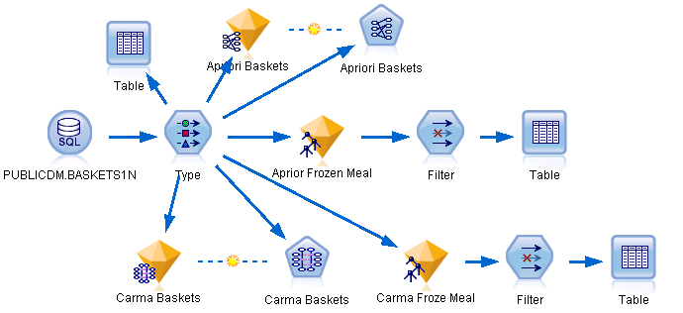

The Aprori model will be illustrated first. Place an Excel node on the model canvas as shown above, open the edit window and import the Baskets1n.xls file. Click the Types tab and click the Read Values button. Add a Type node and connect the Excel node to the Type node. Remember to click the Read Values button on the Type tab of the Excel node. Edit the Type node and do the following:
- Set the CardId variable Direction to None
- Set all the Continuous variables’ Direction to input
- Set all the food categorical (Flag) variables’ to Both

See the settings below.
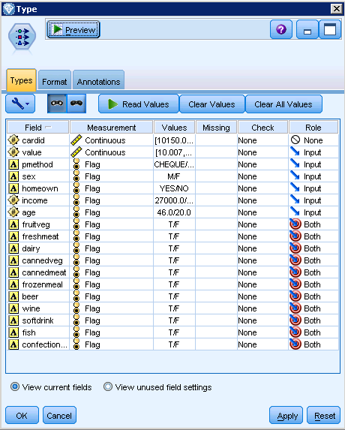

Open the Aprori Baskets node—shown below. Recall that the Aprori model requires all variables be categorical.

This example provides a custom name set in the Annotations tab. In the Fields tab, set the categorical variables that are possible for the Consequents. Note that pmethod, sex, homeown, income and age would not be a consequent---but could be an antecedent.

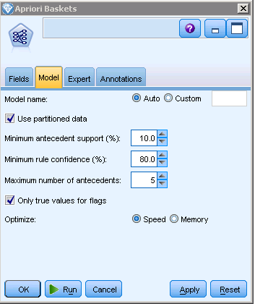
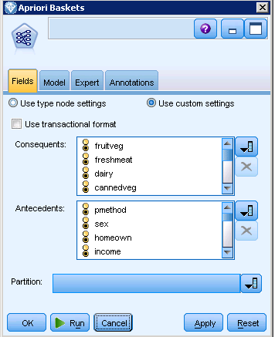

Click the Model tab. A number of options are available for the modeler to adjust as appropriate. First is the Minimum antecedent support. Increasing this value will result in fewer rules as will increasing the Minimum rule confidence. In this case, the Maximum number of antecedents has been set to 5. Execute the Apriri Baskets node. Double-click the model nugget to review the results.

First note that the Consequent and Antecedent columns. The first rule says that males the buy beer and frozen meals also buy canned vegetables 95.27% of the time. Support for this rule is also displayed--14.8. Note that the rules are sorted by the Confidence column—you may wish to sort on a different column. Also, the Show/Hide Criteria Menu allows more data to be shown. The bottom two menu options are Show all and Hide all. Select the Show all option.

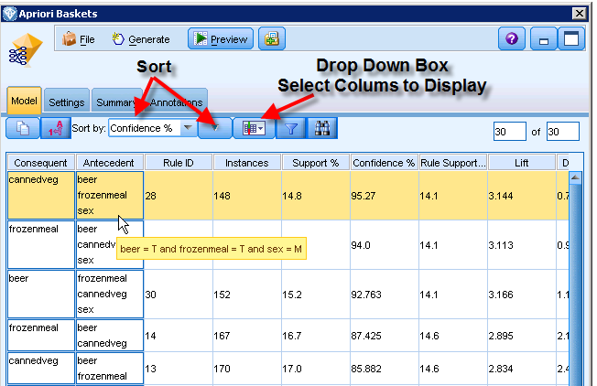

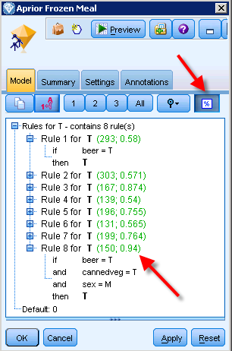
Lift means the same here as in other models. Click the Generate menu option and select the Rule Set.

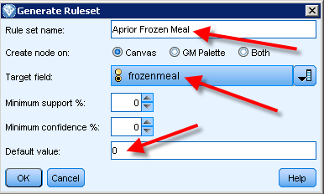

This example has been given the Rule set name of Aprori Frozen Meal, the Target field is set to frozenmeal and the Default value has been set to 0. Click the OK button and the generated rule set node will be placed on the upper left of the stream canvas. Drag the generated model the right of the Type node and connect the Type node to it.

Open the generated rule set node. Recall that this set of rules has a target field or variable of frozenmeal. For this target, there are 8 rules—rule 1 indicates that if one buys beer, then they will also buy frozen meals 58% of the time. Locate rule 8 which has a 94% probability. Males that buy beer and canned vegetables have a 94% probability of buying frozen meals.

For convenience, add a Filter node to the right of the generated node and connect the generated node to the filter node. The purpose of the filter node is to eliminate the fields not used in the 8 generated rules The variables not used in the 8 rules are: value, pmethod, income, age, fruitveg, freshmeat, diary, canndemeat, wine, softdrin, fish, confectionery. Note that two new variables have been created at the bottom of the variable list -- $A-11 fields and $AC-11 fields. Do not filter out these two variables or cardid as cardid will help find records in the data. Connect the Filter node to a Table node and execute the Table node.

As shown below, each record in the dataset has been set to T if the confidence of a frozenmeal in one of the rules is greater than 50%. The T/F is in the ($A-11 fields column) and the confidence is in the $AC-11 fields column. For example, row 3 (cardid=10872) has a confidence 0.747. Can you go back to the rule set generated node and find the rule that made this true?

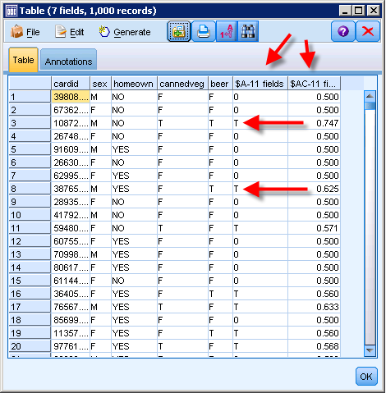

Carma Model

For the Carma model, all inputs are considered to have a role of both. Thus, only the purchasable items should be included in the model as the inputs of the Fields tab. Open the Carma node, click the Fields tab, select the Use custom settings option and select the inputs for the model.
.
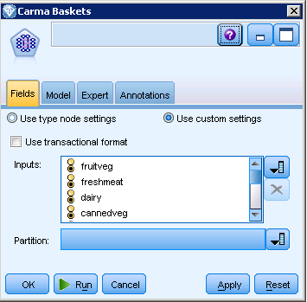

Accept all other defaults and run the Carma node.

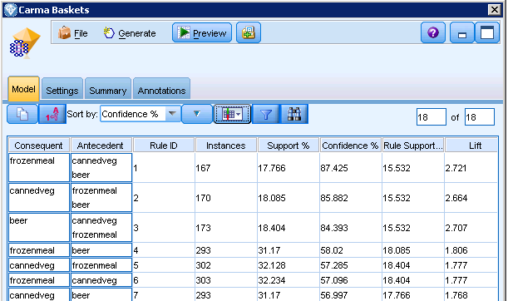

Double click the Carma nugget to view the results. The format of the output is identical to that of the Apriori model so the data presented there need not be explained again. As with the GRI model, generate a Rule Set (use the same target value of frozenmeal), drag it to the right of the Type node and connect the Type node to it. Open the generated rule set node and note that the number of rules, three, is less than in the Apriori model. The rule with the highest confidence is those that buy beer and canned vegetables have a 87.4% probability of also buying frozen meals.

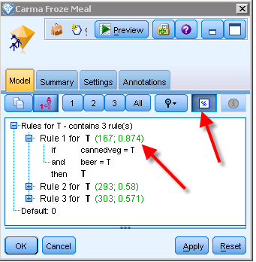
Finish out the stream by adding the Filter and Table nodes. Remember to filter out all the variables not used in the rules to make it easier to read the table. A portion of the table node is shown below. Record 10872 has T the same as the Apriori model but with less confidence; .675 in this case.

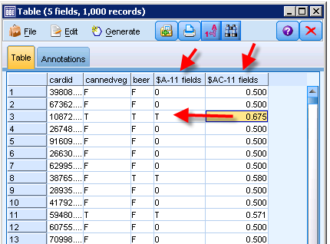
Basket1n Data
Basket summary:
- cardid. Loyalty card identifier for customer purchasing this basket.
- value. Total purchase price of basket.
- pmethod. Method of payment for basket.
Personal details of cardholder:
- sex
- homeown. Whether or not cardholder is a homeowner.
- income
- age
Basket contents—flags for presence of product categories:
- fruitveg
- freshmeat
- dairy
- cannedveg
- cannedmeat
- frozenmeal
- beer
- wine
- softdrink
- fish
- confectionery

A transaction file format will be used to illustrate IBM SPSS Modeler 14.2 – Apriori, Carma and Sequence. The file, GroceryTrans1-Time.xls contains transaction data with a sequence column, Time, as shown below. Notice that the Product variable Role has been set to Both.

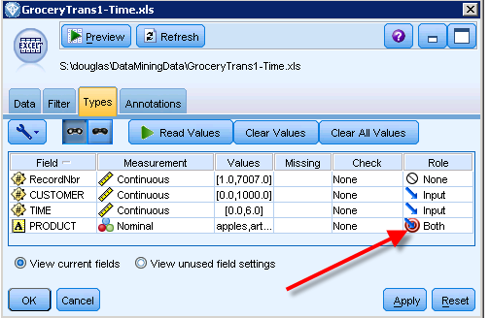

Recall that only the Sequence model makes utilization of Time so it will not be used in the Apriori and Carma analysis. Create a IBM SPSS Modeler 14.2 stream as shown below.

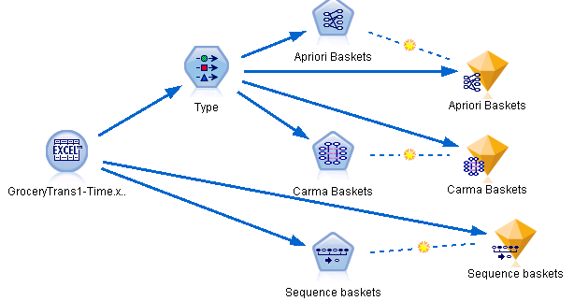

Because the Time field cannot be used by the Carma or Apriori model, a Type node is used to remove this field from the analysis. To do this, ensure that the Role for the Time variable is set to None.
Then, open the Carma node and click the Fields tab. This will require setting the ID variable as well as the Content variable—the how to do this may not obvious until you click the Use Custom Settings option. Click the Use custom settings option and then click the Use transaction format check box.

After clicking the Use transaction format checkbox, the Carma node produces the drop down boxes to allow the user to enter the ID field and the Content field. In this example, the ID field is Customer and the Content field is Product. Recall that the Time field was set to None in the Type node so that it would not be with the Carma model.
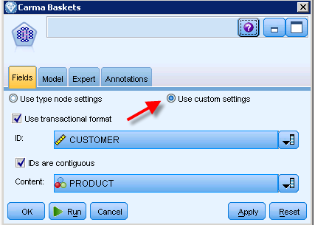
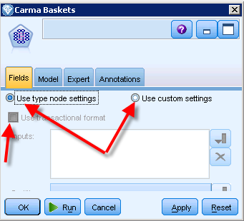

Set the ID field and Content field of the Fields tab of the Apriori model to Customer and Product, respectively, as was the case with the Carma model.

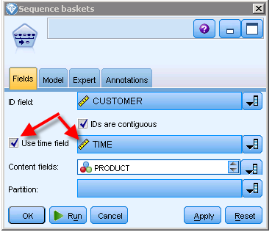
Click the Fields tab on the Sequence node and note that there are drop down boxes already visible. However, the Use time field must be checked before the time drop down box can be used. Select the Customer for the ID field, Time as the time field and Product as the Content fields. These setting are shown at the right.

Now execute all three models and Browse the results of each model. Note that reading the output follows the discussion of previous models. An example output for the Carma model is shown below.

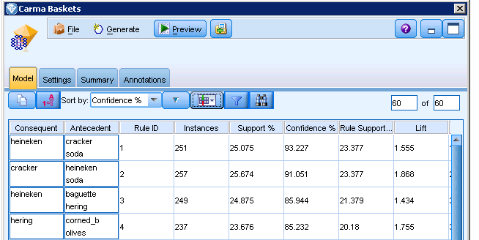

The default sort is by Confidence which results in purchasing crackers and soda leads to purchasing Heineken.

A portion of the Sequence model is shown below. Note that 6 of the top 8 (based on confidence) include Heineken as a consequent.

