

Data Mining with IBM SPSS Modeler 14.2
University of Arkansas
David Douglas

Decision Trees
Logistic Regression
Neural Network
Comparison
Decision Tree, Logistic Regression and Neural Net Comparison

IBM SPSS Modeler 14.2

The flow diagram below includes analyzing data using three different types of models: Decision Trees, Logistic Regression, a Neural Net and a K nearest neighbor.

IBM SPSS Modeler 14.2 includes four decision tree nodes—C&R, Quest, CHAID and C5.0. Each of these nodes have different modeling algorithms and settings, for example, C&R only allows binary splits whereas C5.0 allows more than binary splits and defaults to a branch for each category when splitting on a categorical variable. See Help for complete details. However, keep in mind you need to think about tree depth, number of records in leaf nodes and pruning bushy trees. The models built here will use the PUBLIC.CHURN data. The Types tab of the database source node is shown below (the Read values button has been clicked). Note that the variable PHONE is set to Typeless because it has too many unique values for a categorical variable.

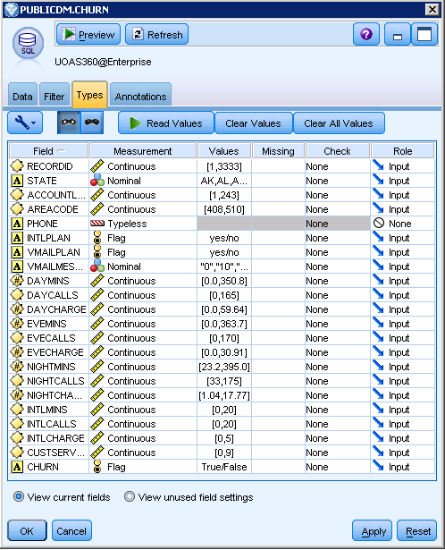

The CHURN data was used in the “Introduction to IBM SPSS Modeler 14.2” which included a discussion of the data. Recall that several variables should be eliminated from analysis because of errors—these are STATE, AREACODE and PHONE. RECORDID should be eliminated because it adds no value to the analysis and the minutes and charges are all highly correlated so all the charge variables will not be included in the analysis. Use the Data Audit and Statistics nodes to verify these findings. Set the CHURN variable as the target variable and set NONE to the other variables mentions above that should not be included in the analysis.

The variable settings should be as shown below. Note that these settings could also be accomplished in the Type node.

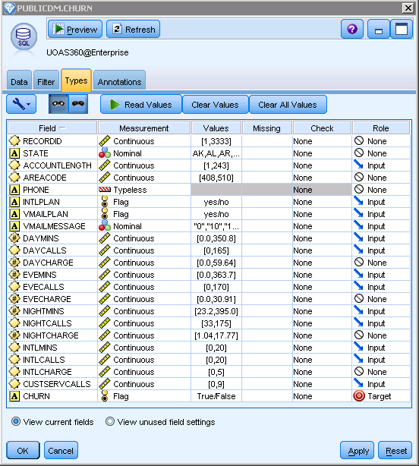

Build a model flow as shown below. The initial model flow will use defaults for all the models; however, you are encouraged to experiment with model settings in order to find the best model. The Partition node has been set to 60% for training and 40% for testing. Provide a custom name for each of the modeling nodes—via the Annotations tab of the modeling node. ‘Also, initially, missing and bad values are ignored.
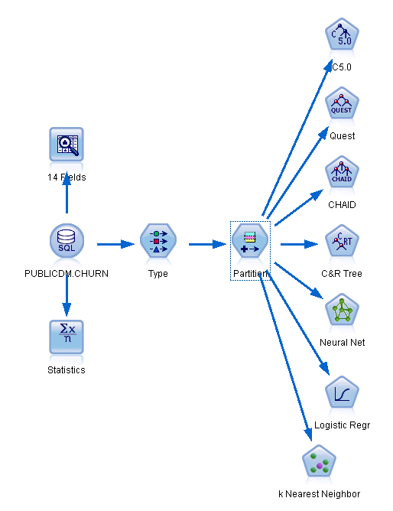
Run each of the models—the K Nearest Neighbor model requires selection of the option “Predict a target field” on the Objectives tab for it to work. The diagram gets a bit messy as model nuggets are added to the canvas as the models are run. After running each model, attaach an Analysis node to each of the model nuggets and run each analysis node. Your model flow should resember the diagram below.

Recall that the model nuggets are also placed in the Models tab of the upper right pane and the Outputs tab will have the results of each of the Analysis nodes that your ran. Review the results of the Analysis Nodes that you ran to find the model that had the most accurate predition. The C5.0 decsion tree had a 93.65% accuracy rate for the Testing sample—and the Testing sample should be used. Find the least accurate of the models. The Logistic Regressioin was the least accurate model at 86.18%.

Recall that these models have been run at default settings and the models may be improved by changing the various paramters.

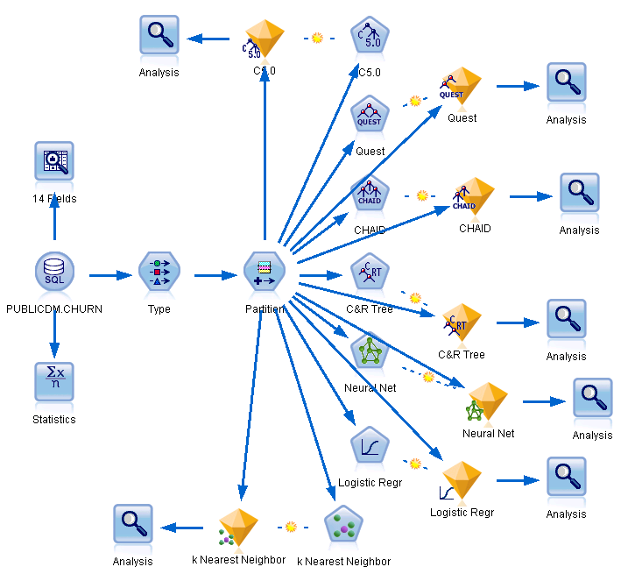

One can also string together the model nuggets using an Analysis node at the end fo the string for comparison of all the models. Drag each of the model nuggets from the Models tab and connect together as shown by the partial screen shot below accomplishes this task.

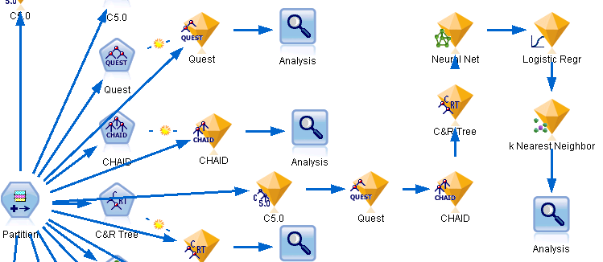

A portion of the output of the Analysis node is shown below. Note that for these default settings, the C5.0 Decision Tree node results in the most accurate model on the Test set—93.65% and is the best of the Decision Tree models. The Logistic Regression model was the least accurate at 86.18%.

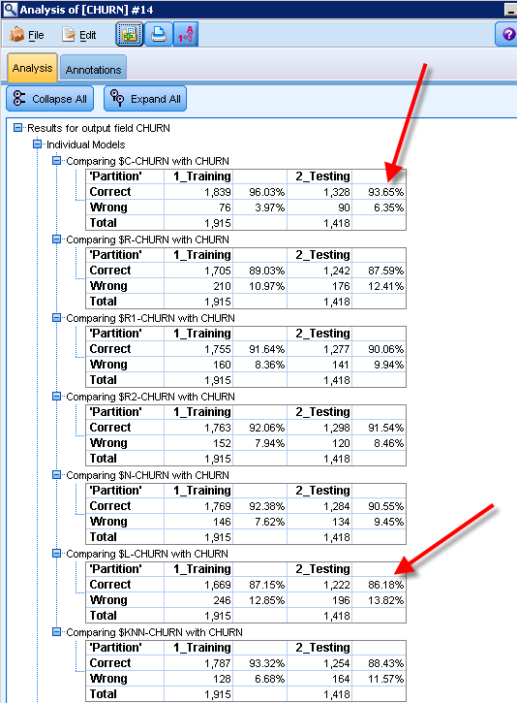

The Neural Network (NN) Node has a number of interesting settings—all the defaults have been accepted which includes the QUICK method. Explore this node by clicking the Expert tab followed by the Expert option. Notice the ability to have 2 or 3 hidden layers as well as a number of parameter settings related to the Learning rate. The Help documentation provides excellent guidance on all the nodes.

Reviewing selected Model nodes provides greater insights improving models of the model type. Double-click the Neural Network nugget to review the output of the model run. The default is the model summary as shown below. It is a pretty good model as we had already determined via the Analysis node—90.55% accuracy. Click the Predictor Importance icon (2nd) in the left pane.

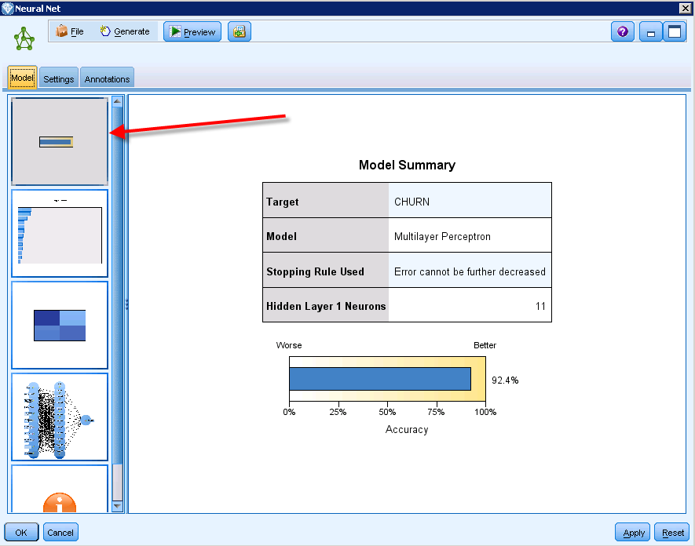

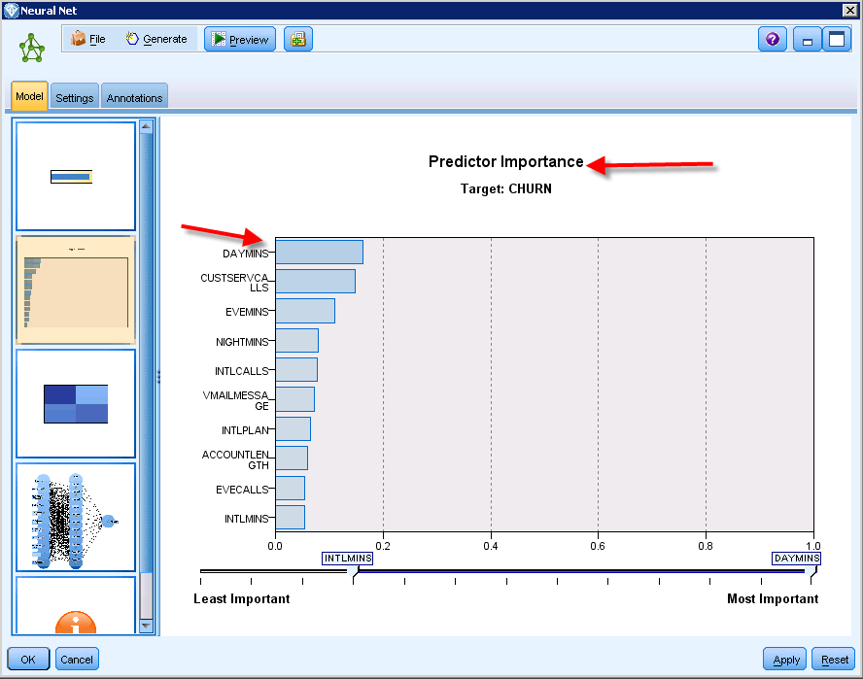

This output indicates DAYMINS as the strongest predictor variable followed by CUSTSERVCALLS. Click the 3rd icon in the left pane to open the Classification table window as shown below. Note that only a few observed False churn values were predicted True but a lot of True values were predicted False.

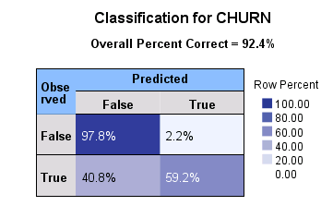

Click the Network icon (4th) in the left pane to open the Network Window. The Network shows DAYMINS as the most important predictor variable and INTLMINS as the least important predictor variable. The thickness of the lines between the input predictor variable and the middle layer show the strength of the predictor variable—the thicker the more strength.

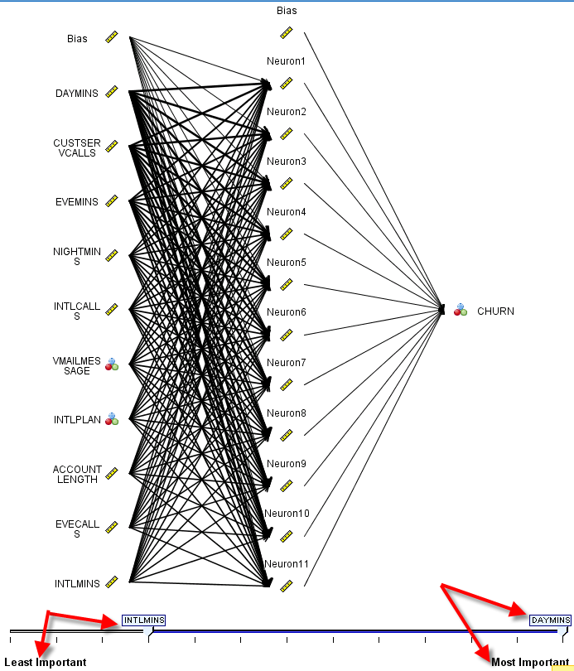

Edit the Neural Network node to the Build Options tab. Notice the menu items on the left starting with Objectives and running through Advanced. Click the Enhance model accuracy (boosting) option button. Read the comments—middle bottom—which states an ensemble will be used and the time to run will be greater.

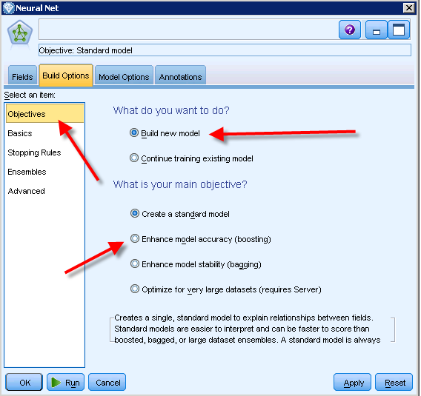

Click the Model Options tab and ensure the Predicted probability for categorical targets check box is checked. Return to th Build Options tab and click the Basics menu item on the left. Multilayer Perceptron (MLP) is the default NN model with a default of 1 hidden layer with automatic determination of the number of units in the hidden layer. By selecting the Customize number of units option, the user can manually adjust the number of hidden layers and units.

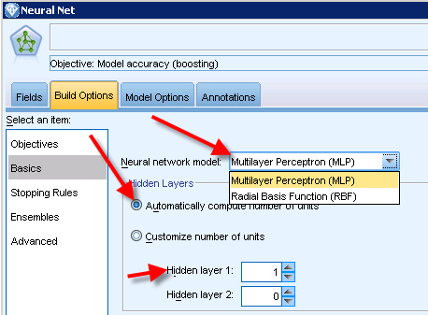

Leave the Basics, Stopping Rules and Ensembers model settings as default. Click the Advanced menu option and note that the Overfit prevention is set to 30%. There is also an option for handling missing values.

At this juncture, boosting and Predicted probability for categorical targets are the only changes from the default settings which had an accuracy of about 90.55%. Run the model with boostng and check the accuracy. Note that the models runs considerable longer than when runing the standard model. Run the Analysis node and note that the model accuracy has improved to 91.89% for the Test data.

To view lift charts, attach an Evaluation node from the Neural Network model nugget and change to settings as shown below right. Execute the Evaluation node.

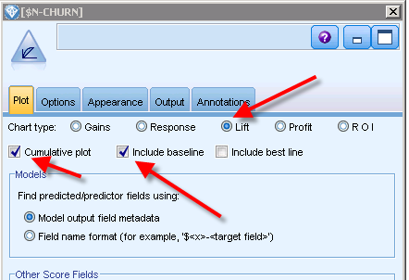

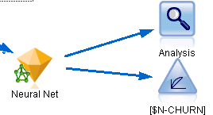

The cumulative Lift chart illustrates the impact of the model on both the Training data and the Test data. Note that at the 20 Percentile of the sample, the lift is 3.43.

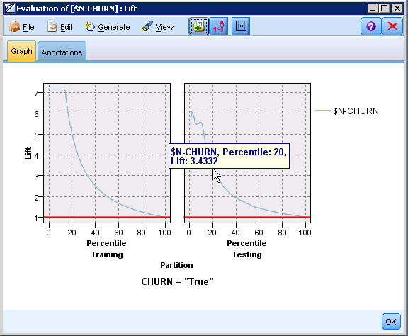

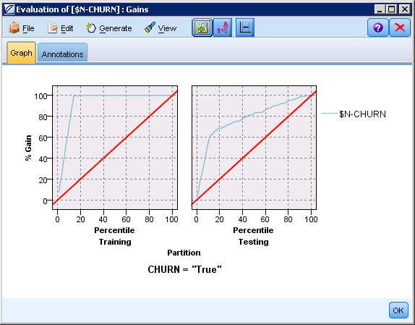
You may wish a Gains chart which better depicts the improvement of the model over random selection-shown to the right. It is important to note that the gain/lift charts for the Training and Testing data are a bit different—lift being 5 at the 20 percentile for the Training data. Thus, one may have some hesitancy about whether the model will generalize well.

The C5.0 decision tree performed best in this run—let’s review the decision tree output. Double-click the C5.0 model nugget. The right pane provides a variable importance whereas the left pane provides an expandable list of rules. The top red arrow indicates a button that adds the number of records at a node and leaf nodes –estimated confidence is also provided for leaf nodes. For example, the tree path that ends with INTLPLAN=no shows 1274 records with a 97.6 % confidence of not churning.

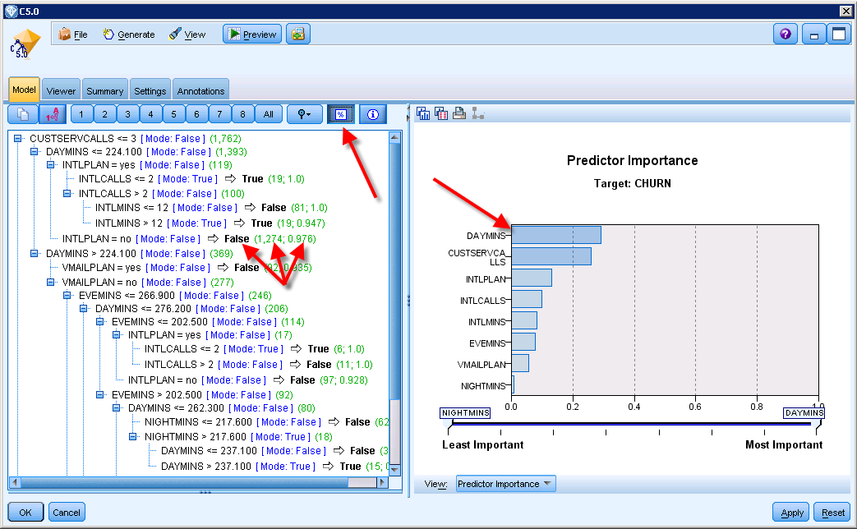

Click the Viewer tab to review the Tree—a portion of the tree is shown below. The target variable is Churn. The root of the tree is shown below and it indicates a sample of 1915—1648 with a value of False and 267 with a value of True. The first split is on CUSTSERVCALLS, records with a value of CUSTSERVCALLS > 3 go to the right branch of the tree and those with a VUSTSERVCALLS value <= 3 go to the left branch of the tree. The next split will be on DAYMINS.

Explore the tree looking for leaf nodes—nodes that do not have any braches. For example, Node 31 is a leaf node with a path that resulted in 100% of the records having Churn value of True. Clearly and good rule but the node only has a small number of records. Thus, it may not be the rule you wish to use.
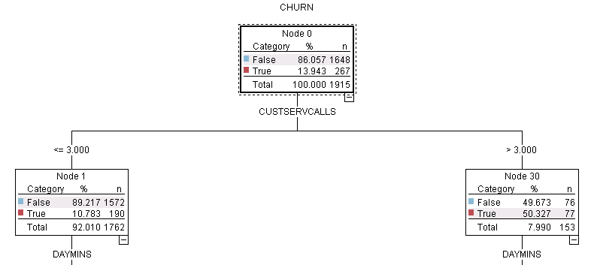

As in the Neural Network, you can use an Evaluation node to review gains/lift charts—see below.

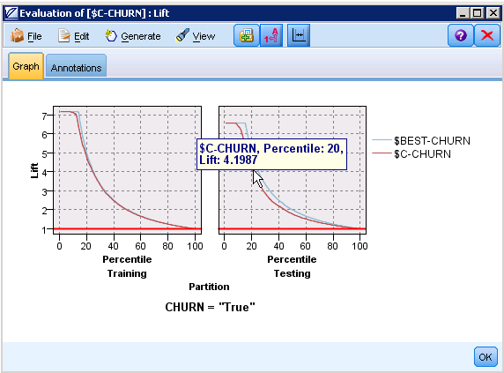

The K-nearest Neighbor model also did not have the accuracy of the decision tree and neural network models. Review the model node results –see graph below. The output consists of a three dimensional graphic with selected inputs and the number of predictor variables, K, included in the graph.

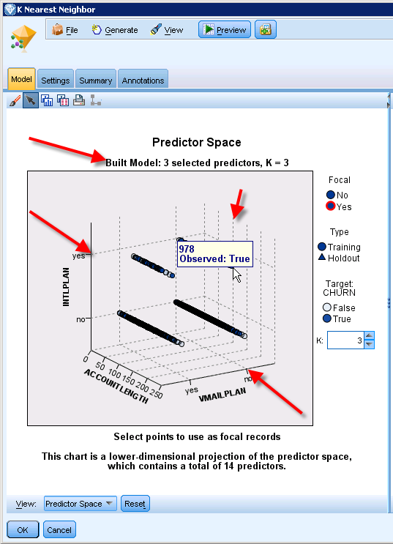

Moving the moue cursor over a data point will provide the record number and the value for Churn. In the example shown, it is record 978 and Churn would be true, the three predictor values being: INTLPLAN=yes, VMAILPLAN-no and Account length is about 100.

Edit the K Nearest Neighbor node and note that it has an Accuracy option of its objective. The default is Balance speed and accuracy. Select the Accuracy option; rerun the model and its associated Analysis node.

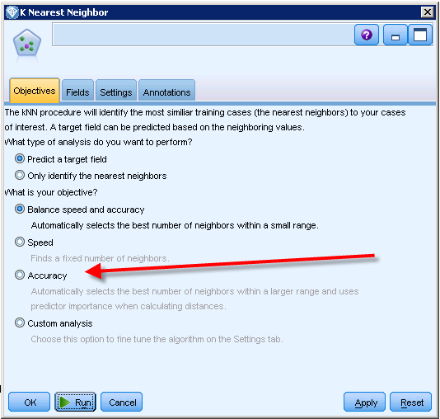

This change resulted in only a marginal increase in accuracy, from 88.43% to 88.79%
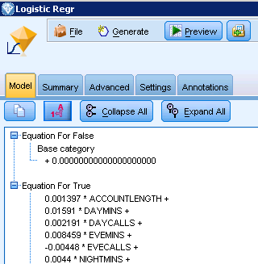

Review the output of the Logistic Regression run. Recall that this model had the lowest accuracy rate of all models.

The Model tab provides the regression equations—a partial screen shot is shown to the right.

The Summary tab provides the variables used in the model and the model settings.

Click the Advanced tab—note the warning. The Logistic Regression model indicates that some predictor variables should be excluded or categories merged.

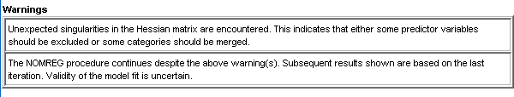
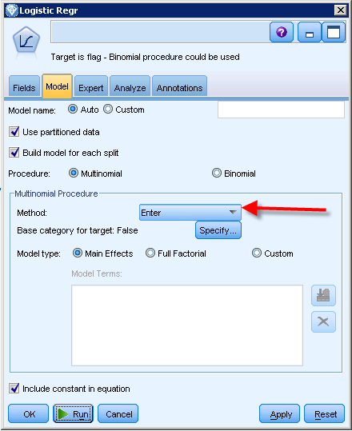
Edit the Logistic Regression node and note that there is a drop down box to select the Method: Click the drop down box and select Stepwise. Run the model and associated Analysis node.

The model accuracy using Stepwise was only slightly better than the default model—improving from 86.16% to 86.46%. Thus, some further work is required for the Logistic Regression model to improve.

Missing Data
IBM SPSS Modeler 14.2 has an Auto Data Preparation node to hand missing data. It is not needed with this data but many sets of data have missing values—the Auto Data Preparation node is very useful to hand these cases.

Auto Classifier
IBM SPSS Modeler 14.2 includes an Auto Classifier node. The examples above included individual model nodes that will be included in the Auto Classifier node. One can use it instead of the individual model nodes. However, it is extremely important to understand the individual modeling nodes as the default setting are seldom sufficient for the desired model.

