Creating a table in your ACCTID using the Control Center

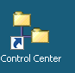
After logging onto the IBM terminal server, click the Control Center icon to open the DB2 control center dialog.

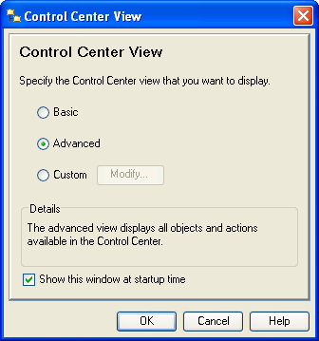
Alternate: Start All ProgramsIBM DB2General Administration ToolsControl Center

This is IBM’s interface to DB2 and is common for DB2 on all platforms. A dialog window may appear allowing the user to select a desired Control Center view. The DB2 dialog window shown here defaults to Advanced--note that the user can uncheck the Show this window at startup time checkbox to always accept the default.

Click the OK button to accept the default Advanced setting to reach the Control Center. Although one can go directly to the Command Editor (a command line interface), the Control Center is probably the better choice. It allows the user to poke around to see what instances of DB2 are available without having to logon to a system. However, one does have to log on and connect to access a particular DB2 instance. Further, after login, reviewing data is possible without queries.
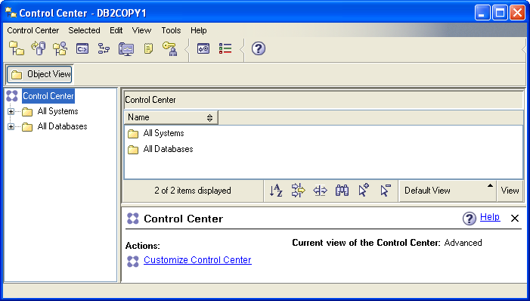
The icons under the menu allow the user to select different types of tasks (Views) to be accomplished. Moving the mouse over the icons displays a tool tip indicating its View. For our purposes here, we will initially work directly from the Control Center View.

The Object View and the expandable tree underneath it provide information about the systems and databases that are accessible by the user. Note that it will change over time. For example, the UA adds student and faculty accounts as needed.

Expanding the tree demonstrates that the UA has three DB2 instances. The ZUAF instance is running on the IBM z900. Trying to expand an instance results in a Connect dialog window that prompts for a user id and password; for the ZUAF instance in this case.

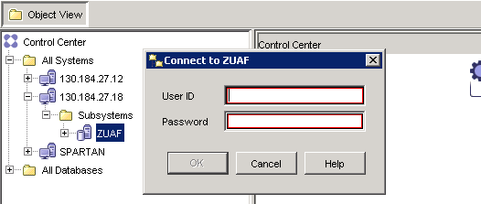
After logging in, expand the ZUAF DB2 instance and click on Tables. Note that the columns in the right pane are sorting by simply clicking the header. Multiple clicks reverse the sort on each click—the first click being in ascending order. In the image shown below, the Database column was clicked twice to get a descending order of databases—an existing database that may be of interest is UADILL. Note that it has six tables.

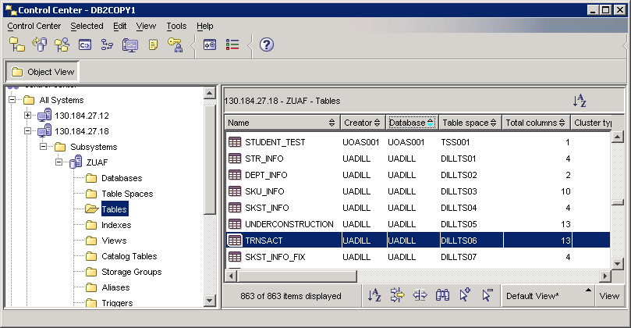

Creating a table
Before working with the UADILL database, lets create a table for an ACCTID. There are a number of ways to do this but one easy way if one knows the SQL to create a table is to use the command editor. Click the icon shown below to open the command editor.

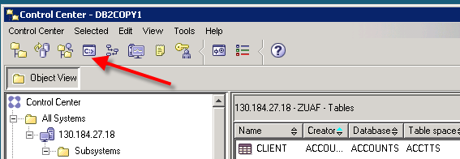

Click the “Add” button to open a dialog that will provide a connection string to the desired database, ZUAF in this case. Enter your sign on credentials.

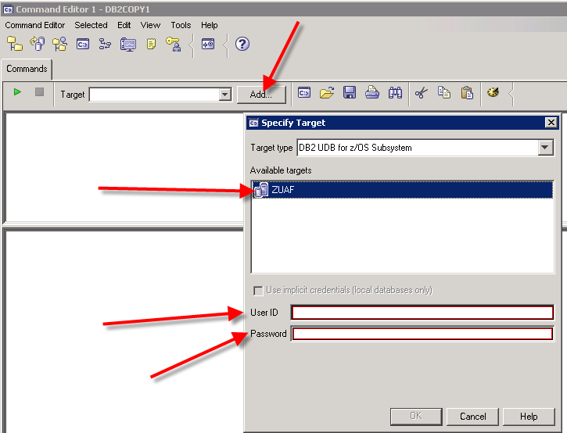
If the login is successful, you should see your account in the Target drop down textbox and the bottom pane of the Command Editor should indicate a successful connection.

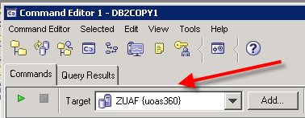

The example table for this illustration is an “Order” table. The SQL statements to create this table is shown below—note that a unique index and primary key are included. Also note that this is a very complete definition and many of the features could be allowed to default.

ALTER TABLE UOAS360.ORDER DROP CONSTRAINT ORDER_ID;

DROP INDEX UOAS360.ORDER_ID_NDX;

DROP TABLE UOAS360.ORDER;

CREATE TABLE UOAS360.Order (
Order_ID INTEGER NOT NULL,
Item_ID INTEGER NOT NULL,
Item_Desc VARCHAR(25) NOT NULL,
Item_Cost DEC(7,2) NOT NULL,
Item_Price DEC(7,2) NOT NULL,
Item_NbrOrdered INTEGER NOT NULL,
Item_Supplier_ID INTEGER NOT NULL
);

CREATE UNIQUE INDEX UOAS360.ORDER_ID_NDX ON UOAS360.ORDER (ORDER_ID ASC)
NOT CLUSTER
NOT PADDED
BUFFERPOOL BP3
DEFER NO
COPY NO
PIECESIZE 2097152 K;

ALTER TABLE UOAS360.ORDER ADD CONSTRAINT ORDER_ID PRIMARY KEY (ORDER_ID);

Copy all of the statements above and paste into the top pane of the Command Editor and then click the green run icon .

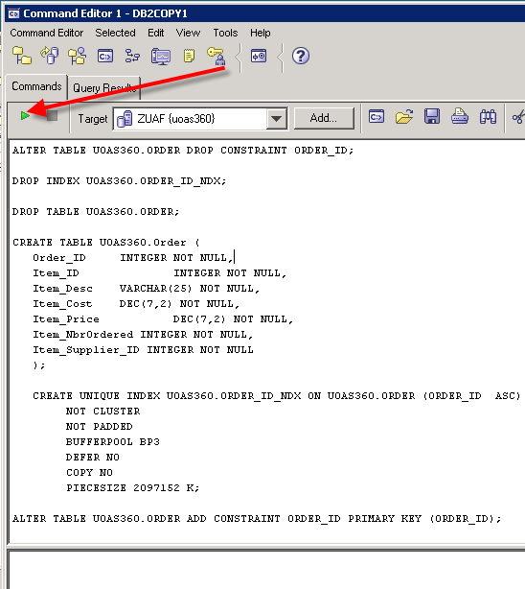

The results of the run will appear in the lower pane—note that if this is the first time you run the SQL statements, then errors will occur as you are asking it to delete the primary key, an index and a table that are all non-existent. Also, the creation of the unique index will throw a warning; but is ok. You need to look for “The SQL command complete successfully” for each SQL statement except for the unique index which throws a warning.
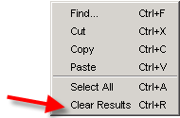
Note1: To clear contents in either the upper pane or the lower pane of the Command Editor, right-click in an open space and select Clear Results

Note2: Because you have added a table, you will need to right-click on ZUAF and select Refresh for it to appear in the Tables list
To populate the “Order” table, you can stay in the Command Editor and use INSERT statements or return to the Control and populate the table. Note—when returning to the Command Editor, you may have to select a Target in the drop-down box. Return to the Control Center by clicking the leftmost icon on the toolbar. In the Control Center, sort the Creator column by clicking on it—as indicated it changes from ascending to descending on each click. Find your account id and double-click it. You can then enter data.

