Creating Entity Relationship Diagrams (ERDs) in Microsoft

- After connecting to Microsoft SQL server, expand the Databases folder in the Object Explorer Menu. From the list, select the Database for the dataset you wish to model.
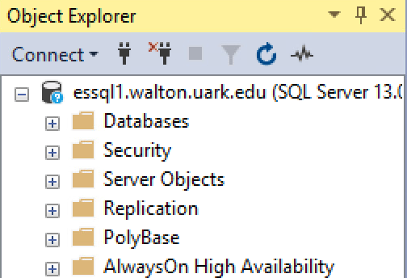

Dillard’s Department Stores
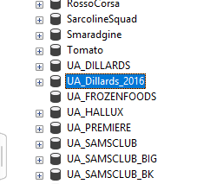
- Click on the + button next to the UA_Dillards_2016 database
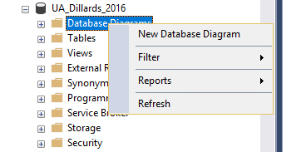
- Right click on Database Diagrams, then select New Database Diagram

- If you see a message about permissions, select OK
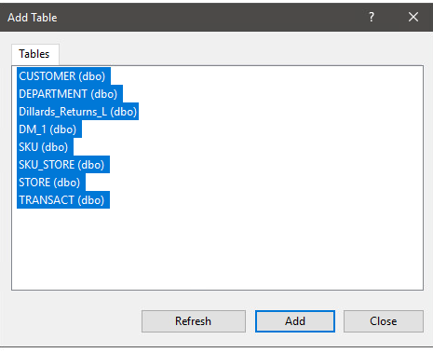
- An Add Table window will appear. Select the tables you want to include in your ERD and click Add.

- The entities and relationships will appear. Your result should look like the picture below. Notice that two tables are not connected to the rest of the data. What could this mean about the Dillard’s dataset?
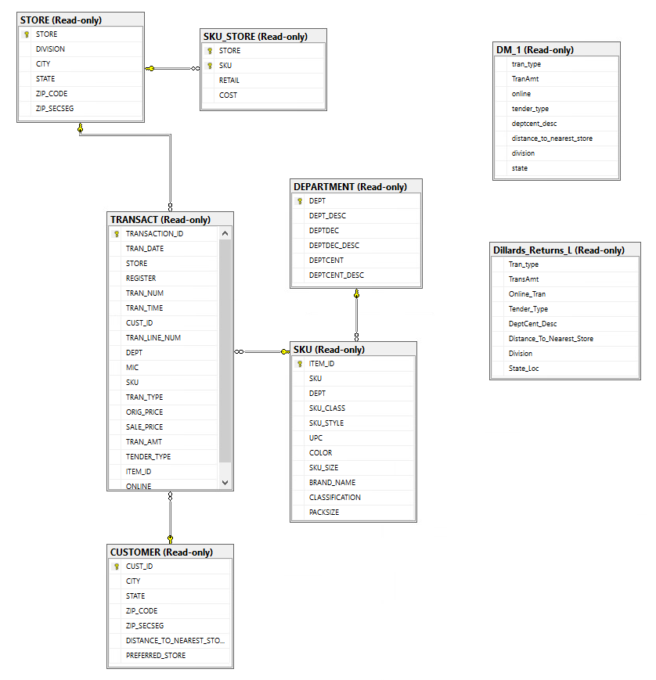

Hallux Productions
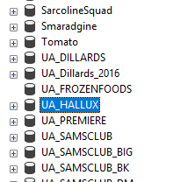
- Click on the + button next to the UA_Hallux database
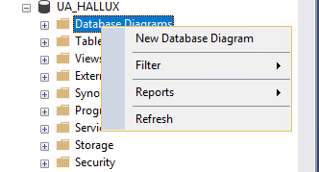
- Right click on Database Diagrams, then select New Database Diagram

- If you see a message about permissions, select OK
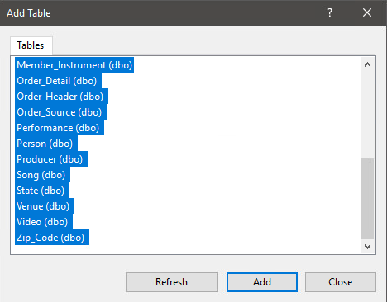
- An Add Table window will appear. Select the tables you want to include in your ERD and click Add.

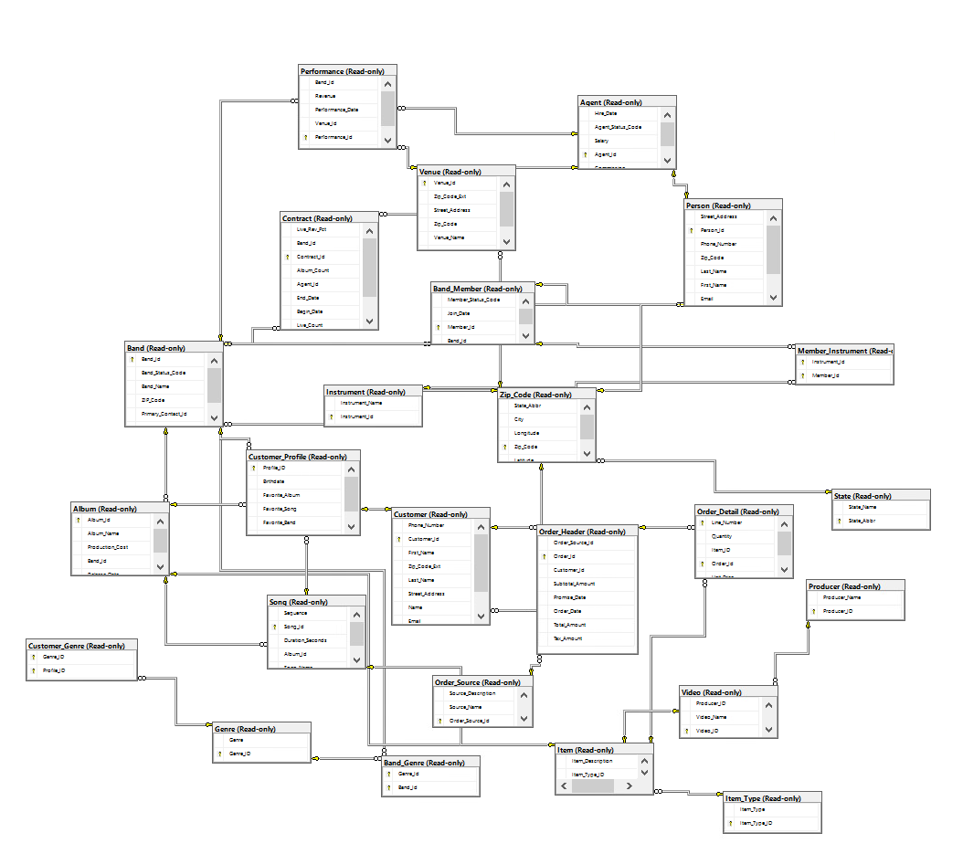
- The entities and relationships will appear. Your result should look like the picture below.

Tyson Frozen Foods
- Click on the + button next to the UA_TYSON_FOODS database
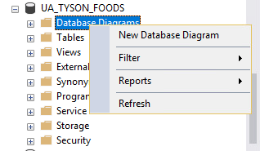
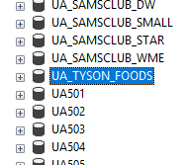
- Right click on Database Diagrams, then select New Database Diagram

- If you see a message about permissions, select OK
- An Add Table window will appear. Select the tables you want to include in your ERD and click Add.
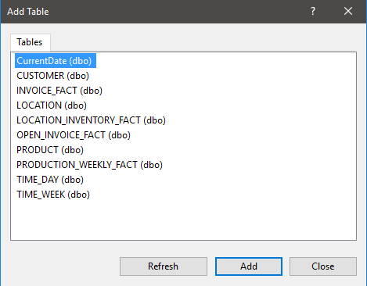

- The entities and relationships will appear. Your result should look like the picture below. Notice that three tables are not connected to the rest of the data. What could this mean about the Tyson Foods dataset?

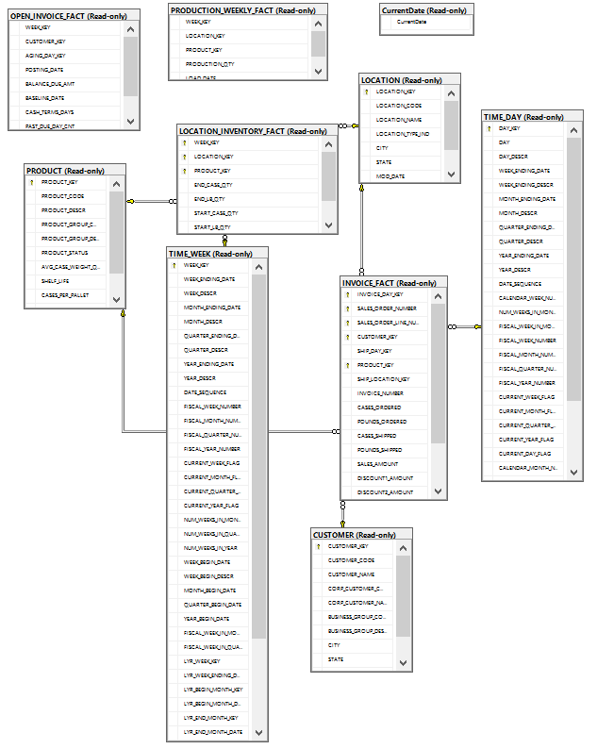

Sam’s Club
- Click on the + button next to the UA_SAMSCLUB_STAR database
- Right click on Database Diagrams, then select New Database Diagram
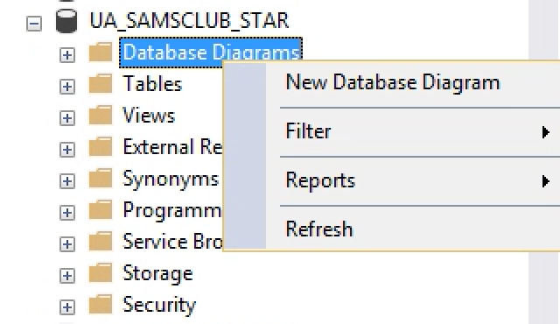
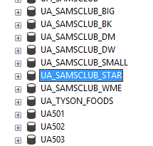

- If you see a message about permissions, select OK
- An Add Table window will appear. Select the tables you want to include in your ERD and click Add.
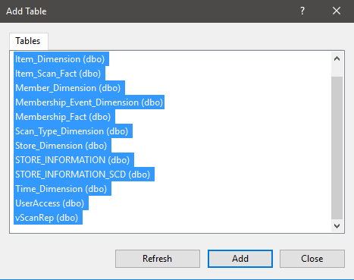

- The entities and relationships will appear. Your result should look like the picture below. Notice that six tables are not connected to the rest of the data. What could this mean about the Sam’s Club dataset?

