WALTON COLLEGE EMAIL SIGNATURE GUIDE

Walton College Email Signatures

Welcome to the official Email Signature Guide for the Sam M. Walton College of Business. This is designed to help faculty and staff maintain consistency, professionalism, and accessibility in every message.

This guide adapts the University of Arkansas’s official email signature standards—outlined by University Relations—to meet the needs of the Walton College. By following these guidelines, you’ll ensure your emails maintain a professional, consistent look that reflects both our college and the university’s brand identity.

At a Glance Steps

Your email signature should be treated like other forms of official university communication. For clarity and consistency, the following email signature format is recommended for university employees.

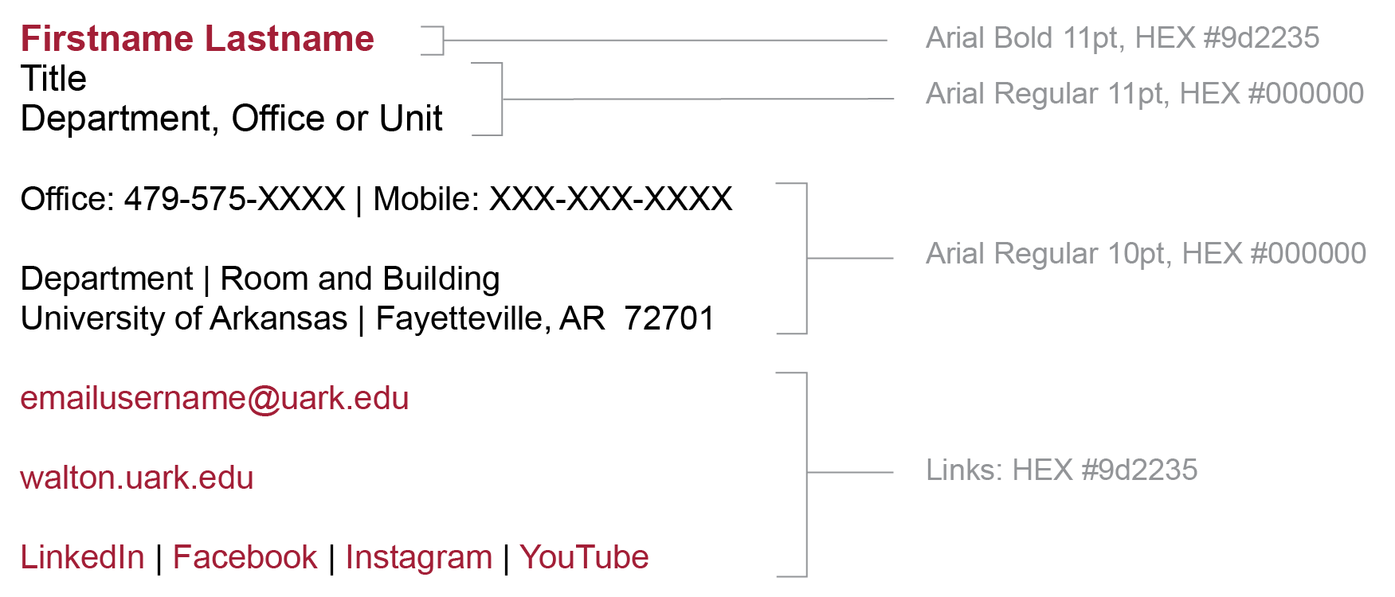

Step by step Microsoft instructions are available for Windows and Mac clients.

Easy Copy and Paste Instructions

Copy the template below (from Firstname through YouTube) and paste into the signature preferences pane of your Outlook client, then replace the generic information with your own. The recommended default font is Arial. The social media links default to the Sam M. Walton College of Business accounts.
______________________________________________________________________

Firstname Lastname
Title
Department, Office or Unit
[optional college, school or division information]
Office: 479-575-XXXX | Mobile: XXX-XXX-XXXX
[other optional information]
Department | Room and Building
University of Arkansas | Fayetteville, AR 72701
emailusername@uark.edu
walton.uark.edu
LinkedIn | Facebook | Instagram | YouTube
______________________________________________________________________

General Guidelines

- Make sure your contact information is consistent, accessible, and easy to read.

- Copy, paste, and use the recommended template for email signatures.

- If your template requires alterations including the addition of optional contact information, always use:
  - Arial (or similar non-serif font if Arial is unavailable)
  - 10-11 point font size
  - Recommended colors, layout, and formatting
- Be concise. Include only contact information. This is especially helpful to those reading on mobile devices.
- Additions indicating that the email content is private or confidential should be avoided. While specific exemptions may apply in some instances, university emails are public records subject to the Arkansas Freedom of Information Act.
- Email signatures should not be created as single images because they are inaccessible and violate the guidelines of the Americans with Disabilities Act.
- Try to avoid the use of images. When needed, make images more accessible by adding descriptive ALT tags (alternative text) to each image.

