Approving an Event in 25Live

- Log in to 25Live at https://25live.collegenet.com/uark

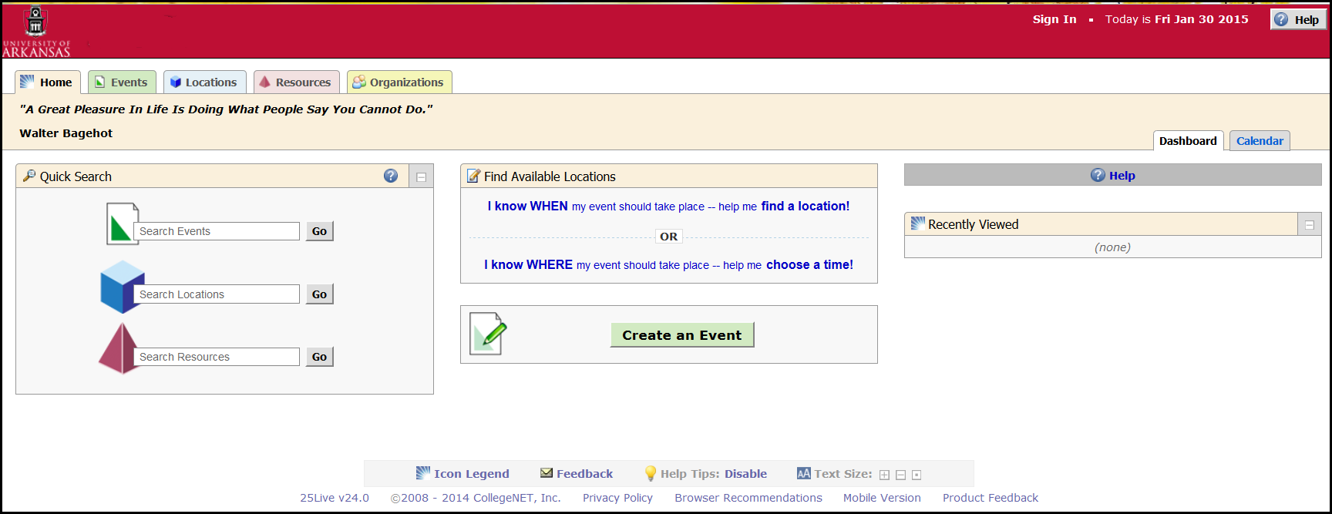

- Click the Sign In Link in the upper right corner.

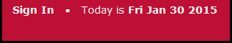

- Enter your UARK username and Password.

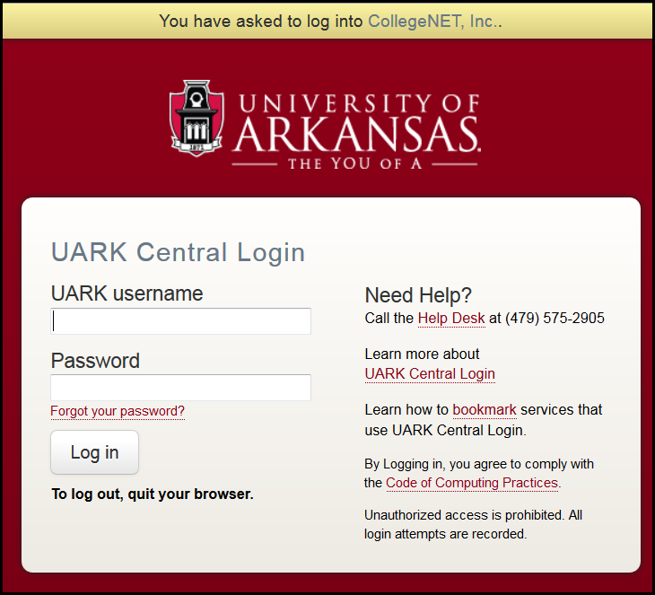

- Click Log in.

- Your Home page is displayed.

- Locate the Tasks section. Approval requests will be listed as an outstanding task.

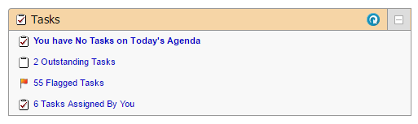
7. Click on the Outstanding Tasks link to view tasks. Note that 25Live will not allow users to approve an event where a conflict exists. Thus, there is no need to verify conflicts.

Click on the name of the event to open the event.
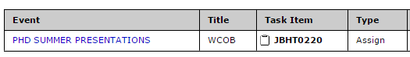

8. To approve an event, click the Assign? link located in green in the Task List tab.

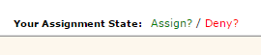

To deny an event request, click the Deny? Link located in red in the Task List tab.

9. After approving or denying the event, send an email confirmation to the event requestor. Under More Actions click, Email Event Details.

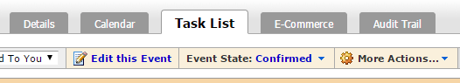

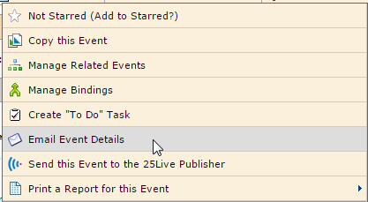

10. Select the checkbox next to the Requestor’s name along with the attach Event Confirmation (Detailed) checkbox and Include event details in body of message. It is also recommended to add a brief note to the message body.

When complete, click the Send button.

