Search for an Event

- Log in to 25Live and click the Events tab.

- A new screen opens where you may search for events by using a Keyword (such as SUST) or by clicking the More Search Options link for additional ways to search for an event.

- Enter the keyword in the blank field and click GO.

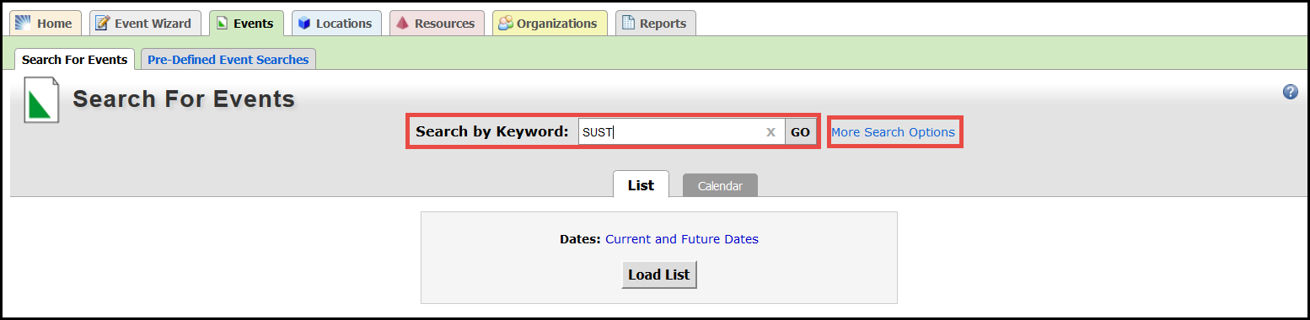
- The search results appear. Note that the results may be viewed in a list (as shown) or in a calendar view by clicking on the tab for the desired view.

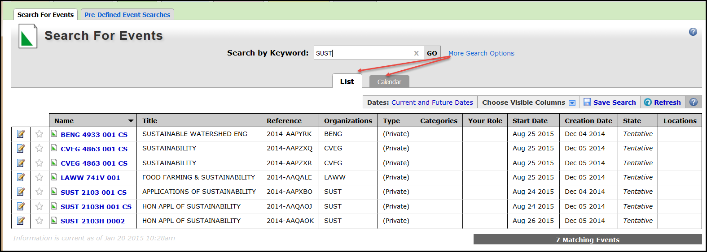

- Click the Current and Future Dates link to select the specific dates you wish to see.

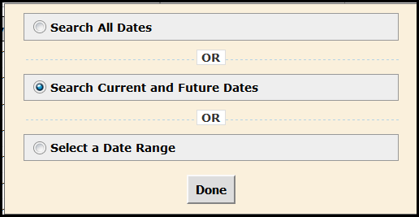
This option will take several minutes to load.
Not recommended.
This is the default value.

- Click Select a Date Range to expand the search dialog box to select the desired start and end dates for the event search.
  - Select the dates and check the Enforce a Date Range Interval check box if this criteria is helpful for your search.

- Click Done when all selections are entered.

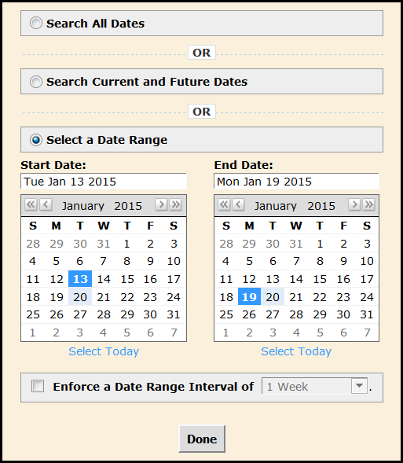

- This example shows the results for events in the system for the week of August 24 – 28 in List view and Calendar view.

List View
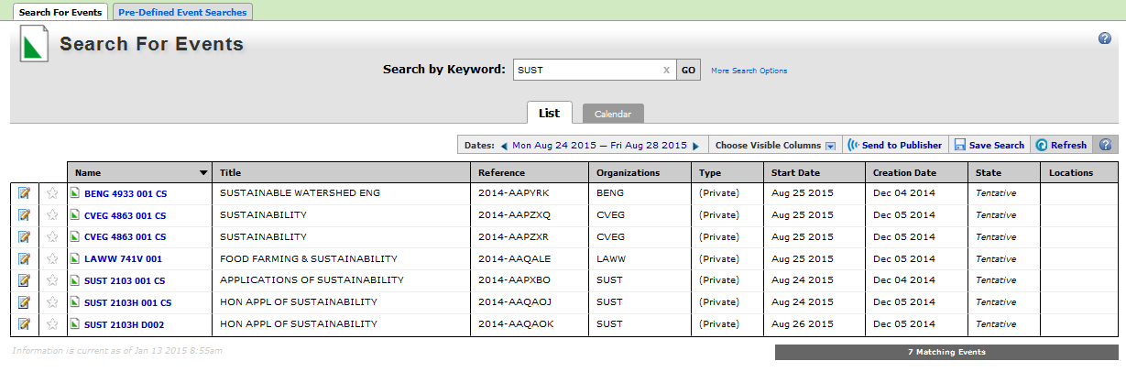

Calendar View
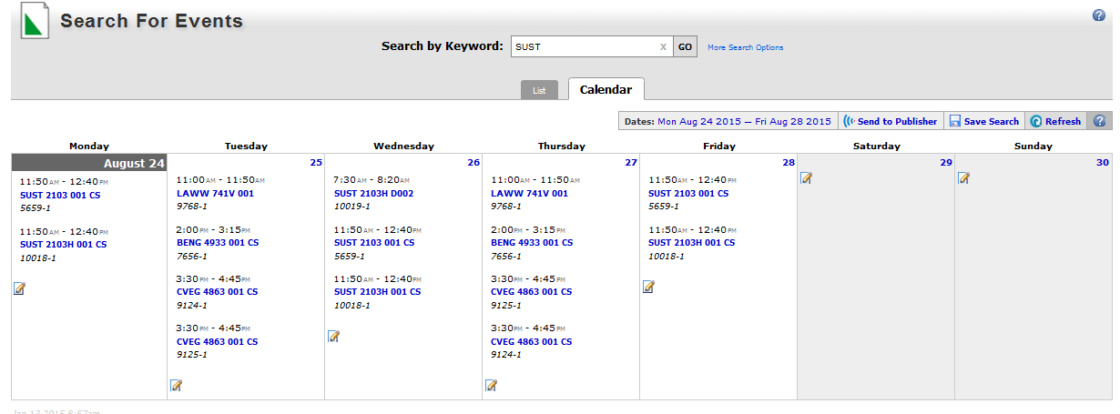

- To view more detail on a specific event, click the link for that event.

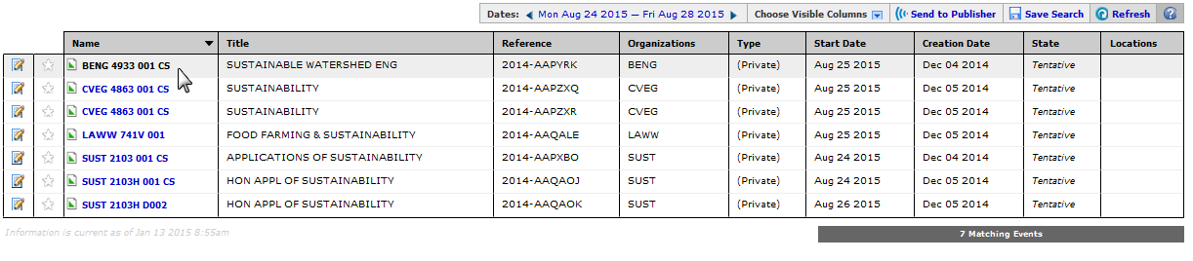

- Details for the event are displayed.

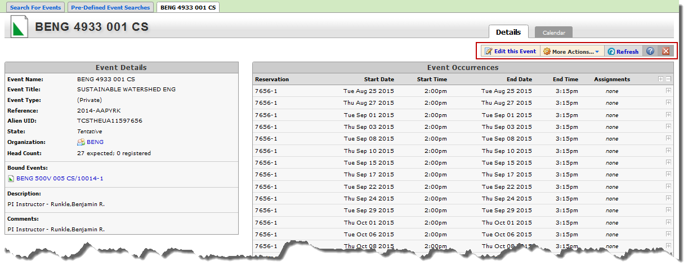

NOTE: There may be more options available based on security access in 25Live/R25. Click on Edit this Event or More Actions to open more options.

- Click More Actions to view new options. A user may not have access to every option on the list. However, all users should be able to add the event to Favorites by clicking on the Star and to e-mail the event.

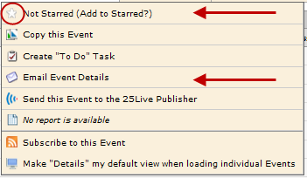

Important: If you do not have the security access for a given area, you will receive the following message:

